EOWG can help you get the word out!
The Education and Outreach Working Group is chartered to support accessibility efforts of all WAI Working Groups by helping to promote awareness, understanding, and implementation of web accessibility. At TPAC this year, we want to hear how we can help your Working Group spread the word about your own accessibility innovations and breakthroughs.
Co-chairs Brent Bakken of Pearson and Sharron Rush of Knowbility are at TPAC from Monday through noon Thursday. We welcome the chance to show you our recent work and learn more about yours.
Especially, we welcome ideas and opportunities to plan for future collaboration.

Most Recent Work from EOWG:
- Collaborated with WCAG to update How To Meet WCAG 2.0  - Created Tips for Getting Started with Web Accessibility  - Reviewed and revised WCAG-EM specifications  - User Interface for the WCAG-EM Report Tool  - Created Planning and Managing Guide to Accessibility  - Produced Web Accessibility Perspectives videos to help public understand accessibility issues  - In process of redesigning the WAI website  - Continually updating Web Accessibility Tutorials, EasyChecks, Intros to WCAG 2.0, ATAG 2.0, UAAG 2.0, and more learning and teaching resources | 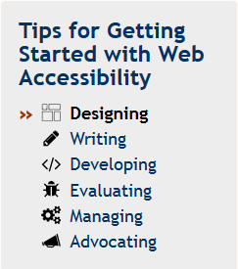

How We Can Help You
As you think about ways in which the EOWG can collaborate with you, consider these possibilities:
- Amplify your outreach effort
- Help craft messages and campaign for disseminating information
- EOWG participants are experienced web accessibility professionals and are available for thorough review and comment on your documents
- EOWG review often results in plainer language, more readable specifications, clearer understanding of requirements.

Let’s meet!
Sept 19th and 20th. EOWG room at TPAC: Room 1.02, Hall 4, First Floor
(If we are not currently in the meeting room, please email us to coordinate a meeting time.)

Contact:
Brent Bakken brent.bakken@pearson.com (EOWG Co-Chair)
Eric Eggert ee@w3.org (Team Contact)
Sharron Rush srush@knowbility.org (EOWG Co-Chair)

