# Proposal: Updating WCAG photosensitive epilepsy guidance via notes

DRAFT 2022-07-25

J Bern Jordan ([jbjordan@umd.edu](mailto:jbjordan@umd.edu)) & Gregg Vanderheiden ([greggvan@umd.edu](mailto:greggvan@umd.edu))  
 Trace R&D Center, University of Maryland

This DRAFT proposal is to update language for photosensitive epilepsy to account for changes in technology.

This is an update to informative content only (i.e., notes for success criteria and definitions) (no normative changes required).

The goal is to see if this is both minor enough and important enough to get into WCAG 2.2.

## Rationale

Since WCAG 2.0 was first published in 2008, there have been relatively few updates to other standards and guidelines around PSE (those mostly around HDR content), but there have been significant changes in web and computer technology. The Trace Center at the University of Maryland hosts the free-to-use Photosensitive Epilepsy Analysis Tool (PEAT), and we get email from people around the world about PEAT and more general questions about characteristics of video content that might cause a PSE response. Some of the email queries demonstrate some confusion over the current wording in WCAG 2.0/2.1.

The proposed changes aim to clarify some of the confusing points and partly future proof the PSE guidance in WCAG 2.2.

This draft proposal is structured as follows:

* All relevant WCAG 2.1 content is included below.
* Where the informative changes (to notes or new notes) are recommended, they are shown as tracked changes.
* Comments and rationale for the recommended changes are provided as well. To help separate them from the current and proposed WCAG language, the comments are indented, in blue, below the relevant WCAG content. Each block starts with: “Comments on…”

We welcome all comments on this draft.

# Proposed edits

(The proposed edits are shown below as tracked changes with rationale in blue.)

## Success Criterion 2.3.1 Three Flashes or Below Threshold

Web pages do not contain anything that flashes more than three times in any one second period, or the flash is below the general flash and red flash thresholds.

### NOTE

Since any content that does not meet this success criterion can interfere with a user's ability to use the whole page, all content on the Web page (whether it is used to meet other success criteria or not) must meet this success criterion. See Conformance Requirement 5: Non-Interference.

## flash

a pair of opposing changes in relative luminance that can cause seizures in some people if it is large enough and in the right frequency range

### NOTE

See general flash and red flash thresholds for information about types of flash that are not allowed.

### NOTE

See also blinking.

## general flash and red flash thresholds

a flash or rapidly changing image sequence is below the threshold (i.e., content passes) if any of the following are true:

1. there are no more than three general flashes and / or no more than three red flashes within any one-second period; or
2. the combined area of flashes occurring concurrently occupies no more than a total of .006 steradians within any 10 degree visual field on the screen (25% of any 10 degree visual field on the screen) at typical viewing distance

where:

* A general flash is defined as a pair of opposing changes in relative luminance of 10% or more of the maximum relative luminance where the relative luminance of the darker image is below 0.80; and where "a pair of opposing changes" is an increase followed by a decrease, or a decrease followed by an increase, and
* A red flash is defined as any pair of opposing transitions involving a saturated red

Exception: Flashing that is a fine, balanced, pattern such as white noise or an alternating checkerboard pattern with "squares" smaller than 0.1 degree (of visual field at typical viewing distance) on a side does not violate the thresholds.

### NOTE [1]

For general software or Web content, using a 341 x 256 pixel rectangle anywhere on the displayed screen area when the content is viewed at 1024 x 768 pixels will provide a good estimate of a 10 degree visual field for standard screen sizes and viewing distances (e.g., 15-17 inch screen at 22-26 inches). (This resolution of 75 – 85 ppi is known to be lower, and thus more conservative, than the nominal CSS pixel resolution of 96 ppi in CSS specifications. Higher resolution displays showing the same rendering of the content yield smaller and safer images so it is lower resolutions that are used to define the thresholds.)

Comments on the addition to Note 1: Since typical screen resolutions have changed with time since WCAG 2.0 was first released, it would be good to give some context about why we are sticking with what might look like archaic numbers.

Alternatively, a case could be made to switch to the nominal 96 ppi CSS px with a ten-degree square of 470×470 px, but this is not as conservative as what is in WCAG 2.0 and 2.1. With this “modern” analysis square, 55,225 pixels would have to flash for failure versus only 21,824 pixels with the more conservative, rectangle area given in the note in WCAG 2.0 & 2.1. A “modern” 10°×7.5° rectangle (akin to the aspect ratio of the current pixel rectangle), would be 470×353 px (with 41,478 flashing pixels for a failure).

### NOTE [new note A]

Content should be analyzed at the largest scale at which a user may view the content, and at the standard zoom level of the user agent. For example, with a video that may play in an area of a web page and also at full screen, the video should be analyzed for risks at full screen. When determining the size of the “full screen” for analysis purposes, a safe assumption to use is that the short dimension of the full screen represents a 25-degree viewing angle. This metric works well for computer screens, and is even safer when used for content displayed on TVs and smart phones because of typical viewing distances.

Comments on new note A: With many (perhaps most) types of potentially flashing content on the web, people can choose their viewing size (e.g., a video in a player on a website vs. in full screen mode). For content only analyzed once, it should be analyzed at a nominal, largest size.

To be actionable, there needs to be a sensible definition of full screen in degree size or physical size + typical viewing distance. For reference, here are some screen dimensions in degrees.

|  |  |  |
| --- | --- | --- |
|  | Screen long dimension | Screen short dimension |
| 20-inch TV (4:3) viewed at 7*H* | 10.9° | 8.2° |
| 60-inch TV (4:3) viewed at 5*H* | 15.2° | 11.4° |
| 15-inch computer display (4:3) viewed at 56 cm | 30.5° | 23.1° |
| 19-inch computer display (4:3) viewed at 68.0 cm | 31.0° | 24.0° |
| 27.5-inch computer display (16:9) viewed at 75.7 cm | 42.7° | 27.5° |
| 6.1-inch smart phone (19.5:9) viewed at 32 cm (and 19 cm minimum distance) | 24.8° (40.6°) | 11.6°  (19.4°) |

### NOTE [new note B]

For cases where output luminance is known, or for color spaces other than sRGB, the industry standard definition of a general flash is a change in luminance of 20 cd/m2 or more where the darker image is below 160 cd/m2. [ITU-R BT.1702] This is applicable for standard dynamic range (SDR) and high dynamic range (HDR) content. For HDR content when the darker state is 160 cd/m2 or more, a general flash is one where the Michelson contrast is 1/17 or greater — where the Michelson contrast is calculated as (LHigh – LLow) / (LHigh + LLow), and where LHigh and LLow are the luminance of the high and low luminance states, respectively. [ITU-R BT.1702]

Comments on new note B: I feel that this new note stretches a little bit what can be done in a note. It does give clarification for cases where luminance is known (not just relative luminance). It also helps tie the WCAG recommendation to other guidance and standards, which all use differences in luminance in units of cd/m2. Where it goes beyond a typical note is setting a flash threshold for high brightness in HDR colorspaces (whereas somebody strictly following the definition might use the wrong—riskier—scaling if using relative luminance over a larger dynamic range).

### NOTE [new note C]

For short clips that might be looped (such as GIF animations), the content should be analyzed while looping.

Comments on new note C: Many animations loop. A naïve analysis that does not measure the looping might miss provocative content formed when content is viewed in a loop. In the understanding document, it might be useful to add this reference that has cited this as a problem:

South, L., Saffo, D., & Borkin, M. A. (2021) Detecting and Defending Against Seizure-Inducing GIFs in Social Media. CHI '21: Proceedings of the 2021 CHI Conference on Human Factors in Computing Systems. Article 273. https://doi.org/10.1145/3411764.3445510

### NOTE [2]

A transition is the change in relative luminance (or relative luminance/color for red flashing) between adjacent peaks and valleys in a plot of relative luminance (or relative luminance/color for red flashing) measurement against time. A flash consists of two opposing transitions.

### NOTE [3]

The current working definition in the field for "pair of opposing transitions involving a saturated red" is: a pair of opposing transitions where, one transition is either to or from a state with a value R/(R + G + B) that is greater than or equal to 0.8, and the difference between states is more than 0.2 (unitless) in the CIE 1976 UCS chromaticity diagram. [ISO 9241-391]

The chromaticity difference is calculated as:

∙ SQRT( (u'1 - u'2)^2 + (v'1 - v'2)^2 )

where u'1 and v'1 are chromaticity coordinates of State 1 and u'2 and v'2 are chromaticity coordinates of State 2. The 1976 UCS chromaticity coordinates of u' and v’ are calculated as:

∙ u' = 4 * X / (X + 15 * Y + 3 * Z)

∙ v' = 9 * Y / (X + 15 * Y + 3 * Z)

where X, Y, and Z are the tristimulus values of a color in the CIE XYZ colorspace, which can be calculated as:

∙ X = 0.4124564 * R + 0.3575761 * G + 0.1804375 * B

∙ Y = 0.2126729 * R + 0.7151522 * G + 0.0721750 * B

∙ Z = 0.0193339 * R + 0.1191920 * G + 0.9503041 * B

where R, G, & B are values that range from 0-1 as specified in “relative luminance” definition.

Comments on note 3: ISO 9241-391 is the only other PSE standard that has red flash thresholds that are specific enough to be implemented. The first, saturated red threshold is the same between ISO and WCAG 2.0/2.1. The second metric is very different between ISO and WCAG—it defines the difference threshold between the two states that make up a potentially problematic red flash. ISO uses a color difference on the 1976 CIE Uniform Color Space chromaticity diagram. It looks like WCAG’s working definition may be in the [HARDING-BINNIE] reference, which I have not been able to find.

WCAG allows for two saturated red colors to be the states of a flash—ISO precludes two red colors. Of the few studies on red flashes, they have all used colors very different from red (e.g., blue, cyan, and green). Figure 1 shows the differences between WCAG and ISO thresholds vs. red (#FF0000).

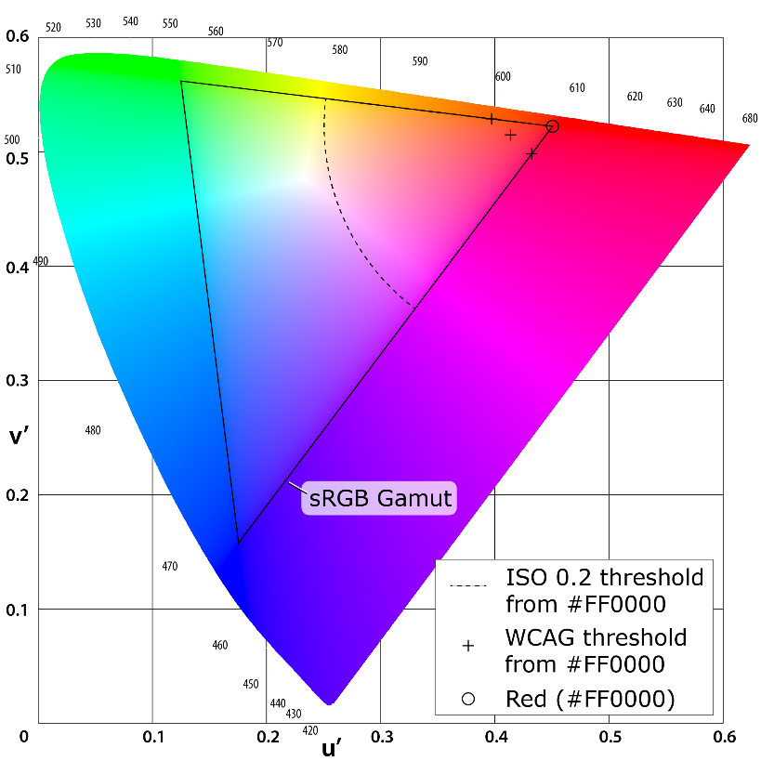

Figure 1. The CIE 1976 UCS chromaticity diagram showing the sRGB gamut (large triangle) and values of select red colors (marked with plus ‘+’) that differ enough in WCAG critical values from full red (#FF0000, in the upper right, red corner of the gamut triangle) to be considered a valid transition. The ISO critical difference is represented by the dotted arc.

### NOTE [4]

Tools are available that will carry out analysis from video screen capture. However, no tool is necessary to evaluate for this condition if flashing is less than or equal to 3 flashes in any one second. Content automatically passes (see #1 and #2 above).

## relative luminance

the relative brightness of any point in a colorspace, normalized to 0 for darkest black and 1 for lightest white

Comments on definition: Note that “1 for lightest white” is correct, but will lead to problematic results in HDR colorspaces for photosensitive epilepsy because it significantly enlarges the spacing in luminance (cd/m2) between states of a flash—thus increasing the risk. In SDR, the relative luminance of 1 is assumed to be 200 cd/m2 (in order to match other PSE guidance). In HLG (HDR), a relative luminance of 1 = 1,000 cd/m2. In PQ (HDR), a relative luminance of 1 = 10,000 cd/m2. Unfortunately, I am not sure how this can be truly fixed in a note, but I did attempt to include HDR in notes above.

### NOTE [1]

For the sRGB colorspace, the relative luminance of a color is defined as Y = 0.2126 * R + 0.7152 * G + 0.0722 * B where R, G and B are defined as:

- if RsRGB <= 0.04045 then R = RsRGB/12.92 else R = ((RsRGB+0.055)/1.055) ^ 2.4

- if GsRGB <= 0.04045 then G = GsRGB/12.92 else G = ((GsRGB+0.055)/1.055) ^ 2.4

- if BsRGB <= 0.04045 then B = BsRGB/12.92 else B = ((BsRGB+0.055)/1.055) ^ 2.4

and RsRGB, GsRGB, and BsRGB are defined as:

- RsRGB = R8bit/255

- GsRGB = G8bit/255

- BsRGB = B8bit/255

The "^" character is the exponentiation operator. (Formula taken from [sRGB] and [IEC-4WD]).

Comments on note 1: The threshold from the final sRGB spec is 0.04045. See <https://github.com/w3c/wcag/issues/360>. For consistency with standard notation, Y (i.e., the Y in CIE XYZ) is relative luminance.

### NOTE [2]

Almost all systems used today to view Web content assume sRGB encoding. Unless it is known that another color space will be used to process and display the content, authors should evaluate using sRGB colorspace. If using other color spaces, see Understanding Success Criterion 1.4.3.

### NOTE [3]

If dithering occurs after delivery, then the source color value is used. For colors that are dithered at the source, the average values of the colors that are dithered should be used (average R, average G, and average B).

### NOTE [4]

Tools are available that automatically do the calculations when testing contrast and flash.

### NOTE [5]

A MathML version of the relative luminance definition is available.