Comments on Jake’s Fundamentals A11Y Portal

- Why is there a skip to main menu link? With this button it is two key presses to get to the main menu and without it there would also be two key presses to get to the main menu.
=> deleted
- I’m not a fan of the skip to content link and don’t think that it is required as there is a good structure to the site content. Won’t complain either way.
=> I think there’s value for certain people in Skiplinks, also see: https://webaim.org/projects/screenreadersurvey7/#skip so as an example I’ll leave it there
- The following link is not in a block of text since it is just one sentence.

Maria Beuving (72)
In order to read her emails she uses Zoom text.
=> Correct, and that’s fine =>”Inline: The target is in a ‘sentence' or block of text;”
- Meeting 1.3.5

Use:
aui-destination="home"
aui-destination="sitemap"
=> Added, but where did you het the ‘sitemap’ from? At https://w3c.github.io/personalization-semantics/ I’ll miss the list to be used…

- I regard the PDF as being on a different site, do you?
=> Yes, also changed URL to original gov.uk site
- I’m a little concerned about this being regarded as an image of text, which it is, but it is supposed to be a screen shot of the resource. We should just be ready to explain that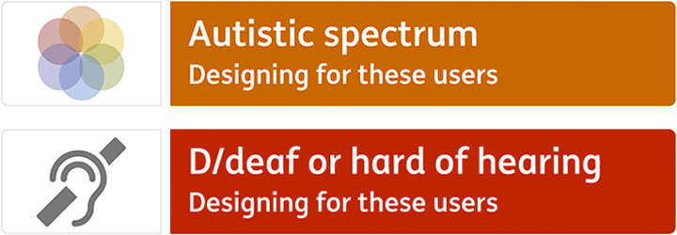
- => Fixed

- Class “full-cover-title” has a 3.81:1 ratio over different gray colors, needs to be 7:1
=> Fixed
- Blue link text (#1570a5) is 5:1, needs to be 7:1
=> Fixed
- Perhaps the link to the current page in the main nav should be made not a link? (helps with 2.4.8 location)
  - On the first page there are 3 links in a row that go to the page that you are on
  - Perhaps combine the accessibility logo and “fundamentals” into a single link?
=>ToDo
- “See getting started steps” is overlapping the arrow. Perhaps “getting started steps”?
=> Fixed
- Links out of context – how about for the tool links and the responsibilities links we use aria-describedby or labelledby?
  - <h3 class="heading-s mt-0 mb-0"><a href="https://www.deque.com/products/axe/" aria-describedBy=”id-for-paragraph” class="link-ts" rel="nofollow"><span>aXe</span></a></h3>

<div class="card-block">
<h3 class="card-title" id=”resp-id”>
Responsibilities for
</h3>
<ul class="list-icons list-linklist">
<li>
<a href="/pages/fundamentals/responsibilities.html#user-experience" class="link-ts" rel="nofollow" id=”resplink1” aria-labelledBy=”resplink1 respid”><span>User Experience</span></a>
</li>
(I put the “responsibilities after the link text to follow our best practice for label in name)
=> Fixed, but H3/Link doesn’t work in VO, VO Focus is on heading and descirbedby will not be spoken… JAWS is ok.
- Abbreviations – I see the following
  - A11Y
  - DoD (this one is defined in the second use)
  - WCAG
  - UX (in labels)
  - CJE (in labels)
  - WAI
  - ARIA
  - WAI-ARIA
  - PDF
  - CSS
  - QA
  - CJE(PO)

=> Done

