Overall
I’m still really liking this in general! I did an informal usability test on it with a novice, and he got the main points perfectly.
(Below are in addition to my comments in the 25 October telecon, for example, about animation too distracting starting at 0:08)

Visuals [medium]
- video introduce resources:
I’m thinking about people getting to one of these videos without context, e.g., search and go to YouTube. I think we need to make it clear that the video primarily *introduces resources*, as opposed to comprehensively covering a topic. (Sorry I didn’t think about this earlier – was looking at the trees in previous reviews and didn’t think about the forest.) I know some didn’t like “the resource” in the script – however, now I’m thinking that is the whole point of the videos – to introduce resources, and I think that is not coming through clearly. Another idea is to make it clear in the title scene and intro text that the video introduces resources.
update: my informal UT participant did understand that, so maybe it’s not an issue?
- 0:38-0:48 Easy Checks:
    - issue: visual focus volley – attention going from Checks page/squares on right to computer monitor on left, back and forth, back and forth, etc. – annoyed me.
    - suggestion: put the Checks on the left – which matches where it is in other places in the video, too.
- Page titles:
Instead of button looking, maybe look like page title in simplified version of WAI website page? e.g.:
- WCAG-EM Report Tool progress bar animation 1:15-:
My eyes and brain do not like this animation. (I think it’s specifically to do with the white spaces between the arrows.) I think probably better to have the whole progress bar there from the start, and animate the selection going along the line (like the tool itself highlights as you go from page to page).
- WCAG-EM whaaat?:
“Website Accessibility Conformance Evaluation Methodology WCAG-EM” is harder text string to process. To help, I think:
- line breaks:
Website Accessibility
Conformance Evaluation Methodology
WCAG-EM
- Have longer pause after it (with the text still on the screen).
- Also, in the draft, the visual resource name appears too late. It should appear right before or right with the spoken name.

Visuals [minor]
- different users 1:23-:
The main point here is the different users. I think the people should be bigger than the monitors. (also, realistically they would, or else them are biggg monitors! ;-)
- script:
“For more experienced evaluators, W-A-I provides "Website Accessibility Conformance Evaluation Methodology", or " W-C-A-G-E-M " for short.
The " W-C-A-G-E-M Report Tool" helps you record the findings as you follow the methodology.”
->
“For more experienced evaluators, W-A-I provides "Website Accessibility Conformance Evaluation Methodology", "W-C-A-G-E-M", or Waa-Cag-E-M.
The "Waa-Cag-E-M Report Tool" helps you record the findings as you follow the methodology.”
- script:
“To help you better understand how users experience your website and applications, W-A-I provides "Involving Users in Web Projects for Better, Easier Accessibility"”
->+ “different”
“To help you better understand how different users experience your website and applications, W-A-I provides "Involving Users in Web Projects for Better, Easier Accessibility"”
- color: I preferred the monitor stand gray. I do not know if my previous comment was lost, or deemed not important, or disagreed with. It’s here: https://lists.w3.org/Archives/Public/wai-eo-editors/2019Sep/0082.html

Visuals: closing scene with link and logo
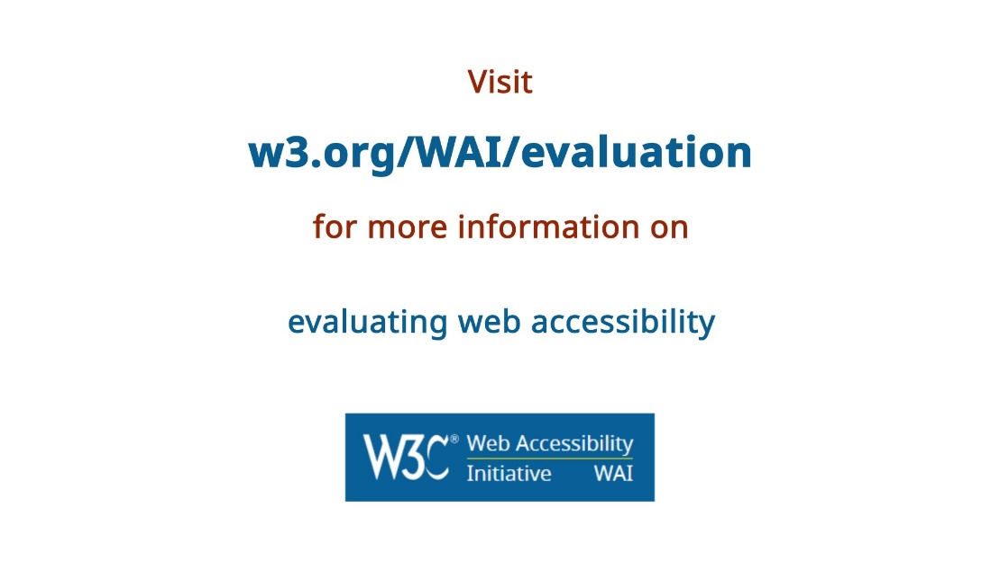
Issues: Awkward spacing between lines. This mixed use of different text colors I think complicates instead of helps. Background color change.
I do realize that this is related to the Perspectives videos. I support having some similarity, yet updating and improving.
Ideas:
- [medium] Make the link blue and the other text the different color (probably not that rust, which is from the old site color palette, see new at https://wai-website-theme.netlify.com/components/colors/ )
- [medium] Equal spacing between lines – or otherwise grouped better (e.g., Perspectives had the first 3 lines as one group, then much more space between that and the last line).
- [minor] Use same background color as rest of the video.
- [minor] Consider simplifying text quite a bit – maybe:
w3.org/WAI/evaluation
[topic]
logo
or:
w3.org/WAI/evaluation
for
[topic]
logo
- [minor] brainstorm: maybe even make it look like typing (like first/title scene) into the address bar of a browser with a WAI page already loaded (showing logo) — e.g.:
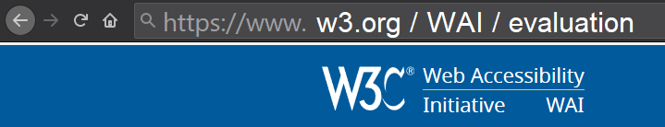

Sound
- [medium-major] I’m hesitant about sound effects. Without knowing what is planned, I think most would be too distracting. The one place where I think we might want a sound effect is with the names of online resources, to reinforce that it, like with a click sound?
- [medium] I strongly support background music, and still think the videos would seem unprofessional without it. I do think we want it quieter than the production company often does in other videos.
- [minor-medium] I agree with some other comments that this particular audio track is a little too bouncy and attention-getting.
I’ll see if I can review the other tracks on Friday. If not, I’m fine going with others’ suggestions.

Voice-over
- [medium-major] I very much support having a mild non-American accent. (I like it personally, and) I think it’s important to help convey that W3C WAI is not a US organization.
- [medium] Will we have the same voice for all, or some male and some female? I’m thinking gender diversity is more important than consistency.
- I will say that I prefer:
    - [medium] strong male voice for Video 5: Involving Users
    - [minor] casual female voice for Video 2: Easy Checks
I’ll pass on commenting on each sample.

