Teaching of UD and Accessibility in Course Content
(Note: this falls under “Presentations – Developing New” at https://docs.google.com/spreadsheets/d/1nJb1_PNbT6bMEz0AuWA1HRj-w2LeujXMatvmajYS4is/edit#gid=0)

Purpose
- To create curriculum resources (specific lessons) for teaching UD and accessibility in course content for Computer Science, Web Design and Digital Media.

Goal
- To increase the teaching and quality of teaching around UD and accessibility in college-level tech courses
- To increase the number of students graduating with tech, media and computer science degrees with a knowledge of accessibility and UD skills
- To use vetted resources that are in compliance with what WAI is providing in other areas (maybe discuss this further)

Audience
- Faculty of colleges, universities, and high schools who wish to teach about UD and accessibility for the web and/or digital media. (Is this too narrow).

Objective
- Create discrete lessons in specific topic areas of accessibility and UD that use WAI resources, when appropriate (see planned topics below)

Scope
- These course components will be geared for use in primarily Computer Science, Web Design and Digital Media. It is possible that these components could also be used by other programs – business, economics, humanities – to discuss issues related to accessibility and disability (to convey general topics and social issues, not specific technical details of accessibility).

Resources to provide for each topic area
- Suggested prerequisites (e.g. knowledge of HTML)?
- Clear learning objectives and outcomes
- Suggested readings (including multimedia resources) for students
- Resources for faculty to develop lectures and slides, including web pages, books, images, articles, etc. (Resources need to be reviewed for accuracy and compliance with international standards before inclusion).
- Point faculty to the existing slides in the topic area, such as WAI training slides, when appropriate (WAI slides need to be updated first)
- Perhaps on rare occasions, the provision of slides
- Lesson outline including suggested in-class student activities
- Suggested student assignments
- Include characteristics for each lesson ala the WAI presentations and training
(below from: https://www.w3.org/WAI/training/topics#intro)
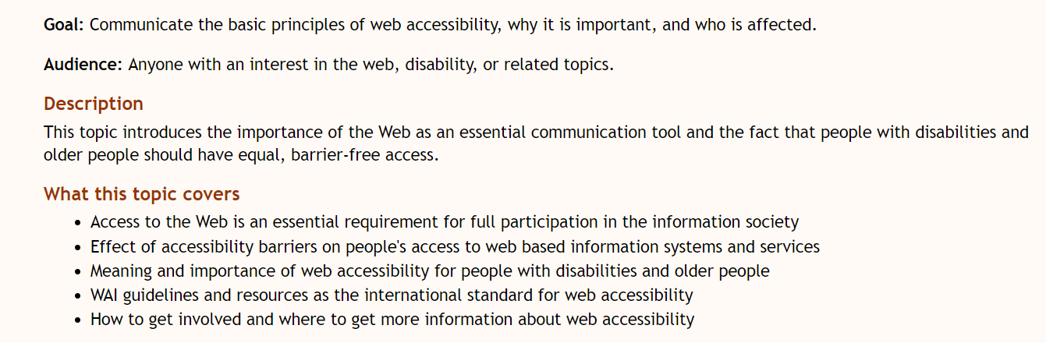

From topics derived from “Who Teaches Accessibility” study/article and the “D.7 Design for All – A major in an ICT Curriculum” in ACM IT 2017 curriculum recommendations

(Based on a Spanish major in a Computers and Telecommunications curriculum proposal – pg. 146)

Design for all (D4All) and target user groups
- Demographics, user preferences and needs, benefits of D4All.
- Diversity of target groups; principles of D4All and user participation.
- Engage with individuals from diverse populations appropriately (i.e. disability etiquette)
- Definition of terms D4All, usability, Universal Design and accessibility (and perhaps for Inclusive Design)

Business Case for Accessibility
- Understand legal accessibility regulations (e.g., Section 508, Americans with Disabilities Act, etc., for Europe, the web accessibility directive, etc.), legal landscape based on recent rulings (i.e. Netflix, Winn Dixie, H&R Block, etc.) (Needs to be localized – i.e. U.S. vs Europe, etc. – or at least how it relates to an international point of view. Make sure not solely U.S. centered.)
- Business benefits of designing for accessibility and UD (for example: https://www.fastcodesign.com/3060090/how-designing-for-the-disabled-is-giving-google-an-edge)
  - Perhaps: examples of all a11y features, products and innovations (not just digital) that have gone onto highly used mainstream technology (e.g. typewriter)

Assistive Technologies & Adaptive Strategies
- Accessibility barriers for persons with disabilities, for AT (i.e. need to follow certain international standards and guidelines to ensure AT compatibility) and D4All (e.g. presenting information in different ways, cultural differences, different technology platforms, neurodiversity, spectrum of abilities and functionality, etc.)
- Adaptive strategies – what specific adaptations do individuals
- Appropriate AT in specific environments for people with concrete needs.
- Understanding of the interoperability between AT and ICTs. (Addressed somewhat in first bullet point in this section)

Web Design
- Introduction to principles and methods for building Web sites for All (more than just one lesson? – probably)
  - (tba)
- Accessible and usable Web design methods and guidelines.
- (Leaving Web applications out for the scope of this project)

Evaluation of systems by users
- Methods for evaluating interfaces, automatically, by experts and by users.
- Introduction to evaluating web pages by accessibility standards and heuristics (e.g., W3C, WCAG) – (have to decide how far to go on this) (have to check what’s included and what’s not included in the existing WAI presentations and training)
  - Depth and sub-topics TBA

Secondary Topics

Consumer electronics and games
- methods and techniques for implementing D4All and Universal Accessibility in consumer electronics and games.

Back end technologies
- back-end technologies support for usability and accessibility of ICT services for end users.

Miscellaneous Suggestions
(topics and actions to eventually incorporate into proposal)
Adina – internships for students – with development firms that practice good coding.
Suggest projects such as interviewing students with disabilities
Discuss Neurodiversity
Brent – need to see where the gaps are
Shawn – at least go through what we currently have in terms of resources so we know what’s there.
Big picture –
Eric - aim for small project that we can ship and then evaluate

Next steps
- prioritize topic areas – which are most important to cover first
- more specific proposal with learning objectives and outcomes for each topic area mentioned above

Notes/to do
- make sure the cite resources

