- Consider the text alternative provide for this image
“Red dot with a white letter 'C' that symbolizes a moon crescent as well as the sun. This logo is followed by a black banner that says 'CITYLIGHTS' which is the name of this online portal. Finally, the slogan of the portal, 'your access to the city', follows in a turquoise green handwriting style and with a slight slant across the top banner.”
Is it appropriate? Why or why not?
- Is a text alternative (alt text) required for each of these images? If yes, what would be the best option? If no, why not? …and as an extra bonus, comment on the link text.
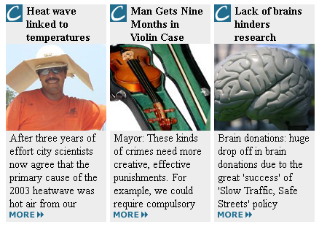

- Activating the links leads to the News page which shows stories as displayed below. What markup will you expect from the following?
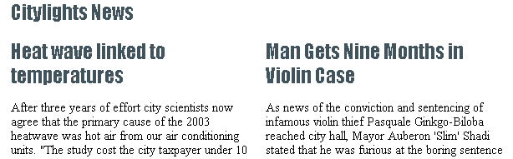
- On the Home page, scroll down to find this listing. Comment on accessibility. What would you expect and how would you improve what is here?
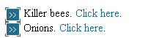
- Provide alt text for this image of text. Then suggest how it could be further improved beyond the provision of alt text.
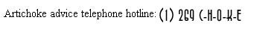
- A table is shown below that presents ticket pricing. Look at the source code if it is helpful, at http://www.w3.org/WAI/demos/bad/before/tickets.html . Identify accessibility barriers and suggest how they would be repaired.
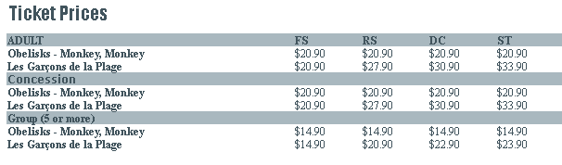
- What tests will you implement to determine if this form is accessible? 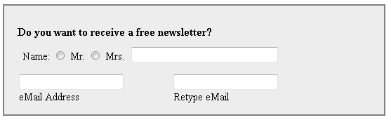
- The following form was submitted with incomplete information. Here is the error message. Is this sufficient information? If not, how should it be changed?
