Crispin,

I have used UML in past software development projects and I am familiar with them and how they can diagram a process and communicate multiple relationships. As you know the purpose of a concept of operations, requirement documents, UML diagrams, use cases, function points, a software architecture, etc. , is to assist a software development team’s internal communication of what is required in building software system or application.

To that end a set of UML diagrams are only part of what is required.

I wanted to review the bidding at this point to understand where we are.

I think we have a CONOPS which is below

XDMDL is envisaged as a high level schema language that will allow innovative ed-tech implementers and communities of practice to define new data models. We believe that better data interoperability is crucial to the future of ed-tech and that the current problems in this area focus on semantic, not technical interoperability. Creating consensus around semantic meaning in round-table discussions has proved to be inefficient at best, and more often impossible.

We envisage an ecosystem in which different data instances (learning activity metadata, runtime data packages, competency and curriculum declarations and attributions) all instantiate XDMDL declarations, allowing different systems to interoperate in meaningful but flexible ways.

I think we have a set of five requirements of which we said we deferred three and would concentrate on these two

• a simple but consistent method of publishing metadata for learning content, supporting both discoverability and the declaration of runtime functionality.

• a data model description language which will enable supplier communities to specify new data structures in a consistent and extensible manner, allowing for the development of new metadata and runtime data models in a timescale that mirrors product innovation

I think you have defined a schema for a Learning Activity Model

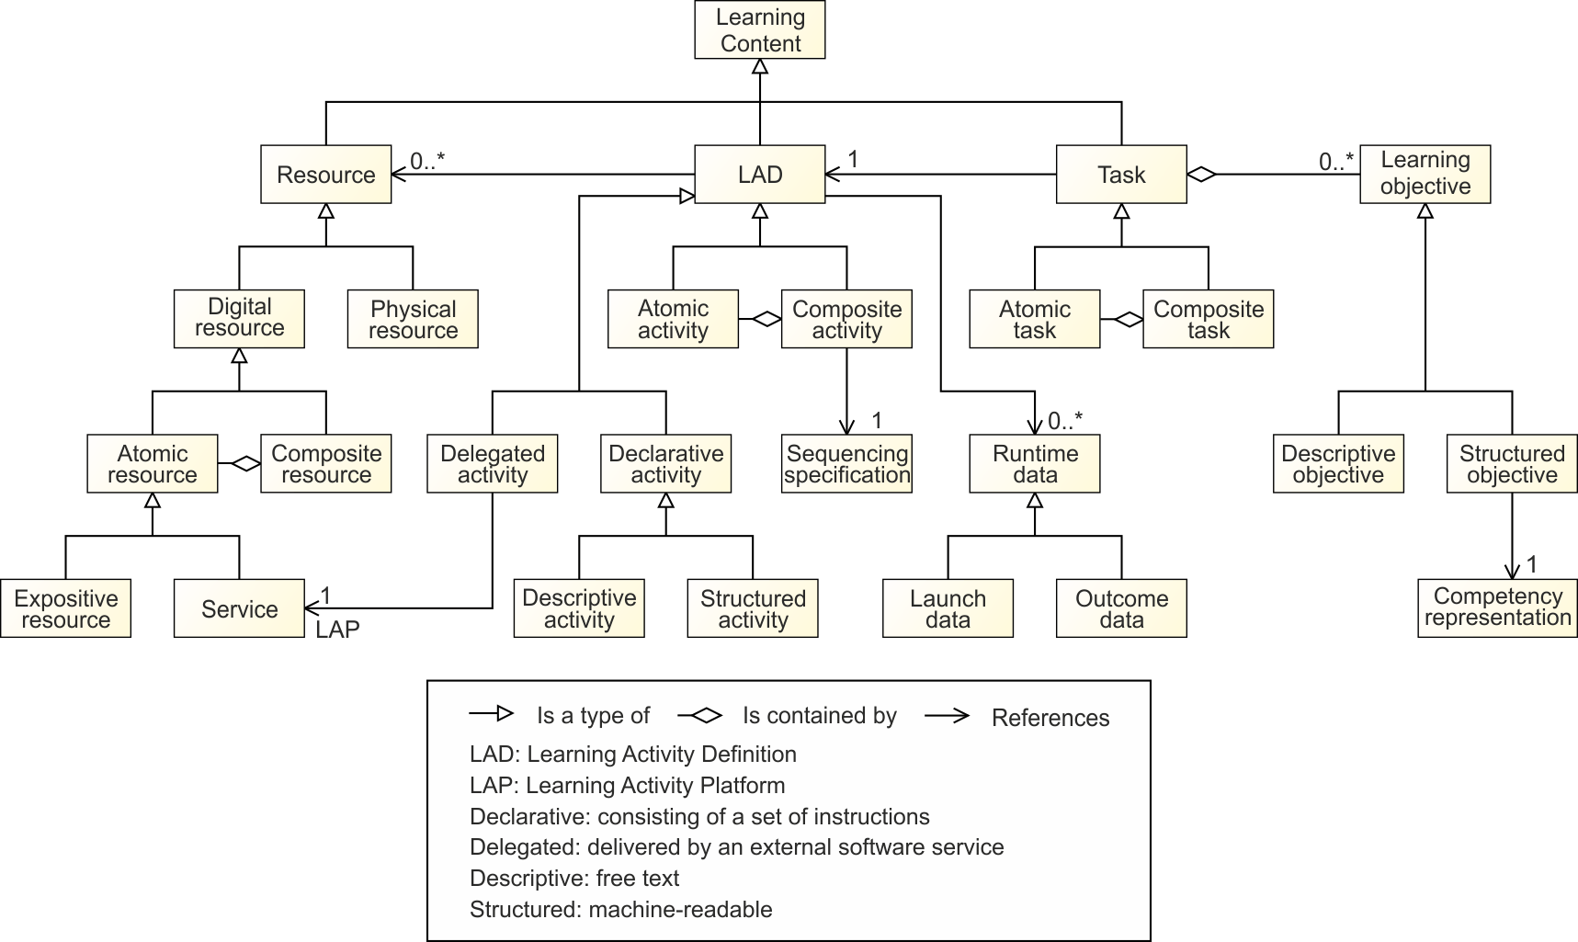

I think we have also a generalized Use Cases

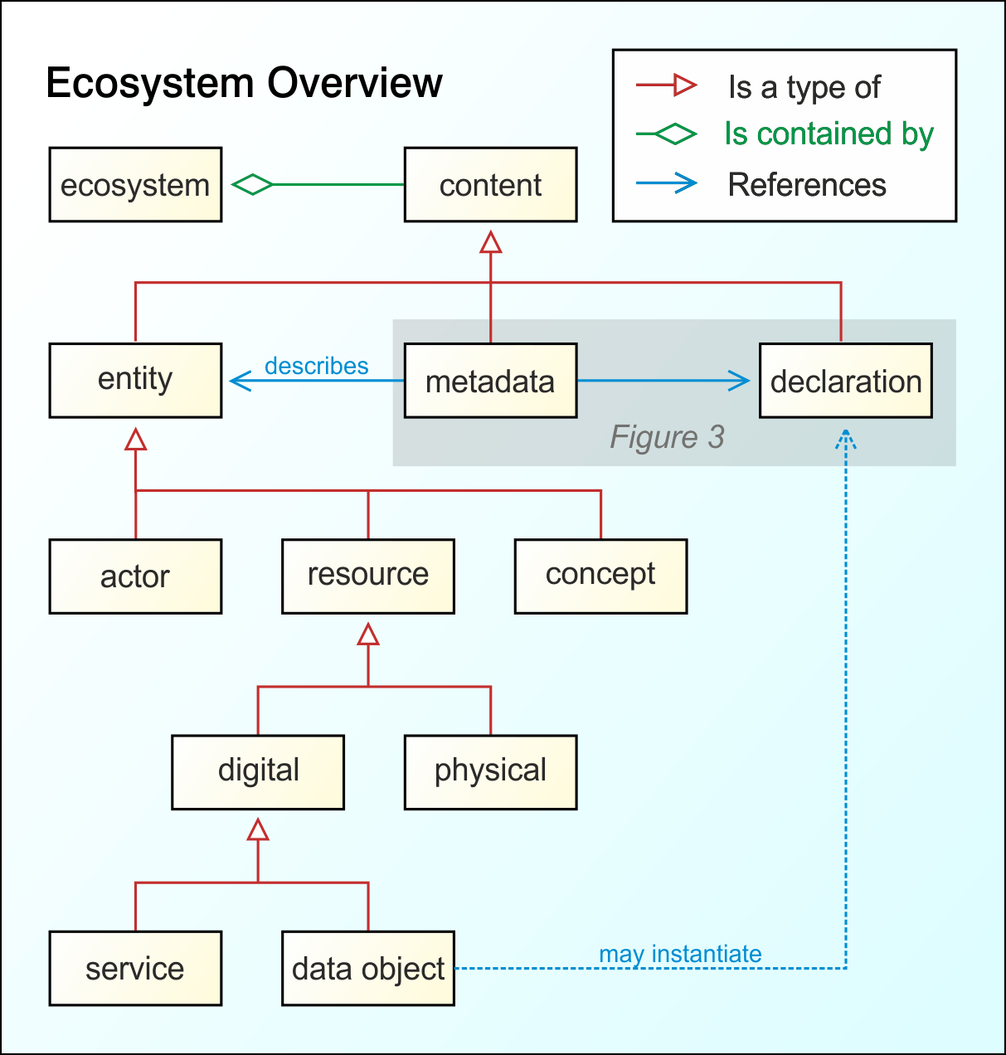

And I think you have describe variants of this generalized Use Case

**Different topologies**

SCORM

xAPI (student launch)

xAPI (formal launch)

Multi-player

**Data model profiles**

SCORM result

xAPI verbs

Competency attributions

Return of creative product

You have taken the first use case - SCORM and developed a UML diagram for it below

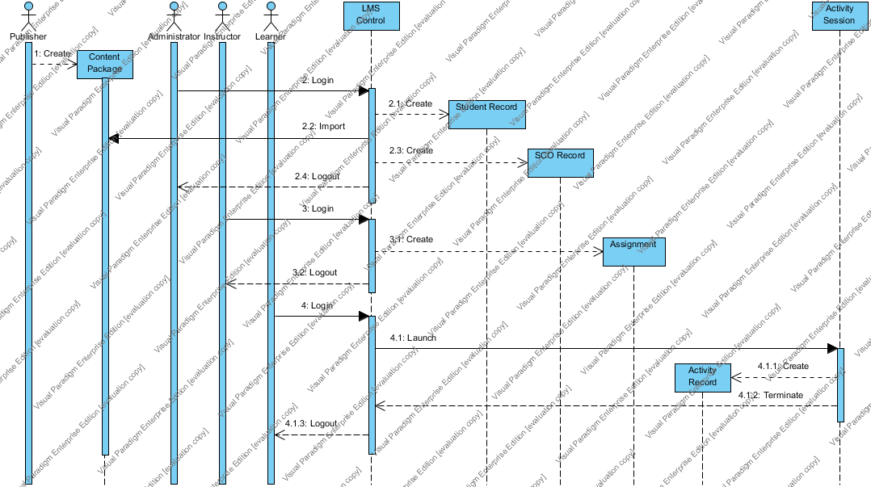

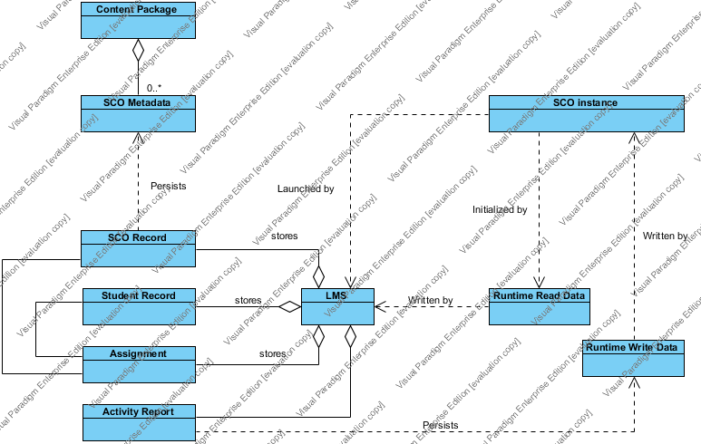

***Question ???***

Are you suggesting we construct additional UML diagrams for

* + xAPI (student launch)
  + xAPI (formal launch)
  + Multi-player

And the accompanying data model profiles

* + xAPI verbs
  + Competency attributions
  + Return of creative product

If the answer is yes I think you are a point of building a bridge to the other three differed objectives

* + - A new specification for the adaptive sequencing of learning content.
    - A specification for the machine-readable description of learning objectives and curricula
    - A machine-readable data handling description language, allowing for the specification of procedures for data protection and privacy

If my logic path is correct then the next step for you is to build a tool, it seems to me that there is a detailed description of the selected UML diagram that is required that describes how someone would use the tool and may look like this.

As I stated at the start I wanted to review the bidding of where we are and in most cases plans are modified after the first contact. I also think we have agreed to somethings that have moved us forward and I want to be explicit as to where we are at this point and therefore better understand our next steps.

Thanks Frank

**1. A4.1.4 Assess Soldier Tasks (28.4)** 5

**1.1 Brief Description 5**

**1.2 Overview 5**

**1.3 Inputs 5**

**1.4 Outputs 5**

1.4.1 Soldier Task Assessment Report 5

**2. Flow of Events** 6

**2.1 Basic Flow 6**

2.1.1 The Actor selects Assess Soldiers Tasks from the main menu. 6

2.1.2 A list of all the organizations units will be displayed. 6

2.1.3 The system will display a list of the Essential Collective trained for the organization. 6

2.1.4 The first time that this window is used all the Assessments will be blank 7

2.1.5 The Actor will have the option to Assess the task as T, P, U or NA. 7

2.1.6 Actor will click on the desired assessment for the tasks. The task will be highlighted. 7

2.1.7 Actor will click on Save when all assessments have be selected and ready to be set. 8

2.1.8 Actor may click on Cancel and cancel the highlighted entries. 8

2.1.9 Actor may click on Help for online assistance. 8

2.1.10 Actor may elect to produce Assessment Reports. 8

**2.1 Alternative Flow 8**

**3. Actors** 8

**4. Associated/Applicable Requirements** 8

**5.0Associated Use Cases** 8

**6. Long-Term Vision Requirements** 8

**7. Special Requirements** 8

**8. Pre-Conditions** 8

**8.1 Organization Force Structure will be established for the Company, Platoon or Squad and include Report Header information for the unit 8**

**8.2 Approved METL is established Company or Battalion. 8**

**8.3 Approved Supporting Collective Tasks have been established for Platoon, Squad, or Section elements. 8**

**8.4 Actor has access to Assess Soldier Tasks 8**

**9. Post-Conditions**