# W3C Web of Things Interest Group Face-to-Face Meeting in EURECOM

Authored by Soumya Kanti Datta

It is widely acknowledged and understood that the current Internet of Things (IoT) market is highly fragmented due to non-interoperable implementations, data and product silos. Therefore, the academic and industrial communities have turned to the web. Exploiting the RESTful web services, web standards and best practices can bring harmony and interoperability in the IoT ecosystem. It also leads to the creation of Web of Things (WoT). W3C as a standard development organization (SDO) can define global standards enabling resource discovery and interoperability through utilization of the web. Recognizing the challenges, W3C has chartered an Interest Group on Web of Things [1]. The main goal of the IG is to converge on a shared vision and identify specific opportunities for standardization allowing open markets of novel applications and services using IoT and the web of data. In essence, there is a trend of extending the web platform from a web of (browsing) pages to a web of things.

The IG first met face to face (F2F) in Munich in April, 2015 where the activities were intensely discussed and split into four task forces (TF) – (i) Thing Description and Metadata, (ii) Scripting API and Protocol Mapping, (iii) Thing Discovery and Provisioning, (iv) Security, Privacy and Resilience. Recently a new task for on Communications and Collaboration is created. I am highlighting the main aspects of these TFs below.

* **TF on Thing Description and Metadata**: It is chartered to address following aspects – (i) clarify and define what aspects of a Thing can be described and what the thing description language (TDL) be used for, (ii) develop a suitable model for TDL, (iii) vocabulary to be used for thing description and (iv) appropriate syntax or serialization format of such TDL. The TF has survey the technology landscape and the first findings include IETF CoRE Link Format [2], W3C RDF data model [3], W3C Semantic Sensor Network (SSN) Ontology [4] and JSON-LD.
* **TF on Scripting API and Protocol Mapping**: It is chartered to (i) survey the existing architectures, protocols and API patterns and evaluate those based on the collected IoT/WoT use cases, (ii) extract common interaction primitives, (iii) define a set of abstract interaction primitives for things and (iv) define language-independent scripting APIs for the purpose of exposing the primitives. More information of the activities of the TF are available at [5].
* **TF on Thing Discovery and Provisioning**: It is aimed at creating a common understanding of discovery, its purpose and applicability to various use cases, develop a landscape of available mechanisms and evaluate them against set of criteria and look into how to provision things as a part of a WoT framework. The activities of the TF can be found at [6].
* TF on Security, Privacy and Resilience: This TF has been examining challenges, requirements, available mechanisms and advanced concepts of security and privacy [7].

The IG met three time F2F in 2015. The Munich F2F was followed by meetings in Sunnyvale, USA and Sapporo, Japan (co-located with the W3C TPAC 2015). During the last F2F, I signaled interest to host the fourth F2F in EURECOM, France. I am writing this report to highlight the discussions and Plugfest that took place in EURECOM during 25 – 28 January, 2016. It was a joint meeting with IRTF Thing-to-Things (T2T) Research Group (RG).

An important aspect of the F2F meeting was the Plugfest on 25th January 2016. During the webinars of the TFs, the moderators and participants decided on a couple of scenarios. These are developed following some guidelines and tested all together during the Plugfest. In principle, we aim to evaluate interoperability among the developed solutions. For this Plugfest, interested participants were asked to bring an implementation of a thing or a client interacting with a thing based on the specifications of the Sapporo Plugfest. There were four proposed tracks of implementations security, APIs, thing registry and HATEOAS. This event attracted more than 20 implementations including remote participations as you can see in the following figure. We saw a lot of cool implementations. The highlight of the event was that our colleagues to interact with an Air-conditioner machine located in Osaka from Sophia Antipolis, France using a cloud server and WoT things based implementation. Amazing, isn’t it …

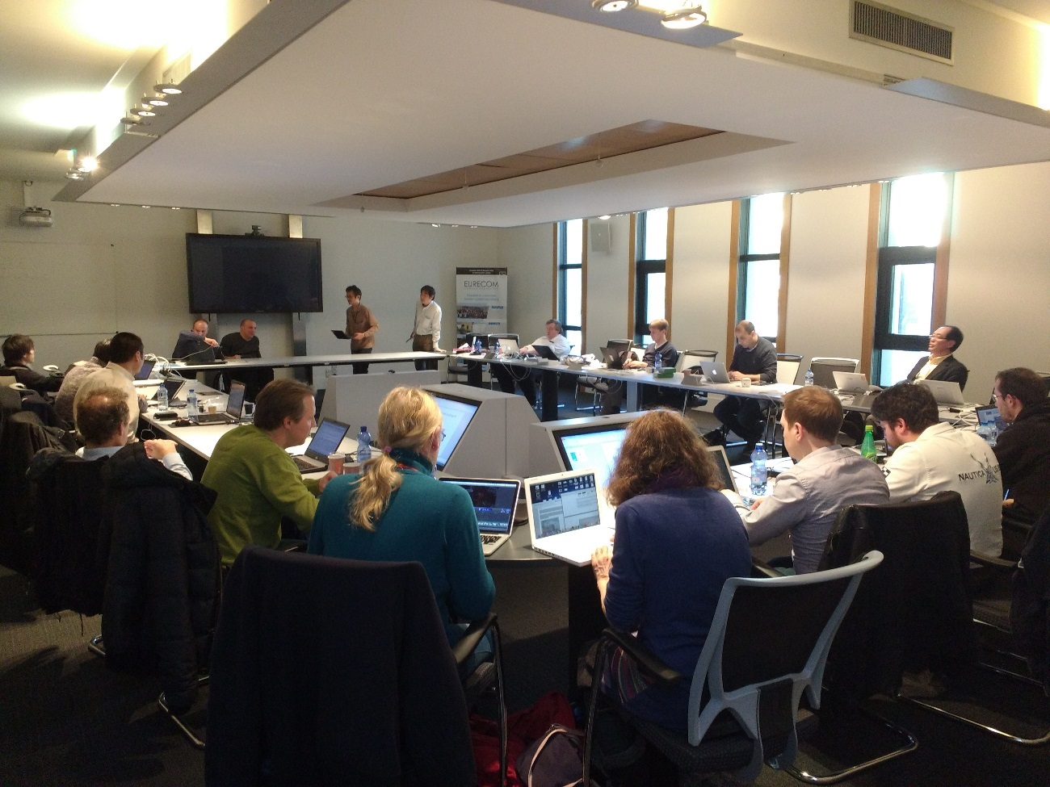

Figure 1: Plugfest participants in W3C WoT IG F2F Meeting in EURECOM.

It was followed by a traditional open day on 26th January 2016 where we saw a wide range of presentations. Following welcomes by Ulrich Finger (Director of EURECOM), Joerg Heuer (Chair of WoT IG) and Carsten Bormann (Chair of IRTF T2T RG), the morning session was kicked-off with three presentations. Johannes Hund from Siemens talked about WoT – exploring the physical world and Dave Ragget from W3C talked about the benefits WoT can bring in manufacturing world creating smart manufacturing. Then it was my turn to describe how WoT can assist vehicles to be a part of the constantly growing ecosystem of IoT. Although I could not take a photo of Johannes and Dave presenting but fortunately I got clicked.

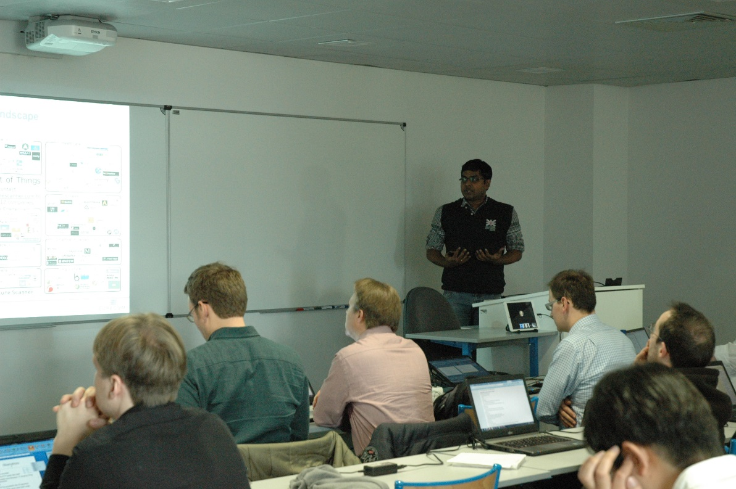

Figure 2: Soumya Kanti Datta from EURECOM presenting about WoT for connected Vehicles.

After the morning coffee break, Victor Charpenay from Siemens and Louay Bassbouss and Fraunhofer FOKUS shared their insights on Resource-based µRDF Store for T2T Interactions and Implementation of Thing API for HomeKit.

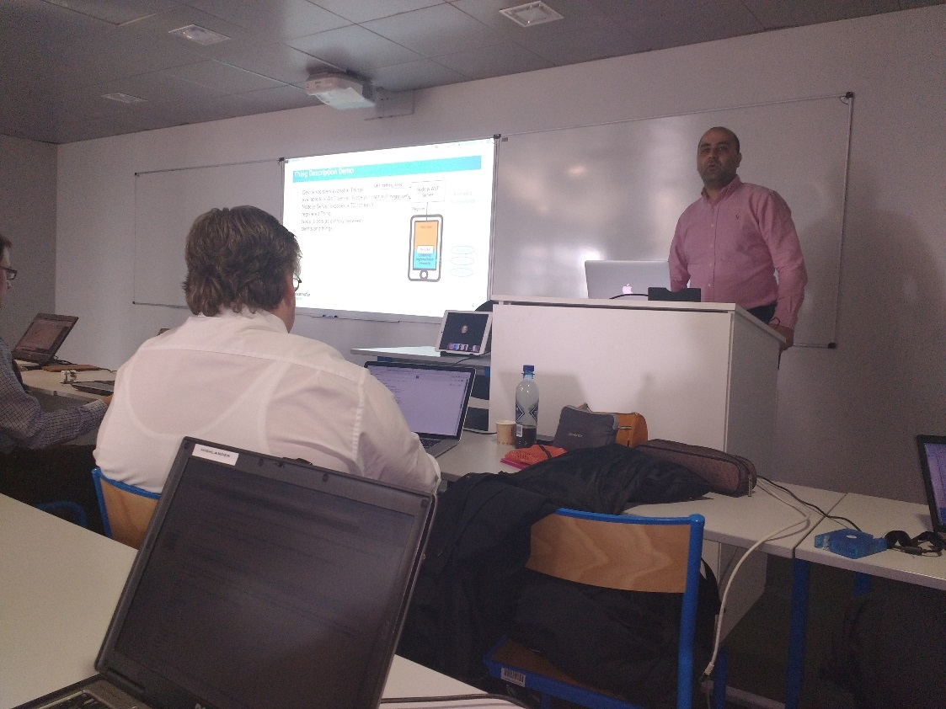

Figure 3: Louay Bassbouss presenting on the open day.

The afternoon session saw talks from Matthias Kovatsch from Siemens who gave an overview of HATEOAS approaches. This F2F was also important in the sense it marks the beginning of a collaboration between oneM2M partnership project and W3C WoT IG. Martin Bauer from NEC and Omar Elloumi from Nokia described the semantics in oneM2M. Dave and I invited participated and presented our WoT related work in the ETSI M2M Workshop 2015 held in Sophia Antipolis. Omar showed his interest to disseminated oneM2M works into W3C WoT IG. Following that Dave, Joerg and I welcomed Omar and Martin in the open day discussion. Before the Plugfest demonstrations, the final presentation was from David Janes on Semantic and the Internet of Things.

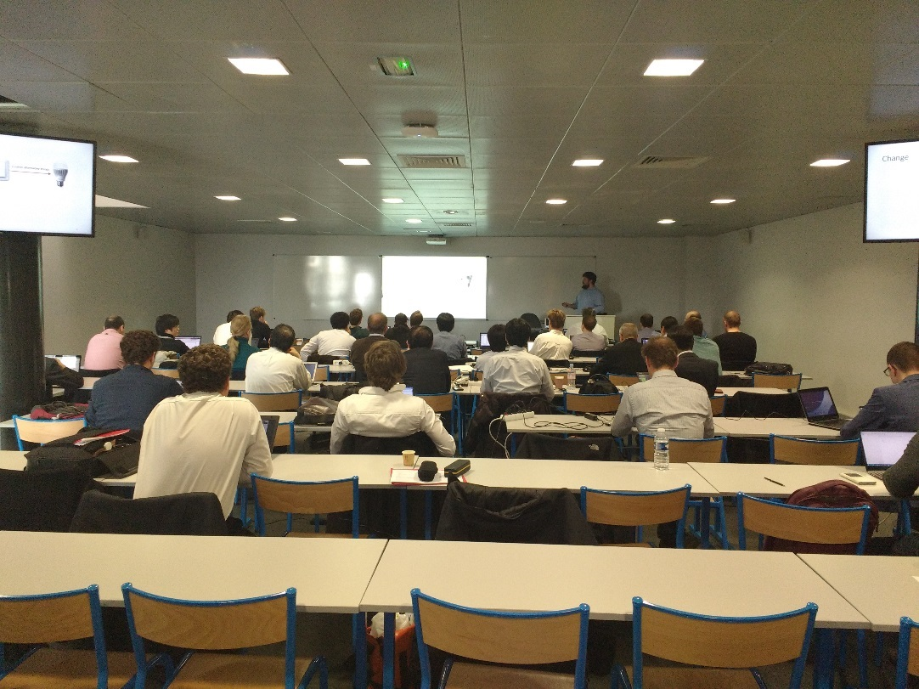

Figure 4: Participants listen to Matthias with rapt attention.

The final attraction of the day was the demonstration of the Plugfest implementations tested the day before. Along with that, my colleague Rui and I showcased our BMW X5 being connected to a WoT platform. Some demonstration pictures are below.

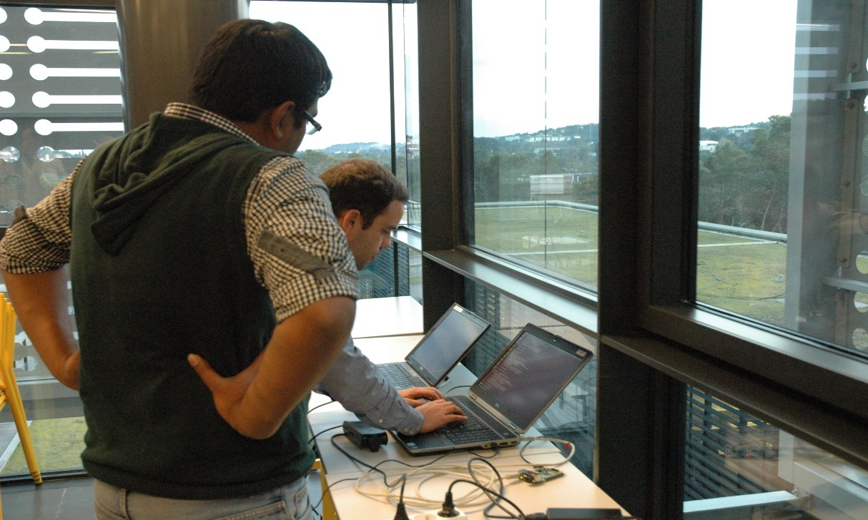

Figure 5: Starting EURECOM demo on WoT for connected vehicles.

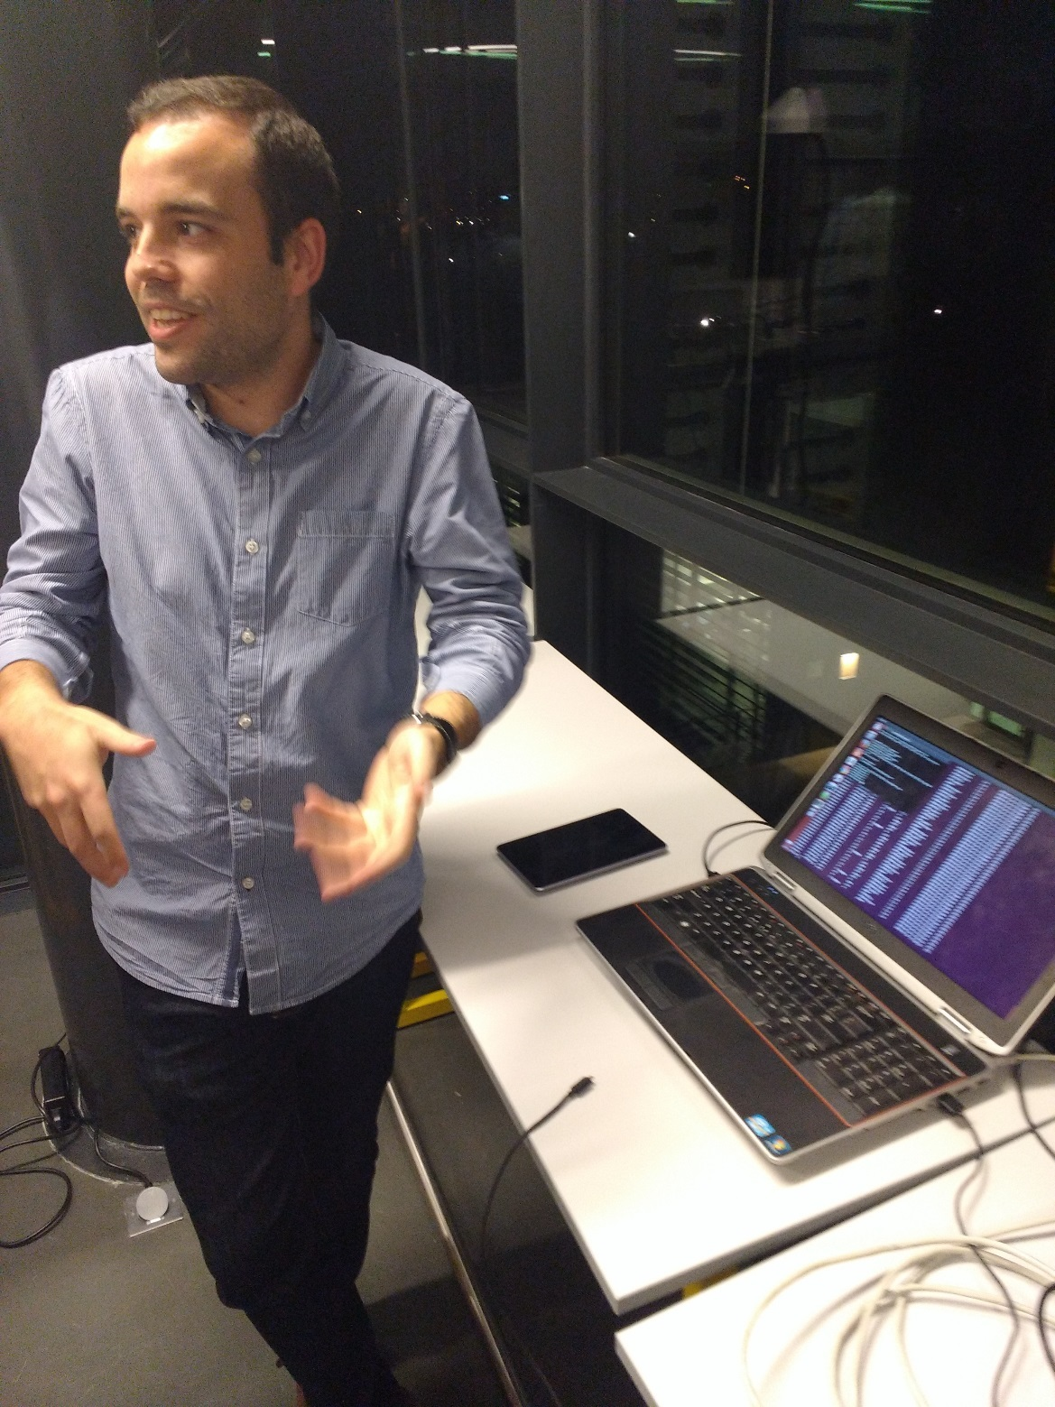

Figure 6: My friend Rui explaining the demo.

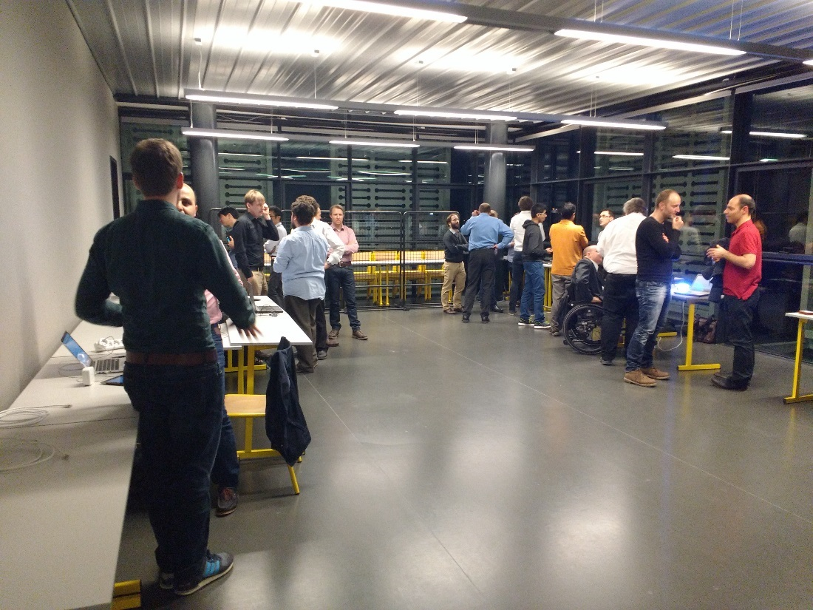

Figure 7: Discussions among participants and demonstrators.

Sumptuous foods were waiting for us at the social dinner. Everyone was very happy with the three course-dinner and the famous French wines.

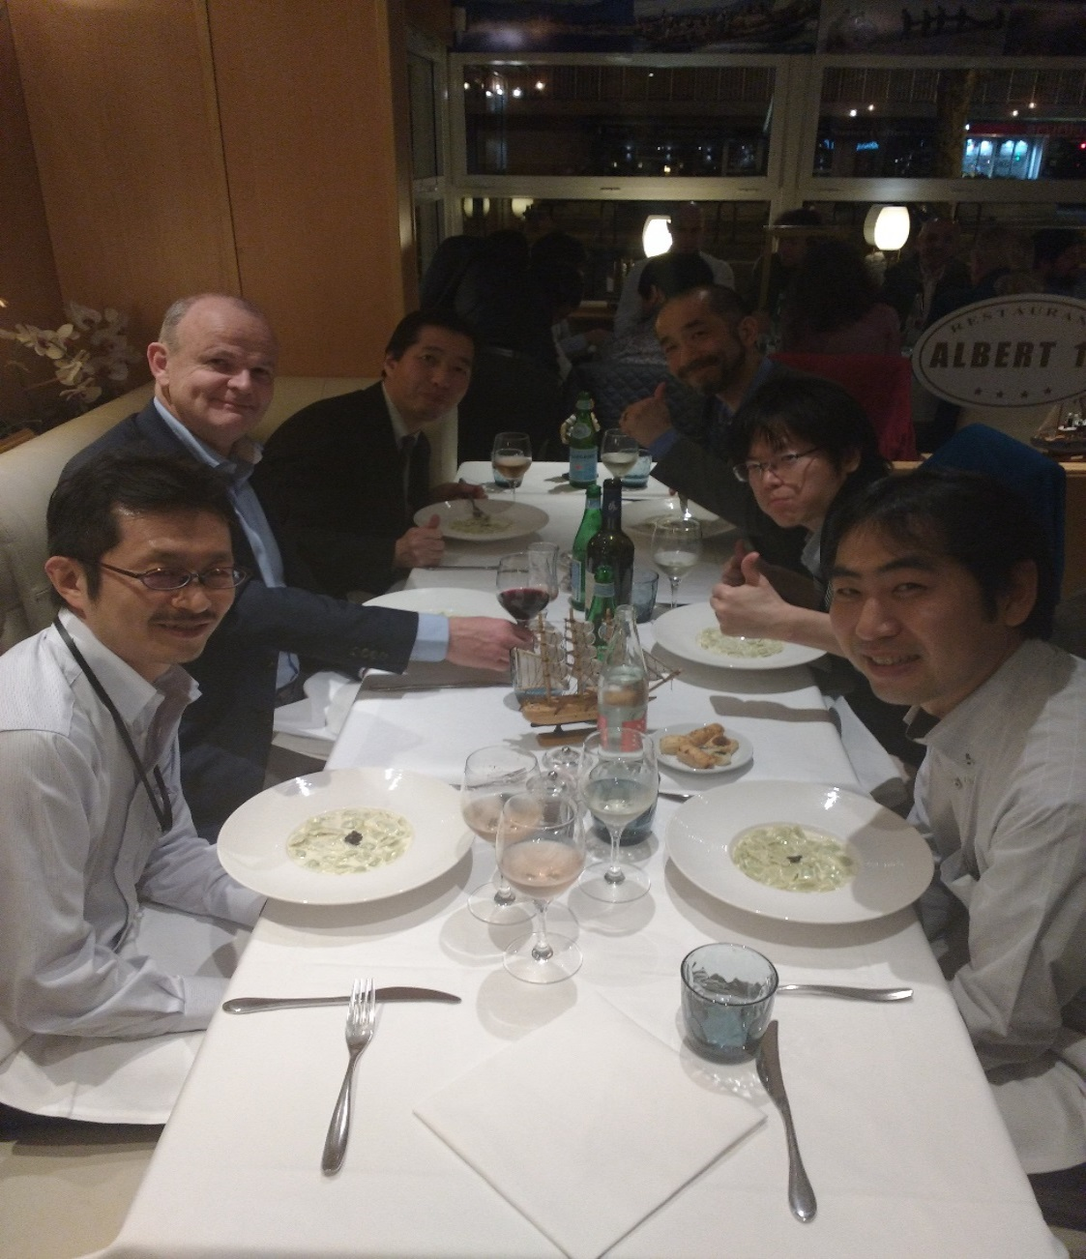

Figure 8: W3C WoT IG colleagues at the social dinner.

The rest of the two days were focusing on the independent and joint discussions among the TFs during Break-outs. You can see our chairs Joerg and Carsten busy scheduling the Break-out sessions.

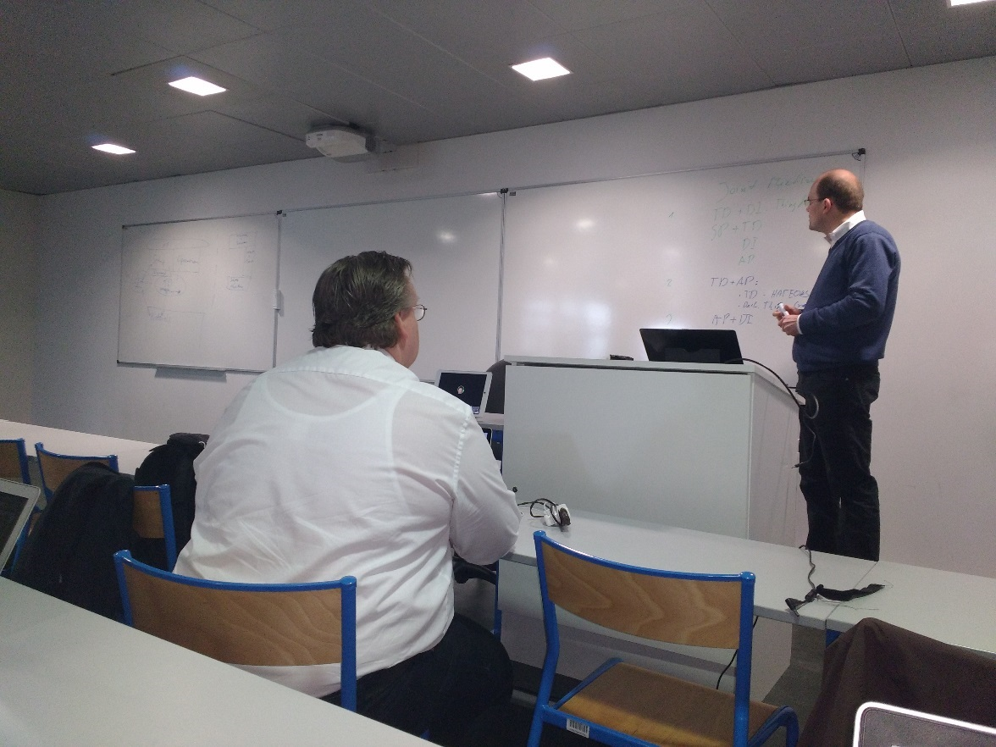

Figure 9: Joerg and Carsten scheduling the Break-out sessions.

The final session was about work organization, time plan and figuring out the next steps. Joerg shared the report from communication and collaboration activities and plans about the upcoming F2F meetings. It was agreed that the fifth meeting in this series will be held in Montreal, Canada co-located with the Word Wide Web 2016 conference (WWW 2016) in April 2016. An important milestone of the meeting was preparation of WoT Working Group (WG) work items. The scope of the IG has been quite broad and several white gaps were identified in terms of the standardization of relevant technologies. IGs typically prepare the ground for standardization of specifications in WGs by collecting use cases, requirements and converging on a shared vision. The preparation of the WG, its work items and charter can be viewed at [8] and [9].

So the WoT IG and the proposed WG is quite important from the consumer perspective. Without interoperability IoT applications and services will not be able to penetrate the consumer market on a massive scale. The proposed WG will definitely work towards such a goal.

As usual, before singing off, I’d like to share a group picture of with all the participants. The weather in Sophia Antipolis was really good during the meeting which made everyone happy.

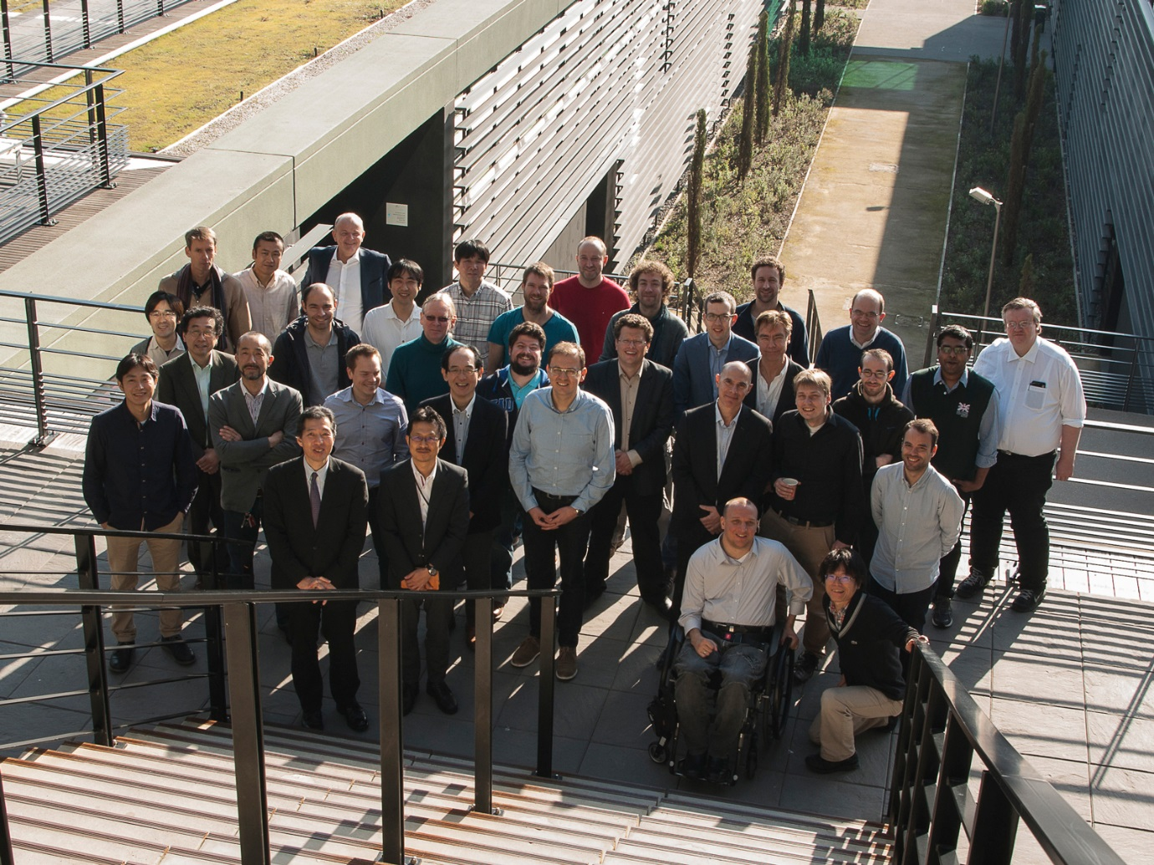

Figure 10: Group photo of the participants.

## About the author

Soumya Kanti Datta is a Research Engineer in EURECOM, France. He currently co-ordinates the Task Force on Thing Discovery and Provisioning in W3C WoT IG. He can be contacted at [Soumya-Kanti.Datta@eurecom.fr](mailto:Soumya-Kanti.Datta@eurecom.fr). The article shares his personal opinions and not that of EURECOM or W3C WoT IG.

## References

[1] W3C Web of Things Interest Group, https://www.w3.org/WoT/IG/

[2] CoRE Link Format, RFC 6690, <https://tools.ietf.org/pdf/rfc6690.pdf>

[3] Resource Description Framework (RDF), <https://www.w3.org/RDF/>

[4] Semantic Sensor Network XG Final Report, <https://www.w3.org/2005/Incubator/ssn/XGR-ssn-20110628/>

[5] <https://www.w3.org/WoT/IG/wiki/APIs_and_Protocols_TF>

[6] <https://www.w3.org/WoT/IG/wiki/Discovery_TF>

[7] <https://www.w3.org/WoT/IG/wiki/Security,_Privacy_and_Resilience>

[8] https://github.com/w3c/wot/blob/master/WG/wot-wg-items.md

[9] <https://github.com/w3c/wot/blob/master/WG/charter.md>