Silver Scoring Proposal - Adjectival Testing – Evaluation of U.S. Based Newspaper

Adjectival Scoring
-1 - No testing done
0 - Does not pass all basic tests
1 - Adjusted Score (see below)
2 - Passes all basic tests but not all advanced tests
3- Adjusted score (see below)
4- Passes all tests

Notes:
- This is using numbers to remove debate about what word to use. Please think of 0 as Horrible and 5 as Excellent
- All tests become pass/fail at the test level. This will sometimes be a judgement call. An outstanding question will be when the test doesn’t apply, does it count as passed or removed from the count?
- Basic tests will often be automated and Advanced tests will be often be manual but the following factors will also likely effect which category a test falls in:
  - Automation - Automated vs. manual
  - Criticality - How important/central is a test to achieving the goals of the guideline its testing
  - Ambiguity - How likely is it that with the same process, different testers will end up with different results
  - Type of test - Is the task a guideline test vs a task completion test
- Could extend rating to 5 and add another level of tests for a higher adjectival rating

Scoring Adjustment (Only one can apply)
- +1 if more than 80% of possible tests pass (if 80% of basic tests are passed it becomes a 1, if 80% of advanced tests pass it becomes a 3)
- +1 if no errors occur within tasks that stops a user from a functional area from completing a task

Functional Areas
- Usage without vision
- Usage with limited vision
- Usage without perception of colour
- Usage with limited hearing
- Usage without vocal capability
- Usage with limited manipulation or strength
- Usage with limited reach
- Minimize photosensitive seizures
- Usage with limited cognition

Testing Process
- Define the portion of the site that will be tested
  - All key tasks should be represented in the sample
- Run basic tests
  - If all basic test pass, move to step 3
  - If 80% of basic tests pass, capture errors for work and rate the test a 1. Then move to step 3.
  - If less than 80% of the basic tests pass, capture errors for work and examine the location of the failures. If the failures do not affect the ability of users in any of the functional areas to complete key tasks, rate the test a 1. Then move to step 3.
  - If less than 80% of basic tests fail and failures are within the key tasks,capture the errors and rate the test a 0.
- Run advanced test
  - If the site is already rated and fails, capture errors for work but don’t adjust the rating
  - If the site is not already rated and:
    - All advanced test pass, rate the site a 4.
    - 80% of advanced tests pass, capture errors for work and rate the site a 3.
    - less than 80% of the basic tests pass, capture errors for work and examine the location of the failures. If the failures do not affect the ability of users in any of the functional areas to complete key tasks, rate the site a 3.
    - If less than 80% of advanced tests fail and failures are within the key tasks,capture the errors and rate the test a 2.

Headings Testing Sample Tests
Silver Headings Text

Basic Tests
- Do headings exist programmatically? (automated)
YES:

H2:Your Thursday Briefing
H2:Listen to ‘The Daily’
H2:Listen: ‘Modern Love’ Podcast
H2:As 6.6 Million in U.S. Join Jobless Rolls, Fed Adds to Its Stimulus
H2:Central Bank Ramps Up Support Amid Devastating Job Losses
H2:U.S.: Senate in Stalemate on New Aid for Small Businesses
H2:‘Sudden Black Hole’ for the Economy With Millions More Unemployed
H2:Most New York Cases Came From Europe, Genomes Show
H2:In Scramble for Supplies, Rich Countries Push Poor Aside
H2:The Times is providing free access on the coronavirus crisis. Start here for a guide to all our coverage.
H2:
H3:A GLOBAL CRISIS
H2:Updates: W.H.O. Chief Says He Was Target of Racist Slurs
H2:Bodies on the sidewalks, cardboard coffins: Ecuador is a warning sign for Latin America.
H2:Worldwide Battle Rages On Amid Small Signs of Hope
H3:U.S.
H2:‘A Tragedy Is Unfolding’: Inside New York’s Virus Epicenter
H2:New York Updates: Coronavirus Preys on the Disabled
H2:The C.D.C. released an early demographic snapshot of the worst coronavirus cases.
H3:POLITICS
H2:Why Republicans Are So Afraid of Vote-by-Mail
H2:Trump Is Pushing a False Argument on Vote-by-Mail Fraud. Here Are the Facts.
H2:Can Bernie Sanders and Joe Biden unite the Democratic Party?
H3:THE MEDICAL PICTURE
H2:Don’t Count on Summer to Stop Coronavirus
H2:7 Answers to Questions About the Malaria Drug Trump Keeps Pushing
H2:More Vaccines and Treatments Move Toward Human Trials
H3:COMMUNICATING IN A PANDEMIC
H2:The Humble Phone Call Has Made a Comeback
H2:Zoom Rushes to Improve Privacy for Consumers Flooding Its Service
H3:Opinion
H2:The America We Need
H2:Why the Wealthy Fear Pandemics
H2:Congress Needs a Plan to Confront the Coronavirus. I Have One.
H2:How Can America Emerge From This Crisis Stronger?
H2:America Has Conquered Plagues Before. We Can Do It Again.
H2:Listen to ‘The Argument’: Fighting Trump’s Falsehoods
H2:New York’s Paramedics, on the Front Lines and Forgotten
H2:Trump Hates Having Too Many Voters
H2:Focus the Covid-19 Fight in Black Cities
H2:Bernie Sanders Was Right
H2:Europe Poised to Repeat Austerity Mistakes in Coronavirus Response
H3:Editors’ Picks
H2:What New York Looks Like Now: A Photo Journey
H2:Sweating to the Oldies. Or Sitting?
H2:Our Best Easter Recipes
H3:Advertisement
H2:Site Index
H2:Site Information Navigation

- Do headings exist visually? (assisted)
Yes and NO. Empty headings, i.e. dotted line under these two articles is an empty h2.
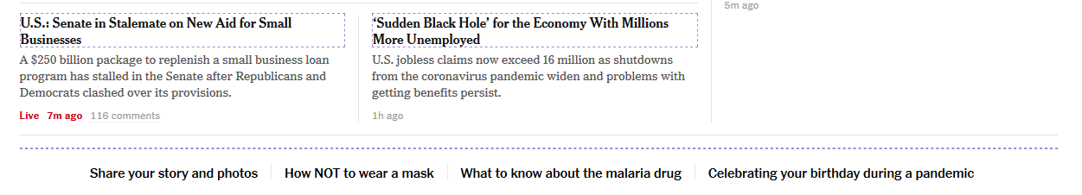

- Are headings and subheadings nested correctly? (automated)
NO. H3 followed by H2.

Advanced Tests
- Do headings tell the users what to expect in each section? (assisted)

NO, empty headings exist, empty h2.

Another example: H3:THE MEDICAL PICTURE, this does not provide context as to what section / article is related to.

Clear Language Testing Sample Tests
Silver Clear Language Text

Basic Tests
- Is spelling correct? (automated)
- Is grammar correct? (automated)
- Is active voice used? (assisted)
- Is a simple tense used? (assisted)

Advanced Tests
- Is literal and concrete language used? (manual)
- Is use of metaphor, similes, sarcasm and iron limited and appropriate? (manual)
- Are common words used to represent concepts? (manual)
- Have unnecessary words been removed (manual)
- Are the following defined or spelled out when first used (manual): NO
  - Technical terms
  - Jargon
  - Idioms
  - Slang
  - Acronyms
  - Abbreviations

Abbreviations are used for hours and minutes and not defined: I.e. 35 m ago, 2h ago vs. minutes and hours

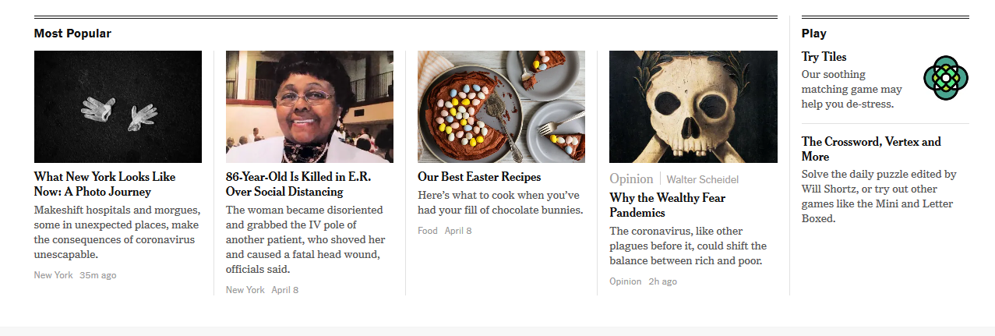

- Are sentences and paragraphs short? (manual)
- Are steps numbered sequentially? (manual)
- Is a summary provided if the document is long? (manual)
- Are alternatives provided for numbers and numeric content? (manual)
- Are alternatives provided for symbols and icons? (manual)

Sample Test Sheet

