Date 10/1/12

Dear all,
I have to say a very interesting discussion emerged on this list, but let’s go back to the original questions and purpose of this discussion:
FDA seeks "input from industry, technology vendors, and other members of the public regarding the advantages and disadvantages of current and emerging open, consensus-based standards for the exchange of regulated study data. "
In the announcement for a meeting 5 November FDA ask for responses, before 5 October, on questions such as "- What are the advantages and disadvantages of HL7 v3 and CDISC ODM?"
And, interestingly, they also ask: "- Are there other open data exchange standards that should be evaluated?"
Is this an opportunity for a semantic web based proposal?
I would say yes to the last question, but only if a semantic web based proposal is linked with ‘structure’, too. Standards that deal with the ‘structure’ such as HL7 and CDISC have inherent problems. It is for others to judge that as a consequence of this those standards are fit for purpose in the clinical research domain.
Vereniging EN13606 Consortium
p/a Huigsloterdijk 378, Buitenkaag, NL-2158 LR, the Netherlands
P.O. Box 376, 2300AJ, Leiden, the Netherlands
T: +31 620347088, T: +31 6 23961239
KvK:51042290
Nevertheless it is a trigger to inform you about developments in the CEN/ISO 13606 Association’s world of users of archetypes that will become part of the renewed standard.
According to feedback received in general the opinion in the May 2012 ISO/TC215 Vancouver meeting was that the 13606 is the best standard encountered in ISO in a long time. There is no discussion whatsoever about the need to have the 13606 renewed. It was decided that the revision process should be executed as swiftly as possible, meaning will take a two year process.
I think there is an open and public data exchange standard that should be evaluated: CEN/ISO 13606.
The 13606 standard continuity is secured.
One of the major distinctions between HL7 v3 and CDISC is that In this renewed 13606 standard even more extensive semantic and meta data descriptions/representations (ontologies) will be defined. This secures a consistent use of ontologies on all levels part of what we like to call the Semantic Stack.
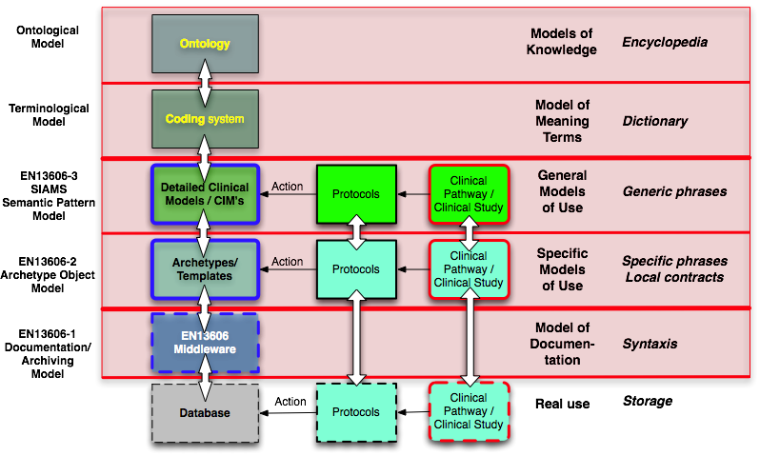
Next to that it is defined how ontologies like those of W3C and Bio Top (light) etc. and coding systems like those of IHTSDO and WHO are integrated in Archetypes.
Archetypes define what needs to be documented about a (clinical/health) topic. It is an artefact that carries the structure (the way it can be used in a message or in a database) and carries mappings to codes from coding systems and bindings to ontologies.
This is possible because an Archetype modeling methodology is defined, that in a formal way deals with the "What", i.e. the terminological model (intensional expressions), and the "When, Who, Where, Why", i.e. the context/information model (extensional expressions). Please have a look at www.en13606.org WIKI for a download of present SIAMS document on this subject. Input to this SIAMS document is welcome, because this SIAMS document will become input for ISO/TC215 13606 renewal Task Force (two years project). At present the SIAMS approach has its final round of updates via contributions of IHTSDO and WHO, experts of two other ISO standards (ContSys and HISA) to define the intersections between those three standards and via contributions in projects like SALUS and SemanticHealthNet Network of Excellence, both EU FP7 projects.
First implementations are built such as a RDF database with SPRAQL end point that uses the OWL export out of the Archetype tooling suite, that is supportive to the use of the standard modeling patterns.
The big advantage of the Archetype tooling is that clinician do not need to be exposed to ontologies, which most clinician’s do not understand, but are actually defining ontologies by defining Archetypes, that are represented as mind maps clinicians are capable of understanding/reading. This is how my company ERS BV contributes to the defining of the ontologies needed for the SALUS project.
For more information go to www.e-recordservices.eu and www.salusproject.eu .

Sincerely yours,

Gerard Freriks
Board EN13606 Association

