Two developments which would make OR even better –

Hopefully this is the easy one: after reconciling data using openrefine, it would be great to be able to see, and use, the resulting hyperlinks in any exported version of that project, eg as a csv or xls file. At the moment, if one wants to explore the links created by the reconciliation process, you can only do this within the OR project.

The other might be harder, but is no less desirable – integrating OR with Rstudio, so that one could cluster and reconcile data within R. At the moment one has to complete the cleaning steps in open refine, then export as a file and re-open it in R – or possibly reshape the data in R, then export as a csv and import that into OR in order to clean it.
At the moment, there is an R package called “refinr” which does a limited set of OR functions – see documentation https://rdrr.io/cran/refinr/.
When you view a dataframe in RStudio it looks like this
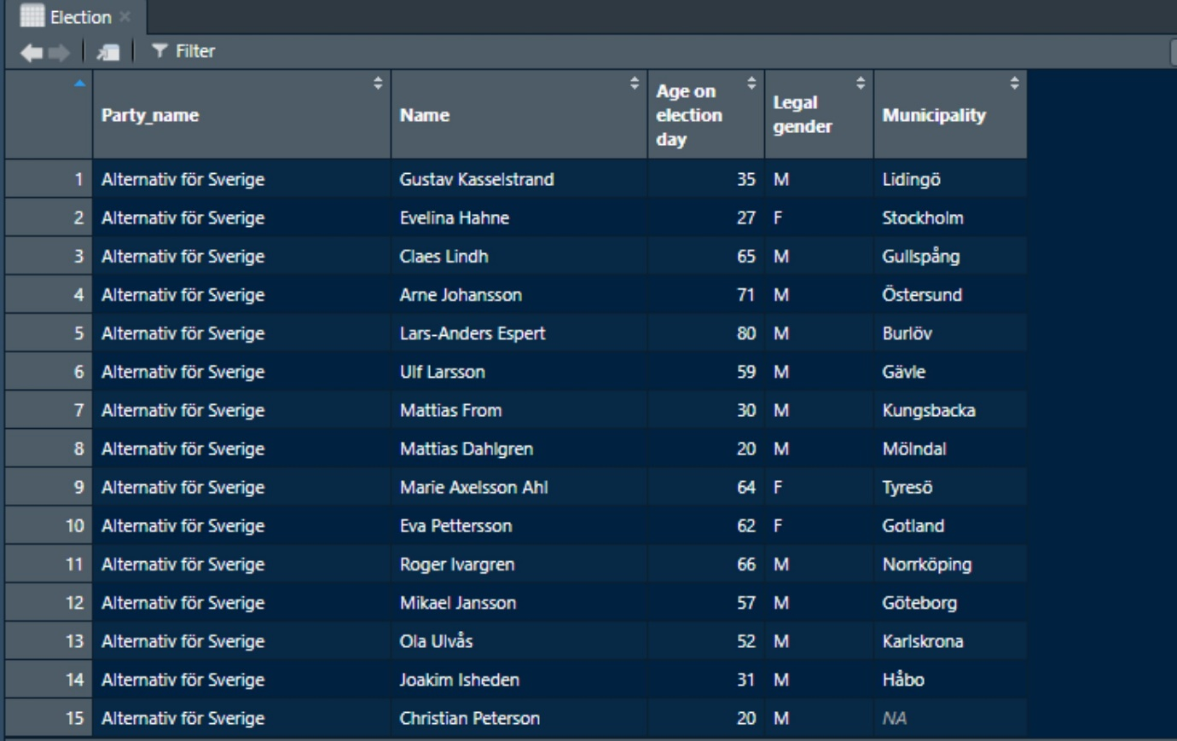
So the “obvious” idea would be to get a package to integrate with OR and put the familiar dropdowns at the top of columns, and then allow you to cluster etc as if you were in an OR project.
RStudio has various addins
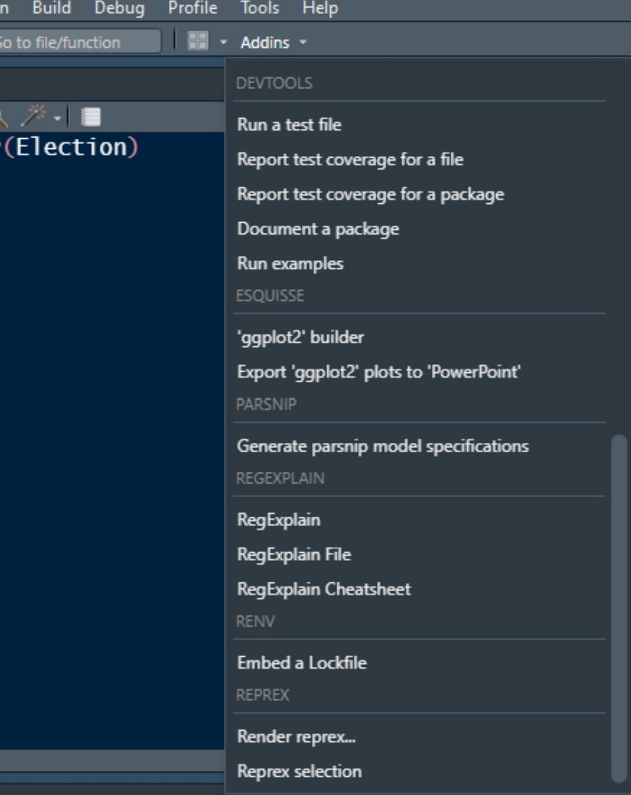

These mimic other programs or functions and write the code based on what you click, rather than making you write the code directly. My most used example is esquisse which allows you to drag and drop variables into a grid, which then lets you build up a graphic, a bit like Excel. The Code button at bottom right reveals the code auto-written as you drag and drop; you then paste the code into your script to make the graphic you want. (I used this as training wheels while I got familiar with ggplot, but you see in the addins, others are there to support you far beyond the training wheels stage!
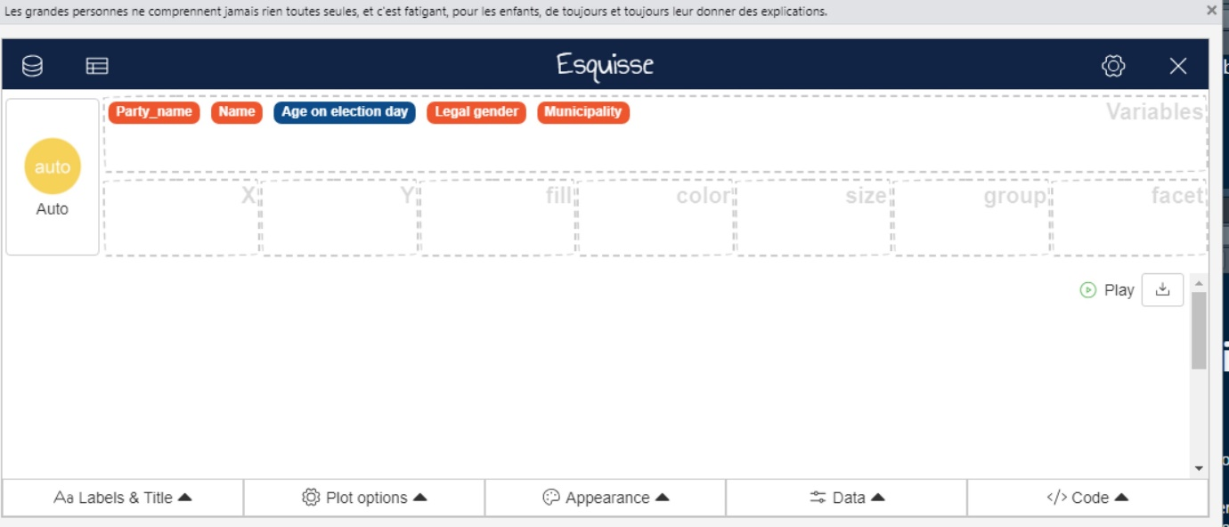
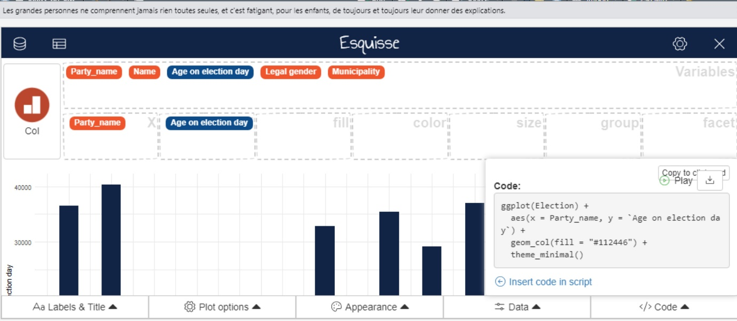

I am sorry I am not a developer – then maybe I’d have a better idea what to do now. But I sense that many things are possible – it’s only a matter of time, and having enough people wanting to make use of any given function!

