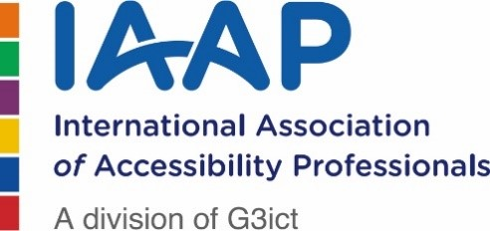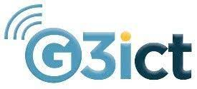

Roadmap towards Inclusion -G3ict Maturity Model
Integrating organizational inclusion through assessment, planning and training

Introduction
Imagine a world that can be where everyone is included.
Diversity, inclusion and accessibility are interconnected concepts—nevertheless there are subtle differences between each term. An organization could be diverse, accessible but not inclusive.
Diversity refers to the practice or quality of including diversity in the workplace (not only multicultural but also across the spectrum of age, gender, disability, sexuality, language, race, etc.). Diversity involves among other things a cultural change, a definition of objectives, targeted internships, diverse mentorships and diversity training.
Inclusion is the next step. It is the practice and policy of providing equal access to opportunities and resources for people that otherwise would be excluded. In an inclusive environment employees and customers feel accepted without having to conform.
Accessibility means that employees and customers can access information, activities and or environments because they are sensible, meaningful and usable for as many people as possible.
Inclusion is a journey. US companies that put disability inclusion at the forefront of their goals can see 28% higher revenue and 30% better profit margins than other companies in the Disability Equality Index, according to research by Accenture. Moreover, an estimated 15% to 35% of the world workforce has a disability.
An organization may target diversity because of its values, vision and the proven fact that diversity increases engagement and performance across teams. For diversity to be sustainable across time and embedded in the organization’s DNA it needs inclusion: a governing framework (policies, indicators, budget, leadership), communication mechanisms and implementation processes that will include the development of accessible environments.
The G3ict “Roadmap Towards Inclusion: Maturity Model” is a tool developed to help organizations / universities / cities in their inclusion journey. The tool will provide a level of inclusion maturity, a roadmap, and specific recommendations to move to the next level. The main characteristic of our tool is its flexibility. Every organization is different, every organization pursues different goals and have a different diversity culture. Instead of having one tool that fits all, our tool can be adapted according to the organization’s vision of its inclusion journey, size and priorities.
The tool is adjustable to support small, medium, big and multinational organizations. The bigger and global the organization the more complex the roadmap but it is our believe that by assessing challenges and identifying quick wins an impact can be achieved at the early stages of the project.

Our Maturity Model tool is built around 10 pillars that in turn are broken down into specific capabilities and enablers. This allows us to have a unique holistic approach to inclusion and accessibility.

G3ict is a vendor neutral that can provide a list of potential service providers if requested for the implementation of specific actions.

Finally, G3ict’s Maturity Model is linked to our Disability Inclusion & Accessibility Criteria Program, a collection of specific measurable actions recommended by the International Disability Advocacy Community that can help an organization take affirmative steps to ensure lasting disability-inclusion and accessibility. These specific actions are included and proposed in our roadmaps according to the companies’ priorities and level of maturity.

Maturity Model: our approach
Maturity for one organization may mean investing in better monitoring and testing tools and adhering to a schedule of regular audits. For another organization, it may mean engaging more with the disability community and hiring usability testers with various disabilities.
Our maturity model is built around 10 pillars, 26 capabilities and 31 enablers focusing on both inclusion and accessibility in the workplace as well as inclusion, accessibility, and innovation for the widest range of customers.
G3ict leverage its experience in creating and using maturity model assessment tools to perform the following key tasks:
- Discovery meeting – G3ict team meets with the organization / university / city to discuss priorities, objectives, and revision of current model if it exists.
- Tool alignment – G3ict team aligns the model to the priorities and objectives of the organization / university / city including other aspects of inclusion for both customers and employees with disabilities.
- Preparation - G3ict prepares the organization / university / city for the Maturity Model assessment and requests any readily available information and documents related to the Maturity Model. G3ict will determine with the organization / university / city’s focal point which staff would be most relevant for participating in the following task, the expert site visit. G3ict will review materials provided to prepare the expert site visit team.
- Expert Site Visit: G3ict curates a team of 3-5 experts for remote site visits with the organization / university / city. A series of 1 hour-long discussions to explore and further refine a common understanding of how the Maturity Model aligns with the organization / university / city’s efforts, priorities and objectives.
- G3ict Analysis: After the site visit, G3ict and the expert team review all input in order to score the organization / university / city’s capabilities and commitments to support accessibility and inclusion across the Maturity Model. G3ict presents a confidential assessment report along with a roadmap for improvement, benchmark results and specific actions from our DI&AC program.
