# Guidance for creating images and infographics

When you convey information within an image or an infographic you will need to conform to certain standards to enable search engines and people using screen readers to access the content. This applies to both web content and to documents such as PDFs.

Any image or infographic which conveys information must follow one of the following:

## **Image within body text**

Informative images that will be supported by explanatory text within the body of the page will need to use the following process:

### **Image title**

* Ensure that there is an informative title for the image set at an appropriate <H> heading
* Make sure the <H> heading is outside of the image itself and not part of the image

### **Alt Text**

* Add content to the Alt Text field which describes the function of the image, in the example below, a chart explaining …
* Follow “chart explaining” with a short description of the subject matter

### **Text below the image**

* Include text below the image which connects the page content to the image, in the example below, The chart above explains …
* Follow this by a short description of the subject matter
* Expand on the detail of the informative image so that the content explains the subject matter as if the image was not there

This approach can usually be achieved without the involvement of web specialists.

### **Example 1 - needs tweaking**

The image below shows reasonable Alt Text but could be improved to ensure a logical relationship between the image and the descriptive text below it.

Alt Text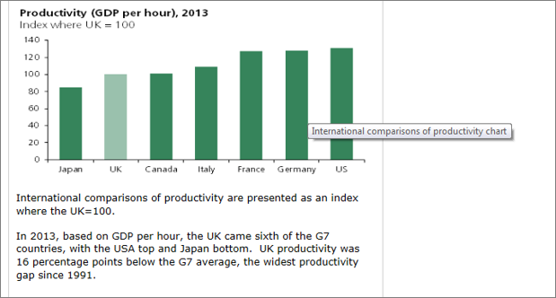

### **Example 2 – preferred format**

Alt Text

|  |
| --- |
| Chart explaining international comparisons of productivity where the UK = 100cid:image020.png@01D08CB2.C21B70F0  The chart above explains international comparisons of productivity where the UK = 100  In 2013, based on GDP per hour, the UK came sixth of the G7 countries, with the USA top and Japan bottom.  UK productivity was 16 percentage points below the G7 average, the widest productivity gap since 1991. |

### **How long can Alt Text be?**

There is no official length restriction on the length of alt text, but many experts recommend 125 characters or fewer because of restrictions within the JAWS screen reader. Some versions of JAWS break up longer text into blocks of 125 characters, and this segmentation can be confusing to users.

## **Image supported by table content**

Informative images that will be supported by a further table format of the data will need to use the following process:

### **Image title**

* Ensure that there is an informative title for the image set at an appropriate <H> heading
* Make sure the <H> heading is outside of the image itself and not part of the image

### **Alt Text**

* Add content to the Alt Text field which describes the function of the image, in the example below, a chart explaining …
* Follow this within the Alt Text by a short description of the subject matter

### **Text below the image**

* Add an active link to the table format which should preferably be located on the same page, possibly at the bottom

### **Present table format**

* Entitle the table with an obvious connection with the associated image
* Create a table with clearly marked-up headings for columns and rows

This approach can usually be achieved without the involvement of web specialists although you may need some guidance about setting up the table.

**Example 1 – Image and link**

This image shows where the link to the table should be located and the type of text required

Link to table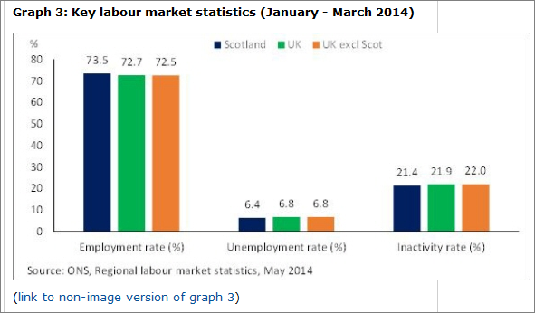

**Example 2 – Table format**

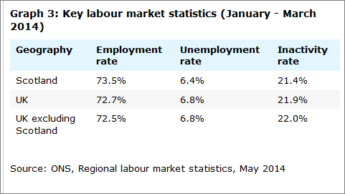

### **Why use tables as well?**

The use of a table enables search engines and screen readers to access the data which are hidden when presented as an image.

## **Infographic supported by bulleted list**

This is a slightly more complicated form of image as it conveys information in a pictorial format. However, for search and for people to understand the flow of the content you will need to produce a bulleted list below the infographic which describes the structure and content.

### **Image title**

* Ensure there is a <H> heading above and outside of the infographic

### **Alt Text**

* Add content to the Alt Text field which describes the function of the image, in the example below, “An infographic explaining … “
* Follow this within the Alt Text by a short description of the subject matter, “…the work of the Energy Committee 2010-2015”
* **Do not** use fly-out boxes with additional text unless the content is available elsewhere.

**Example**

This would result in the following Alt Text “An infographic explaining the work of the Energy Committee 2010-2015”

### **Text below the image**

* Create a bulleted list describing the infographic’s structure and any content and place it somewhere on the body of the page and outside of image. Options are:
  + directly below the image
  + link below the image taking the user to a lower area of the same page
  + link to another page (only in exceptional circumstances)
* If the page has dynamic functionality, then the accessible bulleted list can be hidden, but will need to have a heading which shows that it exists and is an option which people can open if their prefer to engage with the content in that format.

**Example of bulleted list**

Work of the Energy Committee 2010-2015 <Heading>

* 38 Committee reports - We have published 38 reports across a range of subjects. A full list of reports can be found on our website
* 10 debates on committee reports - We have arranged for 10 Committee reports to be debated in the House of Commons, providing a wider group of MPs with an opportunity to follow up on our findings on behalf of their constituents.
* 31 Government responses - The Government has responded formally to 31 of our reports. Responses are usually received two months after publication. A full list of responses can be found on our website.
* 1402 pieces of written evidence - Of the 1402 pieces of written evidence we have published in relation to our 38 reports, 96 came from academics and research institutes, 307 from the general public and consumer advocates, 154 from Government and public bodies, 713 from industry and business, and 132 from third sector organisations.

This type of infographic is fairly straight forward but may need some additional guidance from a web specialist if you intend to hide the bulleted list.

## **Image using HTML and CSS**

This is the most ideal form of infographic as it uses the full value of web technology. However, it will require time and effort from web developers as it will need to be written using Html code and CSS.

This approach to producing the infographic uses multiple images and content which is then brought together by the code to appear as a single collection or single image. In fact, it remains a group of separate images which can be accessed by search and screen readers without being lost within a larger and confusing block of information.

### **Image title**

* Ensure there is a <H> heading above and outside of the infographic
* Ensure that there is a <H> heading for each individual image

### **Alt Text**

* Add content to the Alt Text field for each individual image
* Do not use <title> tag associated the each image as these are not picked up by search or screen readers
* Be careful of using fly-outs to convey information as this may require the same information to be supplied as a bulleted list outside of the image code

### **Code**

* Use the CSS and Html to control the position of each image on the page so that they appear as one overall image whilst really remaining as separate images

An [example of an infographic using Html and CSS](http://throup.org.uk/infographic/) has been produced by Chris Throup

**Alex Fuller**

**July 2015**