Proposal: Indie UI Context Aware

State of the Art in Context Awareness

The concept of personalization and adaptation to context is not new. The IMS Global Learning Consortium created AccessForAll (AfA) for the purposes of delivering personalized learning to meet the needs of the individual. AfA defines digital resource description meta data in terms of a users personal needs and preferences. This allows for a web application, such as a mashup system, or a learning management system to map the right resource, resource adaptation, or resource alternative to an individual based on their personal needs and preferences. When you couple device capabilities, such as screen size, available fonts, and other device specific capabilities, and adapt to these device and user preferences based on the environment the user is operating in you have a delivery context that actually meets the users needs. See Figure 1.0.

Figure 1.0: Delivery Context Adaptation Scenario

AfA version 3.0 comes out in public working draft in the next month. However in addition to AfA two other efforts are beginning to get industry mind-share and adoption: IMS APIP Accessible Portal Item Protocol (APIP) and the Global Public Inclusive Infrastructure (GPII) Registry.

AccessForAll

The AfA Digital Resource Description (DRD) specification is intended for use in combination with the IMS Global AfA Personal Needs and Preferences (PNP) specification v3.0, which provides a means to describe how a user wishes to access online learning content and related applications. This part of the AfA Specification is intended to describe aspects of digital resources or a computer system (including networked systems) that can be adjusted to improve accessibility. The specification is not intended to address non-digital systems that can include physical location, other people, external processes, etc.
The AfA PNP specification is intended to meet the needs of learners with disabilities and of anyone in a disabling context. The purpose of the AfA PNP Specification is to provide a machine-readable method of stating user needs and preferences with respect to digitally based education or learning. The AfA PNP specification can be used independently, for example to deliver the required or desired user interface to the user, or in combination with the AfA Digital Resource Description (DRD) to deliver digital resources that meet a user's needs and preferences. AfA Version 3.0 is now being implemented in both the Teacher’s Domain and the National Science Digital Library.
AfA v3.0 used semantic web technology to do the initial modeling to produce a taxonomy vocabulary not unlike the strategy employed by WAI-ARIA.
In addition to IMS GLC’s AfA, ISO has also produced a version of AfA (in ISO this is known as ISO/IEC 24751:2008 : Individualized Adaptability and Accessibility in E-learning, Education and Training.) that is harmonized with IMS GLC AfA V2. A main difference between version 3.0 and version 2.0 is v3.0’s effort to separate AfA into a simplified core and full profile set to facilitate uptake. Also AfA V3 goes much further to support matching of interoperable IT with assistive technologies in the core profile to support technologies like WAI-ARIA and native platform accessibility services support. Examples of AfA V3 properties are given in Appendix A.

APIP

The learning assessment industry and the U.S. department of education is investing in APIP. The education assessment industry has roughly $5 billion annual revenues.

APIP arose out of an US Department of ED grant (called an EAG or Enhanced Assessment Grant) to a consortia of 8 US states, that included IMS Global Learning Consortium as a partner. The administrator of the grant was the state of Minnesota.

Next the driver became the big Race to the Top Assessment (RTTA) program. This is a $350M multiyear program awarded to two consortia of states - Smarter Balanced (SBAC) and PARCC. Between them they cover 40+ states. This project will redo all of the summative assessment done in schools. While these projects are not investing in APIP, they are requiring it in the implementation. As a consequence, all the assessment suppliers have rallied behind APIP. IMS members focused on APIP include ETS, Pearson, CTB McGraw-Hill, Houghton Mifflin Harcourt, Pacific Metrics, Data Recognition Corp, ACT, LiveText, Chalk & Wire - and now IBM.

There are many more organizations that will be signing up to support APIP. Two other smaller state consortia focused on assessment currently in the process of signing up are: Dynamic Learning Maps and ASSETS/WIDA.

The U.S. Department of ED recently issued a $400K grant to IMS Global and the SIF Association to collaborate on assessment standards, including APIP.

The LMS providers are not involved in APIP at the moment, but, it is to be expected that some will eventually get involved as it moves from summative to formative assessment applications. APIP is based on IMS QTI - an older version of which is implemented as IMS Common Cartridge - i.e. there is already a placeholder for APIP in LMS-delivered formative assessment. Also, the value APIP adds in terms of accessibility (describing accommodations and designating inclusion orders for delivery) could be applied very naturally to all digital learning content. It is likely that this will happen in the years ahead.

IMS Global plans to continue to harmonize APIP and IMS AccessForAll V3 to continue to grow industry support.

Examples of APIP Preferences are given in Appendix B, included here with permission from IMS Global.

Global Public Inclusive Infrastructure (GPII) Registry

The Global Public Inclusive Infrastructure is a development effort started by Raising the Floor to produce an open source, digital on-ramp to the Internet. Over the past year an international development community has been working on it with initial funding coming from a project called Cloud4All. Individual, non-profit, corporate entities based on the Raising the Floor Consortium are being established to garner grant funding to help build the GPII. A cornerstone of GPII is the architecture to deliver a personalized user experience that meets the needs of the user.

GPII’s prototypical approach to a personalization architecture is described here http://wiki.gpii.net/index.php/Architecture_Overview. Whilst it may not yet be appropriate to standardize some features of this architecture and the precise relationship with standards remains to be determined, the group are working closely with the editors of ISO/IEC 24751:2008 (known hereafter as 24751) and their requirements are being taken into account in a revision of that ISO standard that is underway.
In particular, part of the GPII approach to personalization includes a software registry of uniquely identified human-readable definitions of preference terms. The plan is that the revised 24751 standard will contain a management framework for this registry and other parts of the standard will be built upon that. Further, the registry is planned to enable unambiguous device-independent use of terms with storage of “Common Terms” and vendor-specific terms. The structure is currently planned to be completely flat in that each term is unique and not related to any others.

A number of project scheduling issues may present difficulties for Indie-UI to completely base its work on the GPII registry but nevertheless it seems desirable to converge approaches or adopt a common set of terms with that project should that be possible. Some technical issues in harmonization remain to be explored but there may be significant advantages in registering IndieUI terms in the ISO/GPII registry in the context of adoption of usage across education markets worldwide since ISO/IEC JTC1 SC36 ICT Standards for Learning, Education and Training is a major standards body in this domain with participation (and adoption of published standards) by a very large number of countries.

Proposal

Our proposal is to build an aggregation of terms that includes vocabulary from AfA, APIP and GPII, and mold that into a standardized vocabulary that describes the delivery context. This will require Coordination between W3C and IMS Global Learning Consortium because APIP is under active development and market adoption via IMS.

The collection of preferences, device capabilities, and any environmental information we decide to expose should adequately form a delivery context.

In addition to the vocabulary we need to define an API in the browser that allows a web page author to query delivery context properties that also provides a way to register for change notifications so that when context properties change the web application can adjust accordingly.

In the appendix are two diagrams showing the Personal Needs and Preferences and the Digital Resource Description Core profiles along with examples of corresponding properties and their vocabulary values. We have also included some APIP examples.

Note: APIP is expected to be evolving substantially over the next 5 years in terms of both accessibility features and interaction types. W3C members who wish to enable APIP accessibility features in the browser should consider joining in the IMS APIP activity to ensure browsers can support APIP inclusion orders and assessment interaction types.

Appendix A.

Examples from AfA 3.0

Personal Needs and Preferences Examples (PNP) – provided with permission from IMS Global

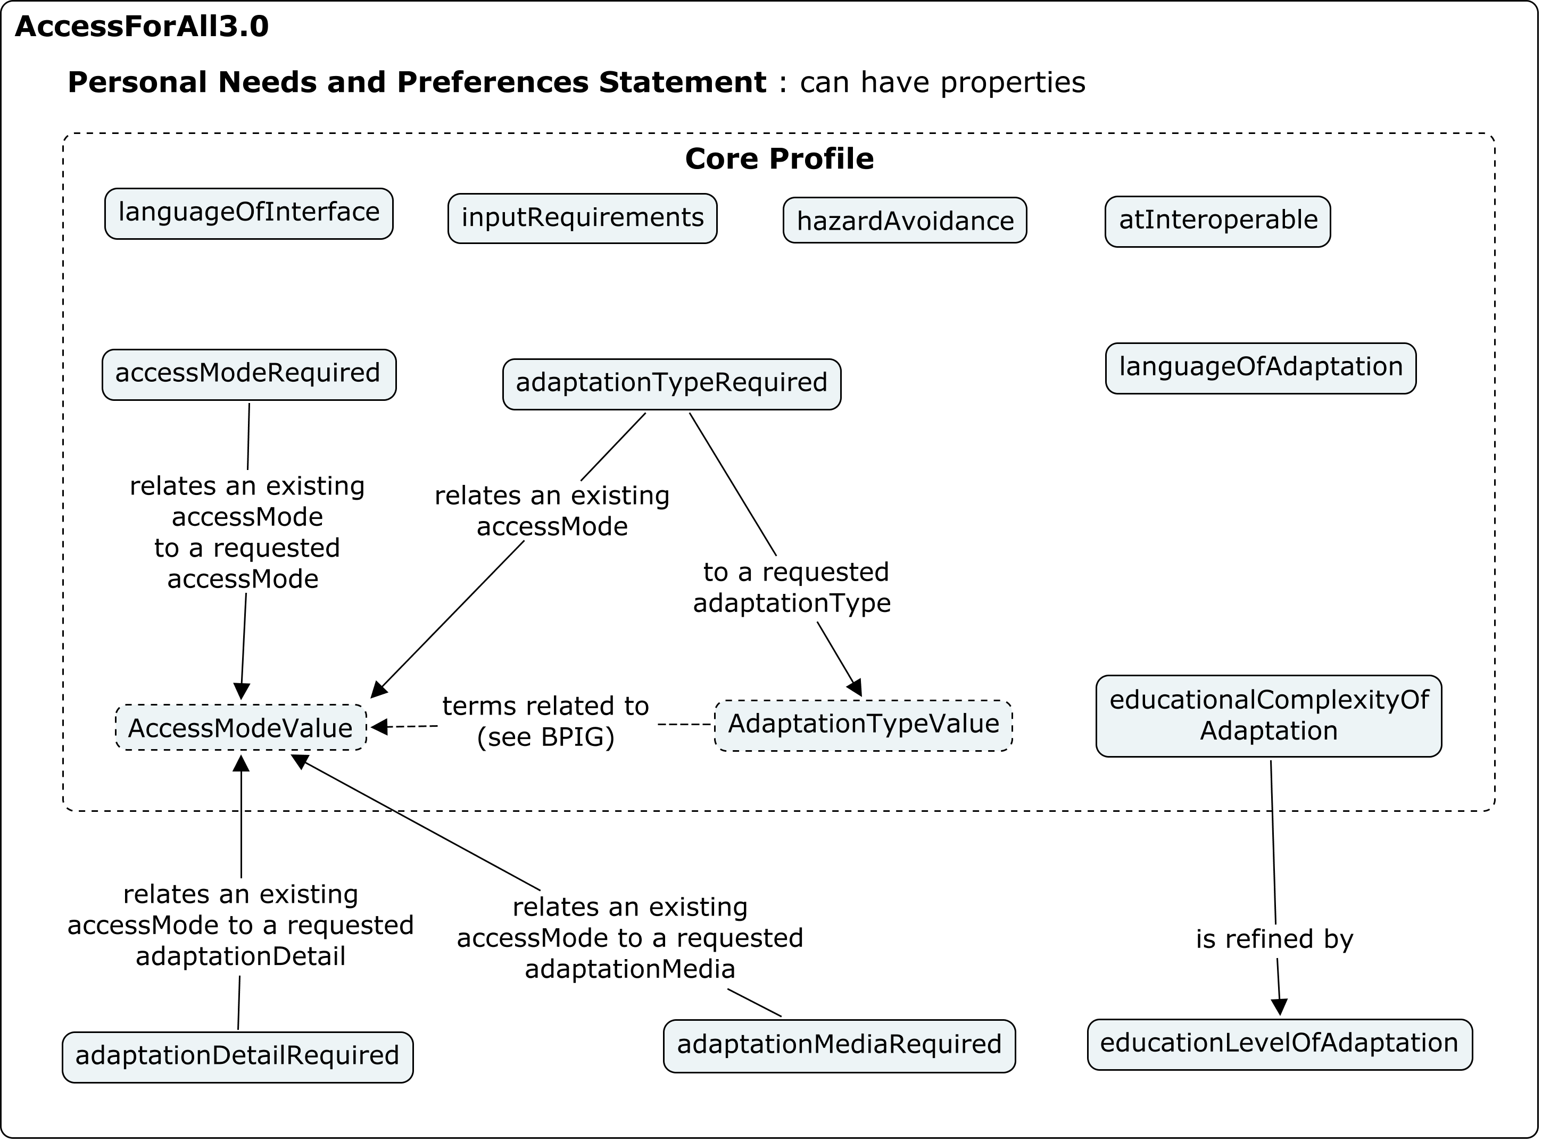

Descriptor | Definition
Attribute name | accessModeRequired
Data type | (AccessModeValue, AccessModeValue) (see sub-section 2.2 in AfA DES [AfADES, 12]).
Value space | Container.
Multiplicity | [0..unbounded], unordered
Linguistic Indicator | Linguistic
Description | Access mode that a user seeks either in an adaptation or an original resource as a replacement for a different access mode.
Notes | This attribute relates an “existingAccessMode” to an access mode that the user prefers, called an “adaptationRequest.”  The example of  accessModeRequired.existingAccessMode = visual  accessModeRequired.adaptationRequest = textual  expresses this statement: “Resources that are visual should be replaced by an adaptation that is textual.”

Descriptor | Definition
Attribute name | adaptationTypeRequired
Data type | (AccessModeValue, AdaptationTypeValue) (see sub-sections 2.2 in AfA DES [AfADES, 12], 2.5 in AfA DES [AfADES, 12]).
Value space | Container.
Multiplicitys | [0..unbounded], unordered
Linguistic Indicator | Linguistic
Description | Nature or genre of the adaptation required as a replacement for a specific access mode.
Notes | This attribute relates an “existingAccessMode” to an adaptation type that the user prefers, called an “adaptationRequest.”  The example of  adaptationTypeRequired.existingAccessMode = visual  adaptationTypeRequired.adaptationRequest = audioDescription  expresses this statement: “Resources that are visual should be replaced by audio description.”

Descriptor | Definition
Attribute name | atInteroperable
Data type | Boolean (see Table A1.1).
Value space | - False – denotes that the user does not require assistive technologies support;  - True – denotes that the user does require assistive technologies support.
Multiplicity | [0..1]
Linguistic Indicator | Non-linguistic
Description | A preference for resources that are compatible with assistive technologies.
Notes | Resources that are interoperable with AT should be selected whenever possible. Interoperability is indicated by compliance with WCAG 2.0 checkpoints: 1.1.1, 1.3.1, 1.3.2, 2.4.4, 3.1.1, 3.1.2, 3.3.2, 4.1.1 and 4.1.2.The specific details of the AT are normally provided by a user agent or the operating system. The example of ‘atInteroperable=true’ expresses this statement: “Resources that are interoperable with AT should be selected whenever possible”.

Vocabularies

Name: | AccessModeValue
Definition: | Human sensory perceptual system or cognitive faculty through which a person may process or perceive information.
Linguistic Indicator: | Linguistic
Value (Range): | The enumeration set is: { auditory | colour | itemSize | olfactory | orientation | position | tactile | textOnImage | textual | visual }.

Name: | AdaptationTypeValue
Definition: | Term describing an adaptation type.
Linguistic Indicator: | Linguistic
Value (Range): | Enumerated set: { alternativeText | audioDescription | captions | e-book | haptic | highContrast | longDescription | signLanguage | transcript }

Digital Resource Description (DRD) Properties:

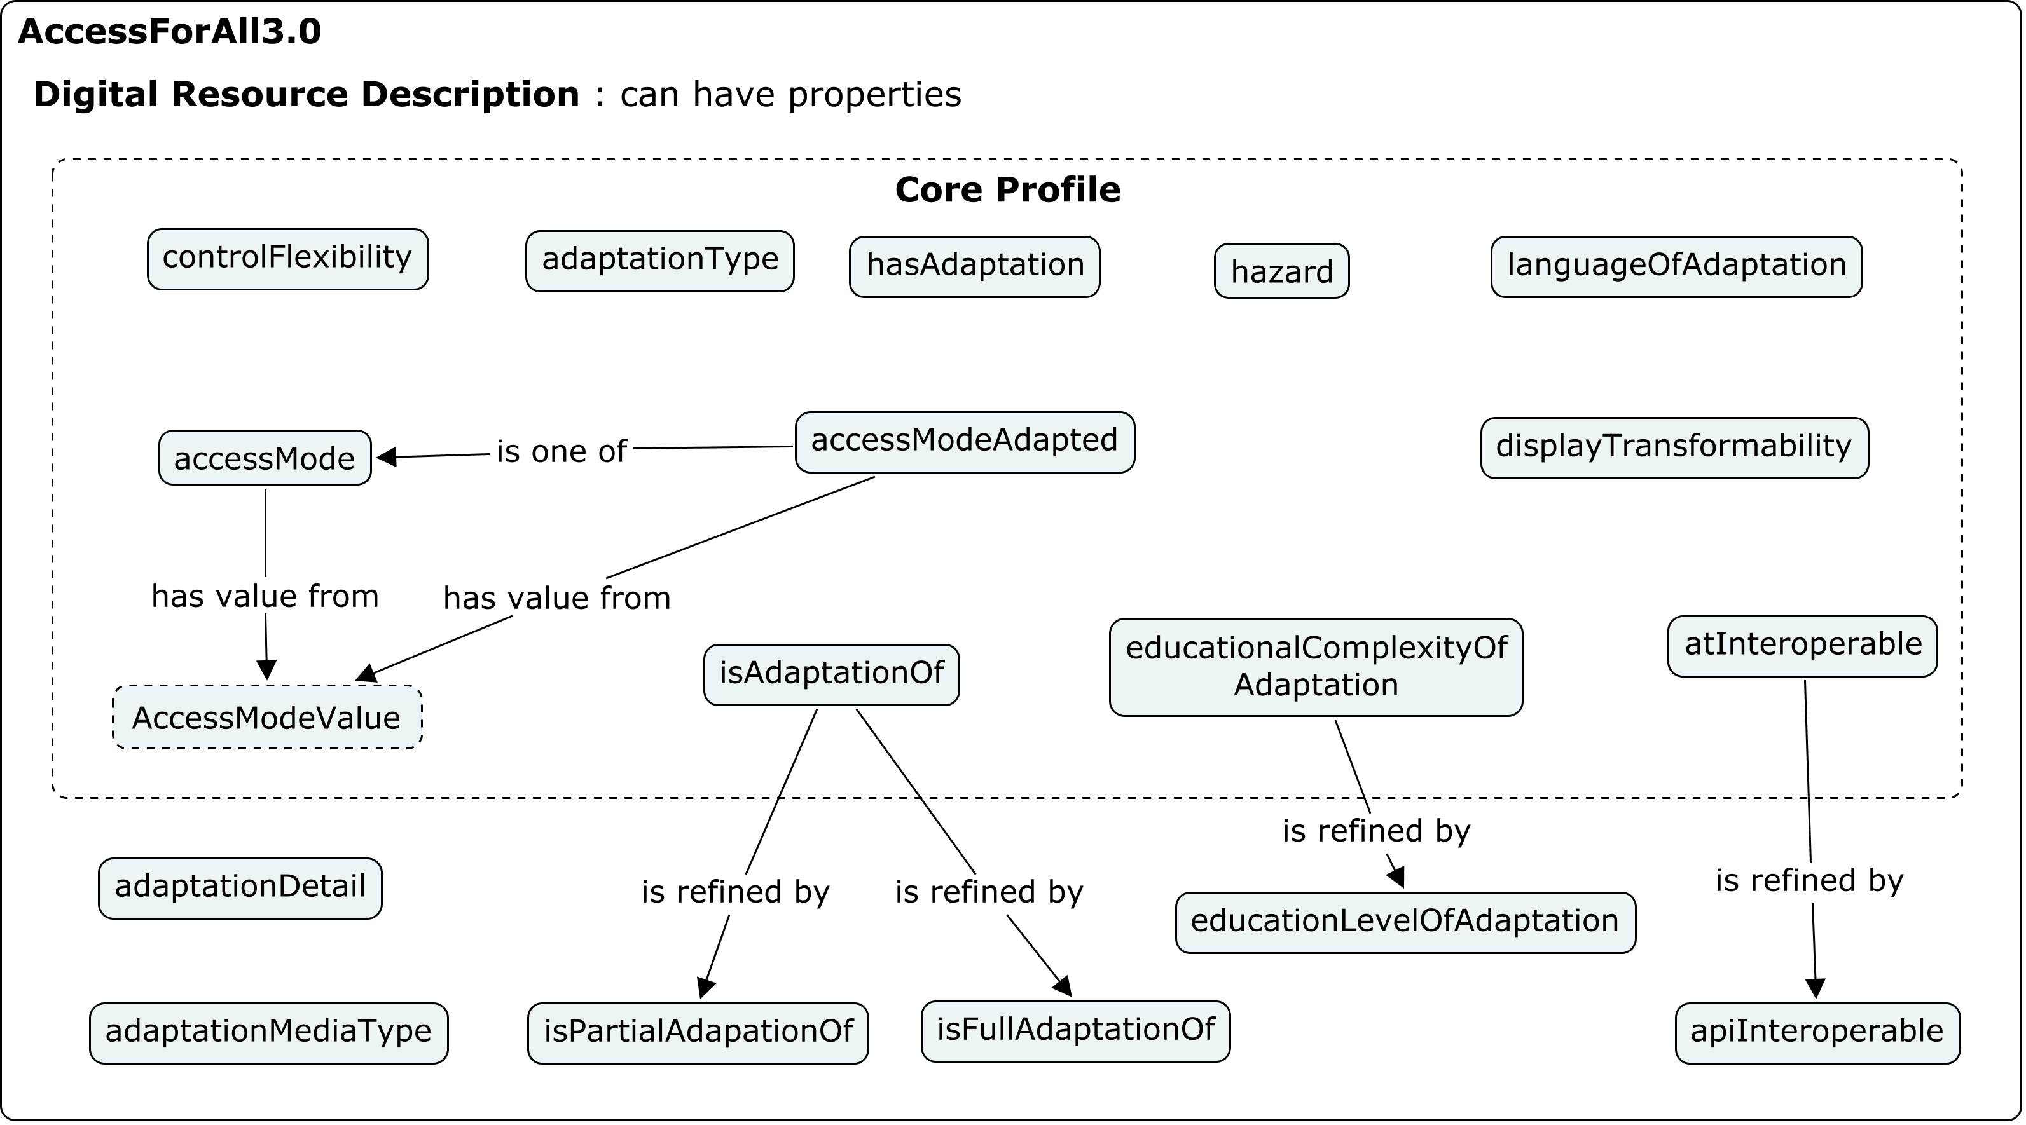

Descriptor | Definition
Attribute name | apiInteroperable
Data type | AccessibilityAPI (see sub-section 2.1 in AfA DES [AfADES, 12]).
Value space | Container
Multiplicity | [0..unbounded], unordered
Linguistic Indicator | Non-linguistic
Description | Indicates that the resource is compatible with the referenced accessibility API.
Notes | The details of how each API is serviced may be different for each one and handled by the User Agent and/or operating system. The example of ‘apiInteroperable=ARIAv1’ expresses this statement: “This object implements the ARIA v1 interoperability specification”.

Name: | AccessibilityAPI
Definition: | Term identifying an adaptive technology API for reference in resource metadata.
Linguistic Indicator: | Linguistic
Value (Range): | Enumerated set: {AndroidAccessibility | ARIAv1 | ATK | AT-SPI | BlackberryAccessibility | iAccessible2 | JavaAccessibility | MacOSXAccessibility | MSAA | UIAutomation }.

Appendix B.

APIP Examples:

APIP has approximately 29 Metadata fields and work to model them in the AfA 3.0 is underway. Below is a small sample that shows potential mapping to AfA 3.0 terms.
Acknowledgements are due to Madeleine Rothberg, WGBH for this data, provided with permission from IMS Global.

APIP attribute | Definition | AfA v3
spoken: spokenSourcePreference | Defines the preferred spoken audio form. The functional meaning of the vocabulary entries are:  - Human – human voice recording is the preferred type of speech;  - Synthetic – synthesized speech is the preferred type of speech. | accessModeRequired (textual, auditory)  AdaptationDetailValue (recorded or synthesized)
spoken: readAtStartPreference | Used to define if the spoken play-back should commence from the start of a recording or not. The functional meaning of the vocabulary entries are:  - false – spoken play-back should start from where last play ended;  - true – spoken play-back should always start at the beginning of the recording. | ?
spoken: userSpokenPreference | Used to define the type of material that should be rendered using the read aloud alternative content. The functional meanings of the vocabulary are:  - TextOnly – spoken play-back should be used for text based content;  - TextGraphics – spoken play-back should be used for text and graphics based content;  - GraphicsOnly – spoken play-back should be used for graphics content only;  - NonVisual – spoken play-back should be used for all non-visual content. | refinements of accessModeRequired (textual, auditory) and (visual, auditory)
spoken: directionsOnly | Defines whether or not the spoken alternative content presentation should be applied to directive content only. | refinement of accessModeRequired (textual, auditory)

References:

http://www.imsglobal.org/
http://www.imsglobal.org/apip/
http://gpii.net
http://standards.iso.org/ittf/PubliclyAvailableStandards/c041521_ISO_IEC_%2024751-1_2008(Bil).zip http://standards.iso.org/ittf/PubliclyAvailableStandards/c043603_ISO_IEC_24751-2_2008.zip http://standards.iso.org/ittf/PubliclyAvailableStandards/c043604_ISO_IEC_24751-3_2008.zip
http://www.imsglobal.org/cc/

