UNICODE FORUM PROPOSED CHANGES – MONGOLIAN BLOCK
January 10, 2015

SUMMARY
New FVS Character
180F-FVS4

New FVS assignments

180A+FVS1-Final
1822+FVS2-Medial
1822+FVS3-Medial
1822+FVS1-Final
1824+FVS1-Final
1824+FVS2-Final
1826+FVS4-Medial
1826+FVS2-Final
1828+FVS4-Medial
1829+FVS1-Isolate
182C+FVS2-Initial
182D+FVS2-Initial
1843+FVS1-Final
1887+FVS4-Final

Differences with the Chinese Standard
182C+FVS2/FVS3-Medial are switched
182D+FVS1-Isolate (Chinese Standard uses a ZWJ)

Character Feature Changes
1885 Baluda – Feature change from “letter” to “diacritic mark”
1886 Triple Baluda – Feature change from “letter” to “diacritic mark”

Unicode Isolate Forms without FVS assignments – This is an FYI at present. The issue is that there is no easy way for the user to type these code-point’s Unicode form without having intrinsic understanding of the block; user will have to use a ZWJ combination; user will have to know the position of the particular code-point that is the Unicode form. It is felt that this should be a simple task to write any given Unicode form whereas in reality it is not.

184A (Final)
184B (Final)
184F (Final)
1859 (Final)
185D (Final)
185E (Second Medial)
1861 (Medial)
1862 (Final)
1863 (Final)
1873 (Final)
1874 (Medial)
1875 (Final)
1876 (Medial)

NEW CONTROL CHARACTER

- New FVS4 Control Character – There are three instances now where the FVS4 may be needed, one of which is definitely confirmed; <U+1887-Isolate><FVS1> is actually a final as confirmed by Professor Quejingzhabu.

NEW VARIANTS

- New FVS1 assignment at Final U+180A-Nirugu – Professor Quejingzhabu’s Specification 9.0 calls for a final with a hook. Current forum members are calling for a final with no hook. As the hook is more standard than no hook, it is recommended that the default be the hook and the no-hook be the variant with FVS.
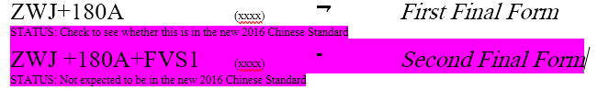

- New FVS2 assignment at <U+1822-Medial><U+180C> Three out of six font developers implement this double-tooth U+1822 form.

- New FVS3 assignment at <U+1822-Medial><U+180D> This variant is needed to over-ride default context of the medial I in words such as NAIMA “eight”.

- New FVS1 assignment at <U+1822-Final><U+180B> This 1822 final variant has been attested by various independent sources.

- New FVS1 assignment at <U+1824-Final><U+180B> This variant is needed for foreign spellings such as “Nassau”.

- New FVS2 assignment at <U+1824-Final><U+180C> This variant has been attested by several independent sources as a variant of the dotted genetive case U/UE after the sequence <U+1828-N><NNBSP>.

- New FVS3 assignment at <U+1826-Medial><U+180D> This variant is needed to over-ride the context so that we can use the DUEGER with or without the NNBSP.
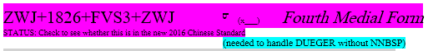

- New FVS2 assignment at <U+1826-Final><U+180C> This variant has been attested by several independent sources as a variant of the dotted genetive case U/UE after the sequence <U+1828-N><NNBSP>.

- New FVS4 assignment at <U+1828-Medial><U+180F> This default form is needed with FVS assignment to over-ride native context for such rare cases as ANAR.
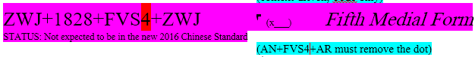

- New FVS1 assignment at <U+1829-Isolate><U+180B> This isolate is evidenced in the dictionary "mongγol nanggiyad üsüg-ün toli bičig" (蒙漢字典) published in 1928. This is shown in context at http://www.cneas.tohoku.ac.jp/staff/hkuri/articles/a62houkoku14.pdf
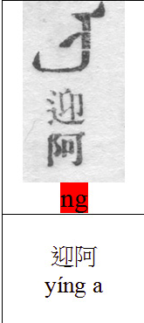

- New FVS2 assignment at <U+182C-Initial><U+180C> This variant is needed for the special case of QQIR.

- New FVS3 assignment at <U+182D><U+180C> This variant is needed for foreign loan words such as GRAM.

- New FVS4 assignment at <U+182D><U+180F> This default form is needed with FVS assignment to over-ride native context for such rare cases as COGAGULA.
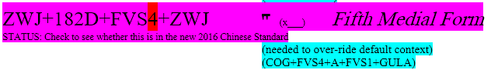

- New FVS1 assignment at <U+1843><U+180B> This variant has been attested to.

- New FVS3 assignment at <U+1887><U+180F> This is currently listed as an isolate in the Chinese Standard. Professor Quejingzhabu says that this is a mistake and is actually a final.

VARIATION BETWEEN CHINESE STANDARD & NEW PROPOSAL

- Variation at <U+182C><U+180C> and <U+182C><U+180D>. NP has the undotted form first and the dotted form second. Chinese Standard has them the opposite way. All font developers implement by the NP statement with the undotted form first.
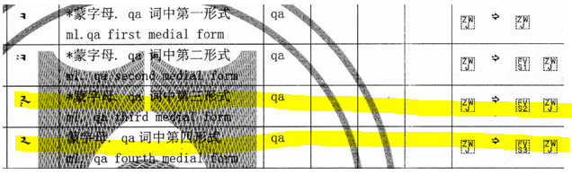
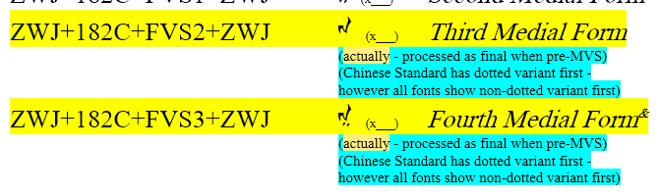
- Variation at <U+182D><U+180B> The Chinese Standard uses the non-standard ZWJ to specify an isolate. As this is not necessary and breaks the common paradigm, the NP uses a FVS1.

