**Questions/Clarifications**

1.) The professor’s use of GHIR is meant to refer to the Unicode sequence <U+182D><U+182C><U+1822><U+1837>?

>>> It is correct.

2.) The professor’s use of GXAN below is meant to refer to the Unicode sequence <U+182D><U+1830><U+1820><U+1828>? GSAN? This is the suffix –GSAN/-GSEN? The SA should not have the double dots?

>>> GXAN 🡪 <U+182D><U+1831><U+1820><U+1828>.

It is not suffix –gsan/-gsen，but a word gshan. The meaning of the word is "a moment, instant".

**Original mail content**

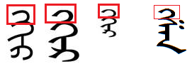

与蒙古文词【GHIR】和【GXAN】类似的常用借词不少。

>>> Use of the two similar words GQIR/GXAN are not uncommon.

其中，部分词来源于藏文或梵文。历史上一直用蒙古文阿礼嘎礼字母KA（U+1889）来书写这些词，其字符图形相（GB 25914-2010中表4中No：0085）对大一些。

>>> Among them, some words from Tibetan or sanskrit. In history, has been with the Mongolian Ali-gali letter KA (U+1889) to write these words. The character graphics (0085 in Table 4 of GB 25914-2010) is relatively large.

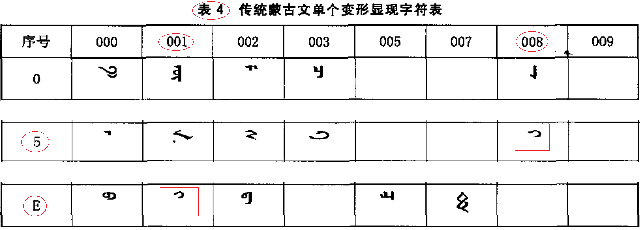

当代人们通常用蒙古文字符GA（U+182D）的“阴性词中形式”来书写类似的借词，其字符图形（GB 25914-2010中表4中001E）相对较小。

>>> Contemporary, people usually in "feminine medial form" of Mongolian Character GA U+182D to write a similar words. The character graphics (001E in Table 4 of GB 25914-2010) is relatively small.

我认为来源于藏文、梵文的部分借词可以选用蒙古文阿礼嘎礼字母KA（U+1889）来书写，也可以选用蒙古文字母GA（U+182D）来书写。

>>> If the word in question is a loan-word of Tibetan/Sanskrit origin, then I think it is fine to use either <U+182D> or <U+1889>.

GB/T 26226-2010和GB 25914-2010未明确说明借词【GA + Consonant ...】的问题，也没给出选用GA（U+182D）的处理方法。

>>> The Chinese Standard GB/T 26226-2010 and GB 25914-2010 did not specify the words [GA + Consonant] problem. Also did not give the selection of GA (U+182D) processing method.

《传统蒙古文转换规则》中明确提出选用蒙古文字符GA（U+182D）来处理。当然，不应选用蒙古文字符QA（U+182C）。

>>> “Traditional Mongolian Rules of Translation” clearly put forward the used Mongolian character GA (U+182D) to deal with. Of course, should not be used Mongolian charactor QA (U+182C).

《传统蒙古文转换规则》

>>> “Traditional Mongolian Rules of Translation”

<http://www.babelstone.co.uk/Mongolian/Specification9.pdf>

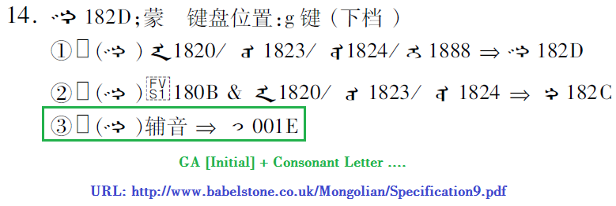

类似的词还不少，请看附件《[GA + Consonant ... - Words .pdf》。

>>> There are many similar words such as the following …

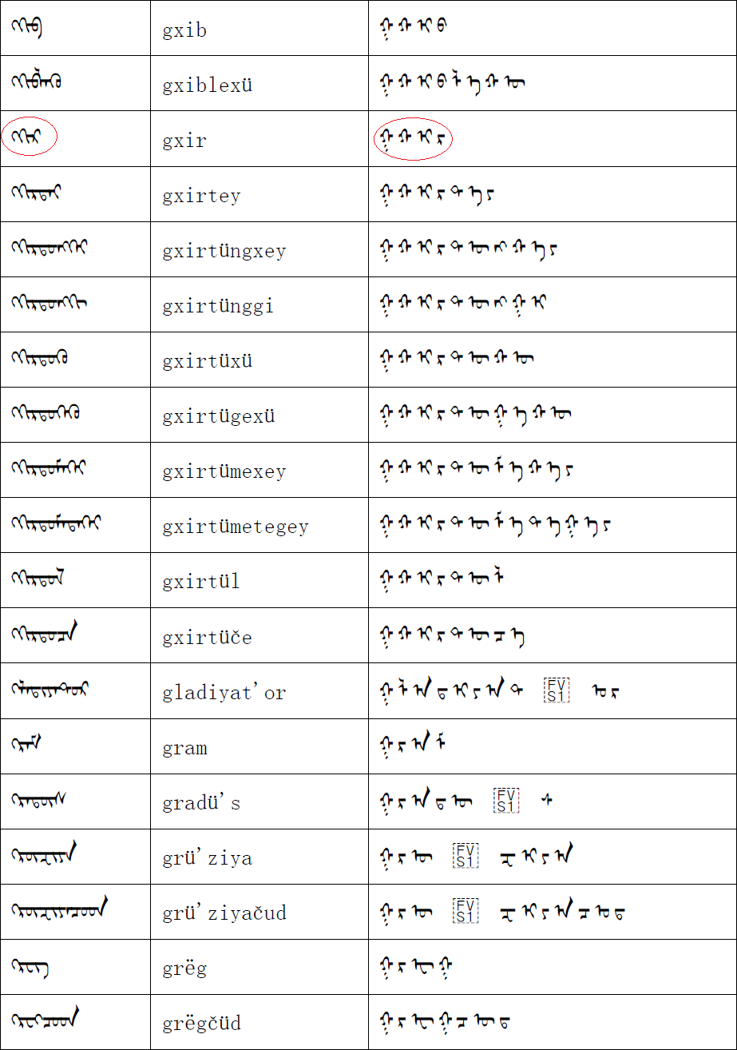

关于新版蒙古文编码国家标准（也许是GB 26226-2016 / GB 25914-2016)中是否定义“第三词首形（Third initial form ） [ 182D + FVS2 + ZWJ ]”的问题，我会转告确老师。

>>> The question of whether or not the new edition of Chinese Standard(Maybe it's 26226-2016 GB / 25914-2016 GB) defines the "Third initial form[182D + FVS2 + ZWJ ]", I will tell the Professor.

顺祝。 >>> Wish everything goes well.

呼斯勒　　2016-03-30