U+182C - QA
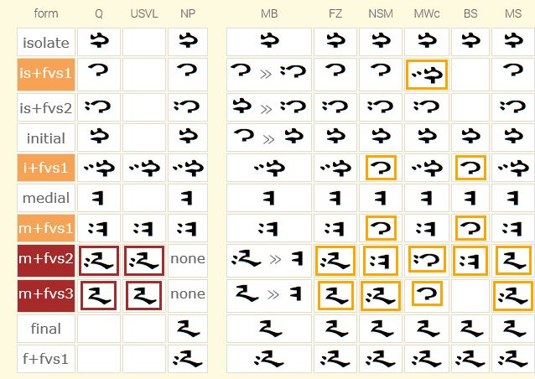
OBSERVATIONS
- There are differences between where the FVS assignment is made for the U+182C double-dotted double-tooth rightward-swept final-type variant 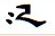 . The standard now places it at M+FVS2. The standard MVS model says that it will be implemented as an final.
(Jirimutu: I agree this.)

- All fonts implement the glyph at F+FVS1.
- FangZhen also implements the glyph at M+FVS2. Could I ask YuXin whether the glyph, in running text, is handled as a medial or as a final?
- NotoSans and MenkhSoft also implement the glyph at M+FVS3. Could I ask Jirimutu and Husele the same question?
(Jirimutu: Yes we implemented F-FVS3. When we teach pupil to write ᠦᠬᠡᠷ will be writen as
- ᠦ‍‍‍‍ ᠊ᠬ‍ ‍ᠡ‍ ‍ᠷ if there are no MWc’s M+FVS3, the spell will become like left side.)

- A standard Mongolian grammar will say that the U+182C never appears in final position.
- The default in regards to dotting for the U+182C is to be undotted.
CONCLUSIONS
It would seem that as the MVS model says that the sequence 182C+180B+180E+1820 tags the 182C+180B glyph as a final AND as all 6 fonts implement the glyph at least in a final position that the FVS stand-alone assignment should be made at the same position as a final rather than a medial.
As the dotting default of the U+182C is undotted, it would seem that positioning two pairs identical apart from dotting behavior, should follow the same pattern. Specifically, it would seem that the undotted glyph should precede the dotted glyph – as seen in the implementation of all fonts above at the final position. (Jirimutu: I agree this.)

For QA, we would like to decrease the variant count. Actually, there no two dotted QA in modern Mongolian. I don’t know when and how it is come into Variant form of the QA.
Let me show one history map here (Maybe I have mistake on the actual years) to explain my comment on the QA.
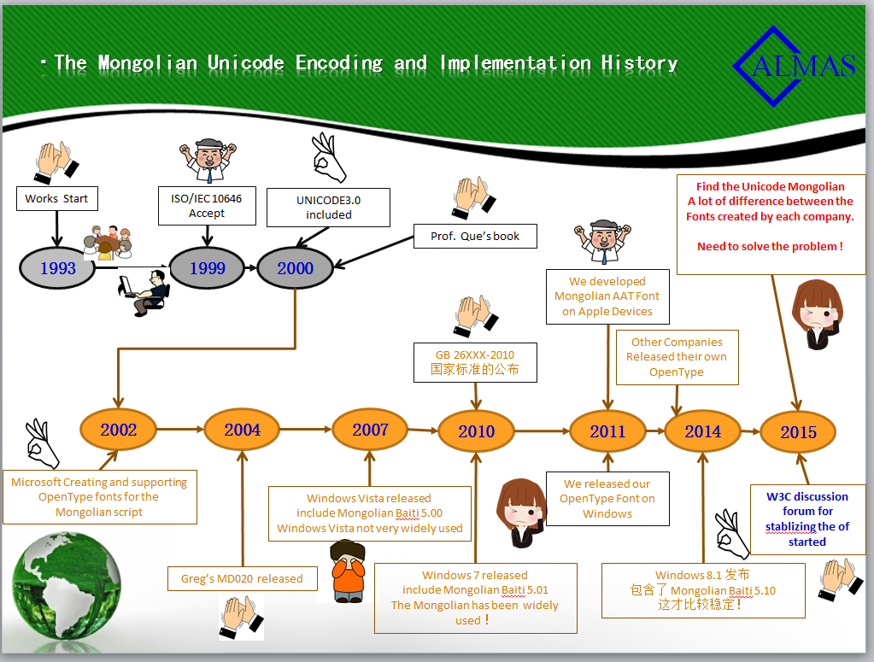

The FVS Assignment for U182C_QA.
 | Clean & Simple | Complete  &Beautiful | Q’s Book | MD020 | GB26226 | New Proposal
ISOLATE Default
IS + FVS1 |  |  |  | None | None
IS + FVS2 | None |  |  | None | None
IS + FVS3 | None |  | None | None | None | None
INITIAL Default
I + FVS1
I + FVS2 | None |  | None |  | None | None
I + FVS3 | None |  | None |  | None | None
Medial Default
M + FVS1 | None
M + FVS2 | None |  |  |  |  | None
M + FVS3 | None |  |  | None | None | None
ISOLATE Default |  |  | None
F + FVS1 | None |  | None |  | None
F + FVS2 | None |  | None | None | None | None
F + FVS3 | None | None | None | None | None | None

- Our first suggestion is make the FVS assignment for QA is clean and simple.
In real word, in modern Mongolian we do not read ,, as QA. Why we can not use GA to replace it and simplify the code structrue. I had never seen in my lifetime. Maybe it is used in the ancient time Monglian, at least not used in modern Mongolian.
I do not think we really need these in our modern Mongolian. The clean and simple structure is listed in first column of the table prepared above.
If this suggestion is not acceptable, we go the complete and beautiful structure is listed in the second column of the table prepared above.

- Our second suggestion is make the FVS assignmengt for QA is complete and beautiful structured.
If the linguists are insisted on keeping the forms for QA, we should keep it completely, For example, have isolate form, no Initial form, but there some initial Liguatures exist in the Fonts. If the Initial and medial form ligature exists, It means the Initial and Medial form of is exist. If exist in Isolate, Its Initial and Medial form is also exist as well. We also prepare the feminine final form of QA.
The sequence of the form selection is,
- the masculine normal form to be the Default Form.
- the masculine two dotted form tobe the FVS1 form
- the feminine normal form to be the FVS2 form
- the feminine two dotted form to be the FVS3 form.

U+182D - GA
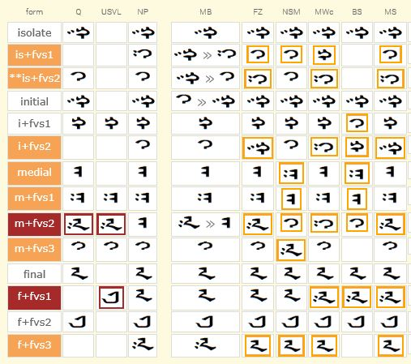
OBSERVATIONS
- There are differences between where the FVS assignment is made for the U+182D double-dotted double-tooth rightward-swept final-type variant . The standard now places it at M+FVS2. The standard MVS model says that it will be implemented as an final.
- There is possible contention for assignment of FVSx in the medial position. I can present this data at a later date.
- There was a mistake made in the early Unicode documentation regarding the final feminine GA with the leftward-swept tail. The MGWBM placed it at F+FVS2. The Unicode documentation placed it at F+FVS1.
- The MGWBM documentation stated as far back as 2000 that the rightward-swept non-dotted masculine final variant was to take F+FVS1 as well as the default final position.
- 4 out of 6 fonts implement the glyph in question (U+182D double-dotted double-tooth rightward-swept final-type variant) in the final slot following the standard MVS model.
- FangZhen and NotoSans implement the glyph in the medial following the standard. Could I ask YuXin and Kamal to verify that their OT rulings are doing the substitution at the medial and not the final? I do not see how this can happen given that the standard MVS model (using ArabicShaping.txt data) tags the 182D+FVS glyph in the sequence 182D+FVSx+180E+1820 as a final.
- There is a small data set which show the need for the FVS assignment over-riding the default final glyph. Possibly Professor Quejingzhabu could provide this?
- The default in regards to dotting for the U+182D is to be dotted.
CONCLUSIONS
The main question at hand is where to place the FVS assignment for this glyph – at M+FVS2 as it is now or as a final.
For QA, we would like to decrease the variant count. Actually, there no two dotted QA in modern Mongolian. I don’t know when and how it is come into Variant form of the QA.
The FVS Assignment for U182D_GA.
 | Clean & Simple | Complete  &Beautiful | Q’s Book | MD020 | GB26226 | New Proposal
ISOLATE Default
IS + FVS1 |  |  |  | None
IS + FVS2 | None |  |  | None | None
IS + FVS3 | None |  |  | None | None | None
INITIAL Default
I + FVS1
I + FVS2 | None |  | None |  | None
I + FVS3 | None |  | None |  | None | None
Medial Default
M + FVS1
M + FVS2
M + FVS3 | None |  |  |  | None
ISOLATE Default
F + FVS1 |  |  |  |  | None
F + FVS2 |  |  | None |  | None
F + FVS3 | None | None | None | None | None

- Our first suggestion is make the FVS assignment for GA is clean and simple.
In real word, in modern Mongolian we do not read as QA. Why we can not use QA to replace it and simplify the code structrue. I had never seen in my lifetime. Maybe it is used in the ancient time Monglian, at least not used in modern Mongolian.
I do not think we really need these in our modern Mongolian. The clean and simple structure is listed in first column of the table prepared above.
If this suggestion is not acceptable, we go the complete and beautiful structure is listed in the second column of the table prepared above.

- Our second suggestion is make the FVS assignmengt for QA is complete and beautiful structured.
If the linguists are insisted on keeping the forms for GA, we should keep it completely, For example, have isolate form, no Initial form, but there some initial Liguatures exist in the Fonts. If the Initial and medial form ligature exists, It means the Initial and Medial form of is exist.
The sequence of the form selection is,
- the masculine normal two dotted form for isolate and initial, no dotted form for medial to be the Default Form.
- the masculine no dotted form for isolate and initial, twodotted form for medial and final to be the FVS1 form
- the feminine normal no dotted form to be the FVS2 form
- the feminine two dotted form to be the FVS3 form.

