U+1820 - A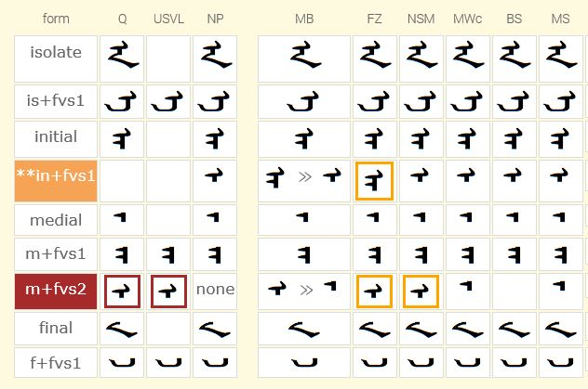
OBSERVATIONS
- There are differences about where the FVS assignment is made for the U+1820 single-tooth variant – the standard now places it at the medial. The standard NNBSP model says that it will be implemented as an initial.
- I+FVS1 – all fonts on display implement the single-tooth glyph here except FangZhen.
- M+FVS2 – 3 out of 6 fonts do not implement anything here. Badral can you verify that you do not implement anything at M+FVS2? Kamal, can you tell us why you implement the single-tooth glyph at both I+FVS1 and at M+FVS2? Your NNBSP OT ruling show that you implement the NNBSP+A+C+A suffix with the U+1820.ini. Do you really need to implement it at M+FVS2 also? Could we confirm with YuXin whether you do indeed implement the NNBSP+A+C+A suffix at M+FVS2?
- There is no U+1821 medial assignment with the one tooth for the NNBSP+E+C+E suffix. Since both suffixes act in the same manner, you would expect them to be documented in the same manner.
CONCLUSIONS
The question that I pose is whether we keep the M+FVS2 assignment or change it to an I+FVS1 assignment? There are different arguments we can make either way. We do not want to spend a whole lot of time on it. But we do need to be aware of the issue and make a decision either way so that there can be a standard assignment of the FVS for the U+1820-A single tooth glyph. The data above would suggest to me that the best assignment is at I+FVS1 – which also matches the U+1821 initial implementation of the <U+1821-E><U+1834-CHA><U+1821-E> suffix.
U+1828 - NA
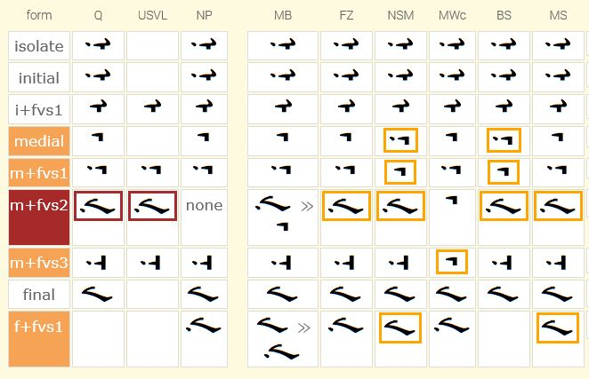
OBSERVATIONS
- There are differences between where the FVS assignment is made for the U+1828 dotted rightward-swept-final-type variant . The standard now places it at the medial. The standard MVS model says that it will be implemented as a final.
- 3 out of the 6 fonts implement the glyph at F+FVS1.
- 4 out of 6 fonts implement the glyph at M+FVS2.
- FangZhen implements the glyph at both locations.
- Could I ask Jirumutu, Badral and Husele how they actually implement this glyph at M+FVS2 given that the standard MVS model says that the position of the variant will be final?
- As FangZhen implements the glyph at two different positions, could I ask YuXin if the actual OT ruling occurs at medial or final?
- There is possible contention for FVSx assignment at the medial position. I will present more on this shortly.
CONCLUSIONS
The question is where to make the FVS assignment for the U+1828 dotted rightward-swept-final-type variant – at M+FVS2 or at F+FVS1?

U+182C - QA
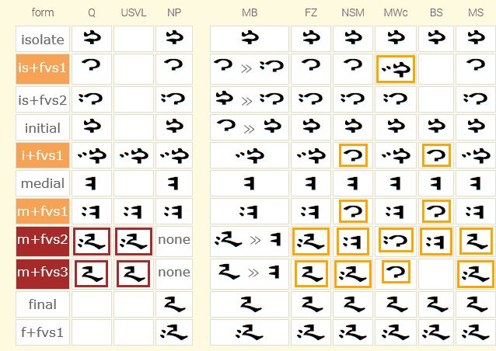
OBSERVATIONS
- There are differences between where the FVS assignment is made for the U+182C double-dotted double-tooth rightward-swept final-type variant 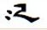 . The standard now places it at M+FVS2. The standard MVS model says that it will be implemented as an final.
- All fonts implement the glyph at F+FVS1.
- FangZhen also implements the glyph at M+FVS2. Could I ask YuXin whether the glyph, in running text, is handled as a medial or as a final?
- NotoSans and MenkhSoft also implement the glyph at M+FVS3. Could I ask Jirimutu and Husele the same question?
- A standard Mongolian grammar will say that the U+182C never appears in final position.
- The default in regards to dotting for the U+182C is to be undotted.
CONCLUSIONS
It would seem that as the MVS model says that the sequence 182C+180B+180E+1820 tags the 182C+180B glyph as a final AND as all 6 fonts implement the glyph at least in a final position that the FVS stand-alone assignment should be made at the same position as a final rather than a medial.
As the dotting default of the U+182C is undotted, it would seem that positioning two pairs identical apart from dotting behavior, should follow the same pattern. Specifically, it would seem that the undotted glyph should precede the dotted glyph – as seen in the implementation of all fonts above at the final position.

U+182D - GA
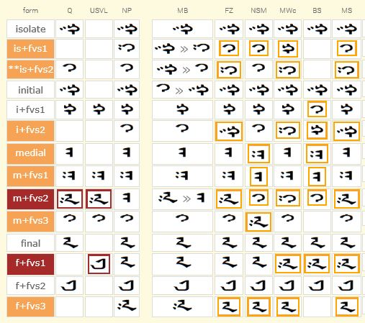
OBSERVATIONS
- There are differences between where the FVS assignment is made for the U+182D double-dotted double-tooth rightward-swept final-type variant . The standard now places it at M+FVS2. The standard MVS model says that it will be implemented as an final.
- There is possible contention for assignment of FVSx in the medial position. I can present this data at a later date.
- There was a mistake made in the early Unicode documentation regarding the final feminine GA with the leftward-swept tail. The MGWBM placed it at F+FVS2. The Unicode documentation placed it at F+FVS1.
- The MGWBM documentation stated as far back as 2000 that the rightward-swept non-dotted masculine final variant was to take F+FVS1 as well as the default final position.
- 4 out of 6 fonts implement the glyph in question (U+182D double-dotted double-tooth rightward-swept final-type variant) in the final slot following the standard MVS model.
- FangZhen and NotoSans implement the glyph in the medial following the standard. Could I ask YuXin and Kamal to verify that their OT rulings are doing the substitution at the medial and not the final? I do not see how this can happen given that the standard MVS model (using ArabicShaping.txt data) tags the 182D+FVS glyph in the sequence 182D+FVSx+180E+1820 as a final.
- There is a small data set which show the need for the FVS assignment over-riding the default final glyph. Possibly Professor Quejingzhabu could provide this?
- The default in regards to dotting for the U+182D is to be dotted.
CONCLUSIONS
The main question at hand is where to place the FVS assignment for this glyph – at M+FVS2 as it is now or as a final.

U+1835 - JA
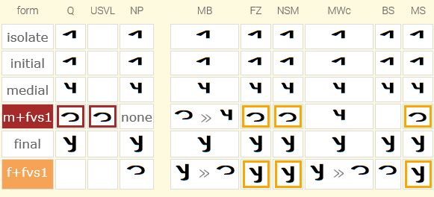 OBSERVATIONS
- There are differences between where the FVS assignment is made for the U+1835 loop variant 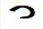 . The standard now places it at M+FVS1. The standard MVS model says that it will be implemented as an final.
- The font implementation are split 50/50 here. 3 implement the U+1836 loop at M+FVS1 and 3 implement it at F+FVS1.
- The standard MVS model says that given the sequence <U+1835><U+180E><U+1820/1821> that the JA will be tagged as final. YuXin, Kamal, Husele, could you confirm that your OT rulings are implementing the U+1835 loop at the medial position?
CONCLUSIONS
The question is whether we move the FVS assignment from M+FVS1 to F+FVS1.

U+1836 - YA
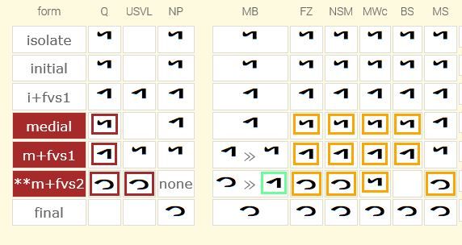
OBSERVATIONS
- There are differences between where the FVS assignment is made for the U+1836 loop variant . The standard now places it at M+FVS2. The standard MVS model says that it will be implemented as an final.
- A Mongolian grammar will state the the U+1836-YA nevers appears in the final position.
- All 6 fonts implement the U+1836 loop as a final.
- 3 out of the 6 fonts double implement the U+1836 loop at the M+FVS2 position. YuXin, Kamal, Husele, could you confirm that your OT rulings are implementing the U+1836 loop at the medial position as well as the final position?
CONCLUSIONS
It would seem from the data above that the FVS assignment for the U+1836 loop should be at the Final position. This begs the question then as to why there is a need to doubly assign the glyph with an FVS to the M+FVS2 position.

