Understanding Success Criterion 1.4.12: Text Spacing
Success Criterion 1.4.12 Text Spacing (Level AA): In content implemented using markup languages that support the following text style properties, no loss of content or functionality occurs by setting all of the following and by changing no other style property:
- Line height (line spacing) to at least 1.5 times the font size;
- Spacing following paragraphs to at least 2 times the font size;
- Letter spacing (tracking) to at least 0.12 times the font size;
- Word spacing to at least 0.16 times the font size.
Exception: Human languages and scripts that do not make use of one or more of these text style properties in written text can conform using only the properties that exist for that combination of language and script.

DO NOT EDIT ANYTHING ABOVE THIS SEPARATOR
Link to Official Published Document for reference: https://www.w3.org/WAI/WCAG21/Understanding/text-spacing.html

User Experience
These quotes from personas (fictional people) help you understand some aspects of the success criteria.
Persona: Student with dyslexia:
and Retiree with low vision:

Problem: “Most text is hard to read. It's so cluttered I can't keep my focus. Just increasing the space between lines makes all the difference. When I'm really tired, I also increase the space between words.

Works well: OK, I know I'm a bit of a geek, but I've perfected a user style sheet to make text spacing just right for me. It's a relief when websites work with my CSS.

Intent
Let users adjust text spacing to make it easier to read
The intent of this Success Criterion (SC) is to ensure that people can adjust or modify text spacing to improve their reading experience, while maintaining full access to the content and functionality. Each of the requirements stipulated in the SC's four bullets helps ensure text styling can be adapted by the user to suit their needs.
This SC focuses on the ability to adjust spacing between lines, words, letters, and paragraphs. Any combination of these spacing adjustments may assist a user with effectively reading text. In addition, ensuring that users can override the author’s settings for spacing also significantly increases the likelihood that other style preferences for text size or font selection can be set by the user. For example, a user may benefit from a wider font family than the author has set in order to effectively read text.
Author Responsibility
This SC does not require that authors set all content to the specified metrics; it specifies that the visual display of an author's content can be changed or adjusted by end users to the indicated metrics without loss of content or functionality. The author requirement is both to not restrict or interfere with the user's ability to override the author settings, and to ensure that such adjustments do not negatively impact or “break” content display or access as shown in figures 1 through 4 in the “Effects of Not Allowing for Spacing Override” section that follows.
Applicability
This SC is applicable if the markup-based technologies and platforms being used are capable of overriding text to the Success Criterion's metrics. For instance, Cascading Style Sheet/HTML technologies enable successful use of the specified spacing metrics without loss of content or functionality. Plugin technologies would need to have a built-in ability to modify styles to the specified metrics. Currently, this SC does not apply to PDF as it is not implemented using markup.
Examples of text typically not affected by style properties and are exempt from this SC are:
- Video captions embedded directly into the video frames and not provided as an associated caption file

- Images of text
Canvas implementations of text are considered to be images of text.
User Responsibility
When the text spacing SC guidelines are met with no loss of content or functionality, and text spacing property changes are initiated by the user, the user assumes responsibility for interpreting the content. If the user initiated adjustments negatively impact the content or functionality when the SC guidelines have been meet, it is the user’s responsibility to return to the default state. Such changes may be achieved via user stylesheet, bookmarklet, extension, or application.

Effects of Not Allowing for Spacing Override
The following images show types of failures when authors do not take into consideration that users may override spacing to the metrics specified in this Success Criterion.
Text Cut Off
In Figure 1, the bottom portion of the words "Your Needs" is cut off in a heading making that text unreadable. It should read "We Provide a Mobile Application Service to Meet Your Needs."
Figure 1: Vertical text cut off is a failure.
In Figure 2, the last portion of text is cut off in all three side-by-side headings. The first text label or heading should read "A cog in the wheel," but it reads, "A cog in the whe." Only half of the second "e" is visible and the letter "l" is completely missing. The second heading or text label should read "A penny for your thoughts," but it reads, "A penny for your." The third heading or text label should read "Back to the drawing board," but it reads, "Back to the drawi."
Figure 2: Horizontal text cut off is a failure.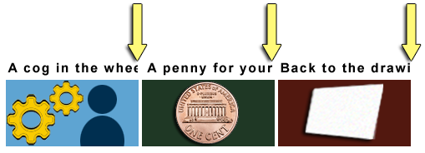
Text Overlap
In Figure 3, the last three words "Groups and Programs" of the text heading "Technologists Seeking Input from Groups and Programs" overlaps the sentence that follows. That sentence should read, "You are invited to share ideas and areas of interest related to the integration of technology from a group or program." But the words "You are invited to share ideas" are obscured and unreadable.
Figure 3: Overlapping text is a failure.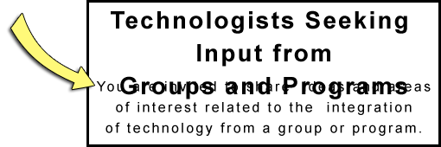
Fixed Text
Text fails the SC when it is fixed and cannot be overridden to comply with the Success Criterion's requirements.
Text that allows for overriding to the metrics passes this SC. Line height must be able to adapt to 1.5 times the font size. Letter spacing must be able to adapt to 0.12 times the font size. Word spacing must be able to adapt to 0.16 times the font size. Spacing underneath paragraphs must be able to adapt to 2 times the font size.
Figure 4: Absolutely fixed text is a failure. Adaptable text passes.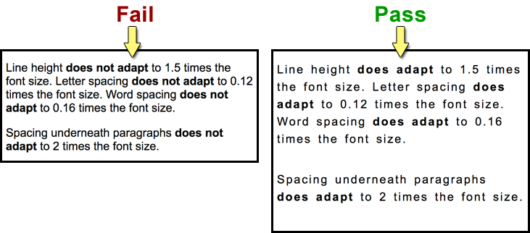
Benefits
- People with low vision who require increased spacing between lines, words, and letters are able to read text with greater ease.
- People with dyslexia may increase space between lines, words, and letters to increase reading speed.
- Although not required by this SC, white space between blocks of text can help people with cognitive disabilities discern sections and call out boxes.
Examples
- Text fits within the bounds of its containing box without being cut off.
- Text fits within the bounds of its containing box without overlapping other boxes.

End of Section EOWG is responsible for editing

EOWG will not be providing edits or content for the following sections
- Related Resources
- Techniques
  - Sufficient Techniques
  - Advisory Techniques
  - Failures
- Key Terms

