Developing Web Accessibility Presentations and Training:

Page 1: Overview

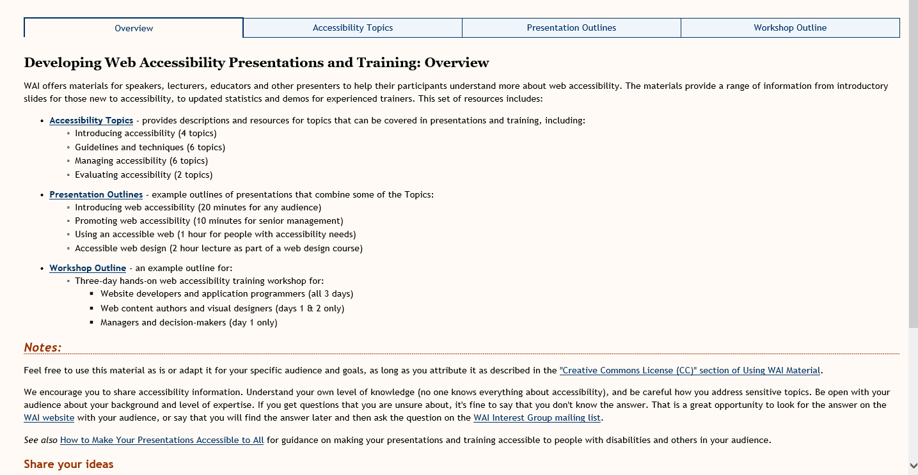

Vivienne’s Suggestions for Page 1

WAI offers materials to assist with communicating the importance of digital accessibility. These materials are suitable for all levels of presentations and include a wide range of topics. This set of resources includes:
Digital Accessibility Topics – provides descriptions and resources for topics that can be covered in presentations and training, including:
- Introduction to digital accessibility
- Understanding guidelines and techniques
- Managing accessibility within an organisation
- Evaluating accessibility of resources
Presentation Outlines - example presentation outlines for:
- Introducing web accessibility
- Promoting web accessibility
- Using an accessible web
- Accessible web design
Workshop Outline – an example outline for a three-day digital accessibility training workshop suitable for:
- Digital developers (all 3 days)
- Content authors and designers (days 1&2)
- Managers and decision-makers (day 1 only)
Notes:
Feel free to use this material as is or adapt it for your specific audience and goals, as long as you attribute it as described in the "Creative Commons License (CC)" section of Using WAI Material.
We encourage you to share accessibility information. Some pointers on sharing:
- Understand your own level of knowledge (no one knows everything about accessibility)
- Be careful how you address sensitive topics.
- Be open with your audience about your background and level of expertise.
- If you get questions that you are unsure about, it's fine to say that you don't know the answer. That is a great opportunity to look for the answer on the WAI website with your audience, or say that you will find the answer later and then ask the question on the WAI Interest Group mailing list.
See also How to Make Your Presentations Accessible to All for guidance on making your presentations and training accessible to people with disabilities and others in your audience.
Share your ideas

Shawn’s ideas:
Add links to new resources:
- Perspectives videos
- Tutorials
- Tips for getting started
- WCAG-EM & report tool
Updating resource titles e.g.
“preliminary review of websites for accessibility” to “Easy checks – a first review of web accessibility”

Notes from discussion with Brent:
Deleting:
References to out of date material e.g. https://www.w3.org/talks/wai-intro
Fix broken links and non-existent targets e.g.
https://validator.w3.org/checklink?url-https://www.w3.org/wai/training/topics
cc emails to: public-eo-develop=training@w3.org or public-eo-archive@w3.org

Page 2 - Topics for Web Accessibility Presentations and Training
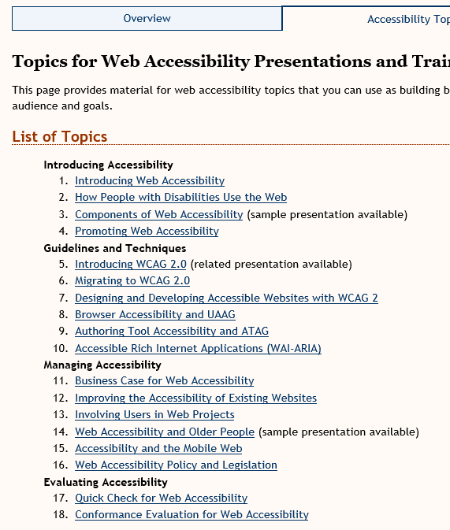

Vivienne’s Thoughts on this resource
- Topics are in dire need of updating
- We will want to make sure that the list of resources and materials is updated in accordance with what will be on the new website
- Does not reflect the work being done on WCAG 2.1 and Silver – need to replace 5&6
- Does not reference the tutorials or videos
- Needs to reference mobile techniques
- Needs to reference non-ICT guidelines
- 17&18 – needs to reference the WCAG-EM and sample WCAG-EM reporting tool
- Each link will need checking against the resources that are being kept on the new website and make sure the links are correct and updated
- Doesn’t reference how to use Easy Checks or BAD

Topics for Digital Accessibility Presentations and Training
(note that I’m suggesting changing Web to Digital)

Topics: (these are all in-page links which lead to a huge number of other links)

Introducing Accessibility (Do we want to change this name?)

Topic 1: Introducing Web Accessibility (suggest a name change to Digital Accessibility)
‘Description’ and ‘What this topic covers’ are probably okay for now
‘Primary Resources’ – these links are from a variety of sources on the W3C site and have all manner of different styles
- Accessibility goes to: https://www.w3.org/standards/webdesign/accessibility and is on the main W3C site, not to a WAI resource
- Introduction to Web Accessibility – goes to a page not updated since September 2005 – the page is heavy with links and much of it will need to be re-written as there is no mention of WCAG-EM and techniques since produced
- Online Overview of the Web Accessibility Initiative – goes to: https://www.w3.org/Talks/WAI-Intro/ and this resource was late updated in 2005 and there is a note at the top of the page that some of the information is outdated (very) – directs people to the WAI Home page
- All of the 4 links under that sub-heading point to different pages of that same resource and is very outdated
- Web Accessibility for Older Users presentation - Not updated since 2010
Refers to the WAI-AGE project and contains information for a presentation which is probably very outdated
Web Accessibility for Older Users Presentation – points to https://www.w3.org/WAI/presentations/ageing/waiage#demog which is a draft of a presentation created in 2010 and either needs to be updated or removed completely
- How People with disabilities use the web – updated May 2017 and is fine to leave as is
- WAI Guidelines for addressing different components – points to a part of the page on ‘essential components of web accessibility’ which was updated August 2005 with a ‘permission note added May 2016’ – no idea what that means. – the part of the page it refers to seems okay, but its destination from this link is rather obscure – why are we pointing to this, and is it appropriate in this setting?
- Participating in WAI – should be fine to leave – minor updated completed in May 20
‘Handouts’ – points to https://www.w3.org/WAI/flyer/#glance which is confusing and probably seldom used. It was last updated in 2009. For instance, the first one is a WAI Handout from 2007 updated in 2008: https://www.w3.org/WAI/flyer/handout2007a
‘Suggestions for Speakers’ – points to
First link – How people with disabilities use the web: overview – points to the new resource which is fine – updated May 2017
2nd link – Demonstration – points to an old resource “Just ask: integrating accessibility throughout Design 2nd edition draft) which is a draft from 2011 and has sponsor logos, not looking like a WAI material
http://www.uiaccess.com/accessucd/resources_videos.html

Summary: -
I think we need to re-think the inclusion of most of the material under these Primary Resources – many are very out of date, point to resources with various styles and not easily recognisable as WAI material. We could replace them with the Perspectives Videos and other WAI resources.

Topic 2: How People with Disabilities Use the Web
Goal, Description and What this topic covers are all fine
Primary resources – once again points to ‘How People with Disabilities use the web’ which is current and fine. Suggest it should also include the videos.
Additional Resources:
- Overview of WAI – also points to a set of slides from 2005 – outdated – as per previous link https://www.w3.org/Talks/WAI-Intro/
- Web Accessibility for Older Users presentation – also referred to in previous material – 2010 and needs updating https://www.w3.org/WAI/presentations/ageing/
- Essential components – as above – updated 2005 with permission note May 2016 - https://www.w3.org/WAI/intro/components.php
- Better Web Browsing : Tips for configuring Your computer – very outdated – 2010 – refers to ability to configure browsers etc. which have all changed significantly
Handouts:
- WAI Web Accessibility Resources – outdated 2009 - https://www.w3.org/WAI/flyer/#resources
- WCAG 2.0 at a Glance - https://www.w3.org/WAI/flyer/#glance – outdated 2009 and link should be replaced with Quick Ref resource
Suggestions for speakers
- Should reference new perspectives videos instead of the old videos http://www.uiaccess.com/accessucd/resources_videos.html

Topic 3: Components of Web Accessibility
Goal is okay
Audience – needs to be expanded and probably remove ‘ICT departments’ – check out the new WIKI page Shadi and I worked on for possible users
Description – needs to be expanded to included non-ICT
Resources:
- Instructions for the “components of Web Accessibility” presentation and step by step guide https://www.w3.org/WAI/presentations/components/ - outdated – 2009
- This resource is describing how to use an old presentation – probably should be removed as the presentation is too old
- How people with disabilities use the web – covered previously
- WCAG overview – material is fine and current – however should contain notes about upcoming 2.1 and Silver
- ATAG Overview – updated 2015 and should be mainly okay but will need to be reviewed quickly
- UAAG Overview – updated 2016 – should be okay, but again should be checked
- WAI ARIA Overview – updated 2016 and should be okay but needs to be checked

Topic 4: Promoting Web Accessibility
Goal – okay
Audience – I think this is too limited – perhaps see that Wiki page Shadi & I worked on
Description – I think this could be improved
What this topic covers – don’t really like the first point – seems likely to scare rather than encourage – maybe just delete this one

Primary Resources:
- Contacting organisations – https://www.w3.org/WAI/users/inaccessible - good updated July 2017
- Why standards harmonization is essential to web accessibility: https://www.w3.org/WAI/Policy/harmon - outdated - published October 2002 and minor update 2011 – very text heavy and unattractive. If we keep this, it should be more in a bullet-point style or short statements followed by brief descriptions
- How WAI Develops Accessibility Guidelines through the W3C Process… http://www.w3.org/WAI/intro/w3c-process - not altered since 2008 – may be okay to keep if the process hasn’t changed, but needs updated including info on WCAG 2.1 and Silver, also needs info on non-ICT and ARIA
- WAI Working Groups and Interest Groups - https://www.w3.org/WAI/groups - should be okay – updated March 2017 (note strange $ sign before and after Shawn’s name at the bottom)
- Using logos - https://www.w3.org/WAI/WCAG2-Conformance - this was modified in 2016, but needs work – strange $ signs at the top of the page. Should also contain references to WCAG-EM – not sure if all of the information on this page is current?
Additional Resources:
- Translating WAI Documents - https://www.w3.org/WAI/translation - not updated since August 2011 – needs to be thoroughly checked – there are links on this page to outdated documents mentioned above
- Developing organizational policies… - https://www.w3.org/WAI/impl/pol - updated May 2016, but published 2002 – will need to be re-checked.
Handouts:
- WAI Web Accessibility Resources – outdated https://www.w3.org/WAI/flyer/#resources last up-dated February 2009
- WCAG 2.0 at a glance – to be replaced with Quick Ref page.

Topic 5: Introducing WCAG 2.0 (suggest changing the name to ‘Understanding WCAG 2.0’
Goal – fine
Audience – can be expanded to include a better description as this sounds too limited
Description – okay, but should be expanded as it’s not use the use of WCAG 2.0 for developing, but also for assessment and meeting at least minimum compliance
What this topic covers – okay except for the last part which is unclear – the gateway?
Sample Presentation – probably remove as it is very outdated – updated August 2010 https://www.w3.org/WAI/presentations/WCAG20_benefits/

Primary Resources:
- Overview – okay – updated March 2017 – but could provide more info on the progress of 2.1 which is mentioned and also Silver
- Understanding the 4 principles of accessibility – link to this part of the ‘Understanding’ document – okay https://www.w3.org/TR/UNDERSTANDING-WCAG20/intro#introduction-fourprincs-head
- The WCAG 2.0 documents - https://www.w3.org/WAI/intro/wcag20 - okay but could use up-dating – first published July 2005, updated 2008, so look is quite dated, however the material should be mainly okay
- How to meet: https://www.w3.org/WAI/WCAG20/quickref/ - leads to the quickref (by the way, this doesn’t have an update date that I could see)
Additional Resources
- WCAG 2.0 – link to full 2.0 document spec
- Understanding WCAG 2.0 – okay – link correct to 2016
- Techniques – okay – link correct to 2016
Handouts
- WCAG 2.0 at a glance - https://www.w3.org/WAI/flyer/#glance leads to 2009 resource, but should perhaps be to the quickref – but that isn’t a handout – consider removing this link
- WAI Web Accessibility Resources – points to old WAI handouts and flyer https://www.w3.org/WAI/flyer/#resources – very outdated – last update February 2009 – includes many links to handouts that may be okay, but are for printing in different formats and sizes. Many are in PDF and as brief posters are okay, but branding and format probably need updating. E.g. https://www.w3.org/WAI/flyer/#resources
Suggestions for speakers
- Demonstration: this doesn’t really provide any meaningful information but points to the How to Meet WCAG 2.0 document – suggest removing this or providing something more helpful such as the Perspectives videos.

Topic 6: Migrating to WCAG 2.0
– suggest removing this completely – migrating from what – 1.0 or from no standard at all? – could eventually replace this with Migrating to or Incorporating WCAG 2.1

Topic 7: Designing and Developing Accessible Websites with WCAG 2
Goal – expand - not just for developers but for any stakeholders in a development team – designers, users, management

Description – ok

Primary Resources – these have been discussed above except the ‘benefits’ link – this is outdated – updated in 2010 and needs to be information needs to be more relevant

Additional Resources:
- Improving the Accessibility of your web site: https://www.w3.org/WAI/impl/improving - looks okay, but links all need to be checked – updated in November 2016
- Implementation Plan for Web Accessibility - https://www.w3.org/WAI/impl/ I think this is the material that is already scheduled for inclusion on the new website as it has the ‘initiate, plan, implement and sustain’ sections. Updated March 2016

Handouts
- WCAG 2.0 at a glance – updated 2011 – okay but print versions are only in PDF
- Including people with disabilities in design studies – points to a section in 2009 update of https://www.w3.org/WAI/flyer/#pwds and is a selection of links to be printed – probably too outdated to use

Topic 8: Browser Accessibility and UAAG
Goal – could be re-worded to make it more relevant

Audience – okay, but not too inviting

Description – okay

What it covers – okay – however UAAG 2.0 2was shown as a ‘mature draft’ and this has probably changed? – updated needed here.

Sample Presentation – link to a previous presentation mentioned above – very old (2009) and in drastic need of updating if we’re to keep it at all
Primary resources
- UAAG Overview – okay – updated 2016
- UAAG Guidelines – link is incorrect – says draft, but this has been updated to the Working Group note December 2015
- UAAG Guidelines 1.0 – this is the 2002 document and should be removed
- Table of checkpoints for UAAG – ‘document not found’ – remove link
- Better web browsing tips - https://www.w3.org/WAI/users/browsing - must be updated – last update 2010 – all browsers and links will have changed
Handouts
- WAI Web Accessibility Handouts - https://www.w3.org/WAI/flyer/#resources – another link to an outdated resource mentioned above – last update 2009
Tips for speakers – all need to be updated and new links provided – suggest pointing to the tutorials and also the perspectives videos.

TOPIC 9 – Authoring tool accessibility and ATAG – updated February 2013

Goal: think it should say what an ‘authoring tool’ is – maybe move the explanation from the ‘description’ section below and put it here at the top
Audience: probably okay
Description: take out description of what an authoring tool is, and move that to the top. Refers to topic 3 as well – perhaps that is a bit circular?
What this topic covers: top part is okay. The note mentions that ATAG 2.0 is a ‘mature draft’, but it is now a W3C recommendation – this needs to be changed. The link to the ATAG Versions states this change, but the comment here needs to be updated.
Resources for developing a presentation:
Sample presentation – points to the ‘components of web accessibility presentation’ which is an outdated 2009 document
Primary resources:
- Essential components of web accessibility – updated 2005 but permission note for 2016
- How people with disabilities use the web – good – updated may 2017
- WCAG overview – good – updated 2017
- ATAG overview – updated 2015 and should e okay but status of documents needs to be checked for any changes.
- UAAG overview – should be okay – updated 2016
- WAI ARIA overview – updated 2016, but the status of various documents here need to be checked to make sure it is correct
Handouts:
- WAI Web Accessibility Resources – outdated document referred to previously – late updated 2009
- WCAG 2 at a glance – points to old resources, but need to check to see if there has been a handout version of the Quick Ref document prepared or if this material is still correct. In any case, the look is outdated and it should be refreshed.
Suggestions for speakers:
- Might be okay, but should be reviewed.

Topic 10 – Accessible Rich Internet Applications (WAI-ARIA)
Goal: as per topic 9 – it is an issue when you refer to something without an explanation, but provide that explanation further down the resource.
Audience: ok
Description: doesn’t seem adequate to me. E.g. why would I need to use ARIA rather than other techniques? This might not be the place for an explanation, but it just occurs to me that it isn’t sufficiently descriptive. Maybe just provide a note to the ARIA Overview rather than attempting the explanation here. There is a link to the ARIA overview further down, so this could perhaps be moved p.
What this topic covers: need definition of what ‘rich’ means in this context as this would be confusing to the new user. The rest of this seems okay.
Resources for developing a presentation
Primary resources:
- WAI-ARIA Overview – updated 2016 – should be okay – but is really text-heavy – there is a note about WAI-ARIA 1.1 coming and I’m not sure if that has happened yet – need to check
- Draft WAI-ARIA – authoring practices 1.0 – link shows it was still a draft 28 June 2017
- Draft – WAI-ARIA Primer – working draft as of 14 July 2016 – progress?
- WAI-ARIA-FAQ – remove the word FAQ as I don’t think this is recommended now. There are some comments in this resource that need updating e.g. “WAI-ARIA is already supported in several browsers and assistive technologies (even though it is not finalized yet) that need to be updated – as the resource is dated January 2016
- WAI-ARIA and scripting techniques from ‘how to meet WCAG 2.0’ points to the Quick Ref and so this link should be renamed
Suggestions for speakers: needs to be updated a bit as it mentions ‘incomplete support and other open issues that will be resolved when WAI-ARIA is completed’ – it is completed, isn’t it?

Topic 11 – Business Case for Web accessibility
Goal: could be expanded – maybe more assertive – there is a business case for accessibility – bandwidth, customer support reduction etc. etc.
Audience: seems okay
What this topic covers: seems okay
Resources for developing a presentation:
Primary resources:
- Developing a Web Accessibility Business Case…not updated since 2012 and originally from 2005. Probably needs an overhaul
- Resources for developing a web accessibility business case for your organisation including: as above – there are quite a few statistics that would be very outdated. E.g. percentage of people with disabilities, market for AT et.
  - Case studies of accessibility improvements – 3 links here, and they are all very outdated – if we’re using case studies, they should be more current – these are 2007, 2004, and 2009. It would also be good to get a variety of countries represented – this look like 2 from UK and 1 from US
  - Statistics on people with disabilities and web use – these need to be replaced with current links – these are all quite old
  - Accessibility improving SEO – 2 links here – first is SEO & accessibility overlap – (link is broken/not found), and the second ‘the ultimate SEO Guide for 2009’ is rather outdated – need to find a new reference
  - Example for ROI calculations – this could be updated, as this is a 2005 reference
  - Cautionary Tales of Inaccessibility – add the Coles case (as discussed with Shadi) for an Australian context, and add some reference to the Winn-Dixie (relates to using inaccessible third-party content) and some of the university court cases (for the educational context) – checked the link to the BBC News link and this is still active
- Overview of WAI Presentation, in particular: - this is a link to the slide presentation mentioned previously – late updated in 2005 and is out of date. Note at the top says to go to the WAI home page for current information – following 2 links are also from that resource
  - Web accessibility is a marketplace issue
  - Accessibility contributes to universal design
- Web Accessibility for older users’ presentation, in particular: - needs to be updated – last update 2010 and the following 2 links also go to that resource
  - Changing demographics
  - Hanging abilities of older people
- Policies relating to web accessibility – link to current resource that others are updating
- Developing organisational policies on web accessibility – updated May 2016 – content should be okay.
Additional Resources: link to “Web Content Accessibility and Mobile Web Making a web site accessible both for people…” – note that the top that it was developed in 2008 and ‘most of it is still relevant’, but we’d need to see which parts are not, and amend them. – refers people to the mobile link: www.w3.org/WAI/mobile/

Topic 12 – Improving the accessibility of existing websites
Goal- needs to be extended – probably not just for organisations, but for developers and also for evaluators and accessibility professionals
Audience - needs to be broadened as well
Description: needs to be re-written as it sounds rather cumbersome
What this topic covers: seems okay
Resources for developing a presentation:
Primary resources:
- Improving the Accessibility of Your Web Site – updated November 2016 – seems okay
- Implementation Plan for Web Accessibility – updated March 2016 – seems okay
- Preliminary Review of Web Sites for Accessibility – is actually Easy Checks – very current resource – suggest changing the name in the link
- Conformance Evaluation of Web Sites for Accessibility – points to WCAG-EM Overview with links to WCAG-EM and the reporting tool – very current – updated 2016
Suggestions for speakers: - seems okay but need to check the links

Topic 13 Involving Users in Web Projects

Goal: need to re-write as the grammar doesn’t seem write
Audience: might be expanded
What this topic covers: seems okay, but could possibly be expanded
Resources for developing a presentation
Primary Resources
- Involving Users in Web Projects for Better, Easier Accessibility – very old resource – last update April 2010 – there are links to other documents and standards and these will need to be updated – there is one line in yellow highlighting which seems out of place
- Involving Users in Evaluating Web Accessibility – last update August 2010 – needs updating. There are also lots of links to associated content which all need checking
- How People with Disabilities use the Web – current content – May 2017
Handouts: Including people with disabilities in design studies – late update 2009 – link to various resources in handout formats – but all PDF or RTF – they would probably all need updating
Suggestions for speakers: note is okay but limited

TOPIC 14 – Web Accessibility and Older People
Goal: I would prefer to amend this goal a little to incorporate the idea of the aging population, and the growing need to address this segment’s needs.
Audience: okay
Description: okay
What this topic covers: okay
Resources for developing a presentation
Sample presentation: Web Accessibility for Older Users presentation – last updated September 2010 – probably outdated as it introduces and reference the WAI-AGE project and a link to a literature review from 2008 – this presentation will probably need to be re-developed to reflect current statistics
Primary Resources:
- Web Accessibility and Older People: Meeting the Needs of Ageing Web Users – updated 2010 – needs to be updated, particularly because it references the WAI-Age project
- Overview of "Web Accessibility for Older Users: A Literature Review" – last updated 2008 – references the WAI-AGE project. A literature review from 2008 may not have sufficient relevance including current research
- WAI-AGE Project – last update 2012 – note at the top that the project ended 30 September 2010, so this resource should probably b e removed. There is a link to the http://www.w3.org/WAI/older-users/ but as this was also updated in 2010, it is probably also in dire need of updating
Handouts: - WCAG 2 at a glance, which should be replaced with ‘quick ref’
Suggestions for speakers:
- Demonstration – says ‘show some videos…’ and a link, which could instead link to the perspectives videos – especially if there is one with older users (haven’t checked)
- Activity – show some simulations – that is okay, but a video would be good

TOPIC 15 – Accessibility and the mobile web

Goal: think this should be updated due to the fact that PWD are relying on mobile devices now
Audience: okay
Description: would prefer a re-write to incorporate the goal above
That this topic covers: this we might need to re-write this as it makes a greater differentiation between web and mobile that we are now seeing – to many users mobile is web, and this note makes a greater distinction – we are seeing a convergence so that whether people use a mobile device or a desk top device, they expect the same interaction and information
Resources for developing a presentation
Primary resources:
- Mobile Accessibility - summarizes existing and developing resources related to mobile accessibility – seems outdated as it is referencing WAI task forces etc. on mobile. – however, links to a 2017 source and also ‘potential new WCAG success criteria and techniques’ – is this information available, or is it coming in 2.1?
- Web Content Accessibility and Mobile Web: Making a Web Site Accessible Both for People with Disabilities and for Mobile Devices – the top of this page indicates to go to www.w3.org/WAI/mobile/ for more current information, so presume it would be better to have that as a target than this page which was last updated 2012
- Shared Web Experiences: Barriers Common to Mobile Device Users and People with Disabilities – note at the top says it was developed in 2008 and most is still relevant but to go to www.w3.org/WAI/mobile/ for more current information – so I’m not sure if should keep this or just the new resource?
- Relationship between Mobile Web Best Practices (MWBP) and Web Content Accessibility Guidelines (WCAG) - technical report describing the similarities and differences between the requirements in WCAG and MWBP – links to the Working Group note dated 2009 – is this still relevant?
- From MWBP to WCAG 2.0 (and From MWBP to WCAG 1.0) - outlines what also needs to be done to meet WCAG for those familiar with MWBP – again a working group note dated July 2009 – question whether this is still relevant
- From WCAG 2.0 to MWBP (and From WCAG 1.0 to MWBP) - outlines what also needs to be done to meet MWBP for those familiar with WCAG – same as above
- Mobile Web Best Practices 1.0 - technical report specifying Best Practices for delivering web content to mobile devices – this is probably outdated – 2008. Is there a replacement document for this??
- Mobile Web Application Best Practices – W3C recommendation December 2010 – is this still relevant?
Handouts –
- Mobile web best practices flipcards. – can’t see a date for this resource – don’t know how relevant it still is
- WCAG 2.0 at a glance – change to the quick ref link as this still goes to the old WCAG 2 at a glance resource
Suggestions for speakers:
- Discussion: refers to a resource: www.w3.org/WAI/mobile/experiences which compares different criteria to the MWBP document – check for currency and applicability
- Refers to the IndieUI document: updated 2014 – check for currency – not familiar with this document

TOPIC 16 – Web Accessibility Policy and Legislation
Goal: okay
Audience: okay
What this topic covers: okay
Resources for developing a presentation
Primary resources:
- Legal and Policy Factors in Developing a Web Accessibility Business Case for Your Organization - provides guidance on addressing legal and policy factors in a business case for Web accessibility – updated 2012 from a 2005 document. – seems okay, but links will need to be checked and updated – probably also best to replace some of them with more current material.
- UN Convention on the Rights of Persons with Disabilities (CRPD) - ratified by many countries and specifically includes accessibility of the Internet and other information and communications technology (ICT) – ‘page not found’ error
- International Policies Relating to Web Accessibility - links to laws and policies regarding Web accessibility around the world (not definitive) – updated 2017 – should be okay but I think others are working on this section?
- Why Standards Harmonization is Essential to Web Accessibility - explains the key role that harmonization of standards plays in increasing the accessibility of the Web – very text-heavy page published in 2002 with minor updates only in 2011 to just reflect change to WCAG 2.0 but no other changes – everything on this page needs to be reviewed due to its age
- Developing Organizational Policies on Web Accessibility - addresses considerations that can arise when developing organizational policies on Web accessibility – updated 2016 from a 2002 document. Should be okay if it was a full update, but this needs to be checked further
Suggestions for speakers: should be okay, but links need to be updated

TOPIC 17 – Quick Check for Web Accessibility
Goal: okay
Audience okay, but maybe include some examples e.g. an in-house developer who wants to see if what they are working meets requirements
Description: okay
What this topic covers: okay
Resources for developing a presentation
Primary Resources:
- Preliminary Review of Web Sites for Accessibility - describes a method to quickly identify some accessibility problems on a website – link leads to ‘Easy Checks’ so the link should probably be re-named to avoid confusion – content is fine and is already being looked at by group
- Selecting Web Accessibility Evaluation Tools - highlights different features of evaluation tools which can assist during evaluation reviews - not updated since 2005, but there are more current resources such as the list of automated tools – put in current resources here and remove this one
- Web Accessibility Evaluation Tools - filterable list of Web accessibility evaluation tools – this is the new 2016 resource which is regularly being updated and enables filtering
- Involving Users in Evaluating Web Accessibility - describes the benefits of evaluating with real people and identifying usability issues that are not discovered by conformance evaluation alone – referred to previously, last updated August 2010 and should be reviewed. There are lots of links here and they all need checking to ensure we are using the most current.
- Better Web Browsing: Tips for Configuring Your Computer - references to resources to help people customize their web browser and computer setup – still in Draft format, but dated 2010 – the page has dozens of links, and because of browser updates, all of these need to be reviewed.
Suggestions for speakers: okay, but could be updated to include more appealing activities

TOPIC 18 – Conformance Evaluation for Web Accessibility
Goal: I’m uncertain on this one – would everyone reading this know what a conformance review was? This might need clarification
What this topic covers: okay – but we should add understanding WCAG EM and the reporting tool
Resources for developing a presentation
Primary resources:
- Conformance Evaluation of Web Sites for Accessibility - describes a conformance evaluation method that combines automatic, semi-automatic, and manual testing – points to the launch page for WCAG-EM so the link should perhaps be renamed – material in the content of that page is fine though – updated 2016
- Evaluation Approaches for Specific Contexts - describes considerations for evaluation of large and complex websites – not updated since 2005, but it appears that it has had some work. However, the template is to WCAG 1.0 – so it seems like it has been partially updated, but the date not changed.
- Using Combined Expertise to Evaluate Web Accessibility - describes the diverse kinds of expertise and perspectives required to evaluate the accessibility of web content – not updated since 2002 – will need major re-write
- Selecting Web Accessibility Evaluation Tools - highlights different features of evaluation tools which can assist during evaluation reviews – not updated since 2005
- Web Accessibility Evaluation Tools - filterable list of Web accessibility evaluation tools – new resource – is fine
- How to Meet WCAG 2.0 - a customizable quick reference to WCAG 2.0 requirements and techniques – current resource with filters – fine as it is
- Involving Users in Evaluating Web Accessibility - describes the benefits from evaluating with real people and identifying usability issues that are not discovered by conformance evaluation alone – updated 2010 – will require an update
- Template for Accessibility Evaluation Reports (refers to WCAG 1.0, but applicable to WCAG 2.0); see also the reports from Before and After Demonstration – should also refer to WCAG-EM – due to the date it needs a major update
- [Draft] Website Accessibility Conformance Evaluation Methodology 1.0 - a methodology for evaluating the conformance of websites to WCAG 2.0 – very outdated link, but this was finished in 2014 – this isn’t a draft, so the link name needs to be changed
Handouts – to ‘Including people with disabilities in design studies’ link to old resource last updated 2009 – this handout isn’t appropriate and needs updating
Suggestions for speakers: activity points to the Before/After demo, activity also okay, and tip. However, I think we can provide more interesting-sounding activities. This is basically a copy of some of the others, and doesn’t really good sufficient direction for someone preparing a presentation.

Page 3 - Example Outlines for Web Accessibility Presentations

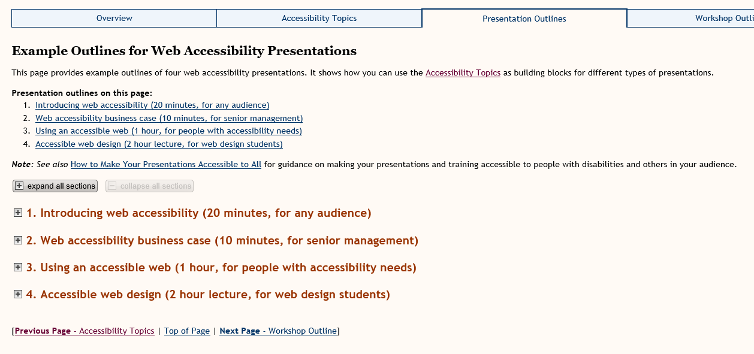

Vivienne’s comments:
- I don’t really like the layout of this page – it is just links and expanding menus and not very engaging
- IMHO none of these provide sufficient time or material to be of great benefit
- I can’t imagine anyone in senior management attending a 10-minute presentation, but perhaps that’s just my perspective
- We do a 45-minute introductory presentation with 15 minutes for Q&A (Learn at Lunchtime style) for these type of presentations, but perhaps others have a different experience

Page 4 Example Outline for a Web Accessibility Workshop

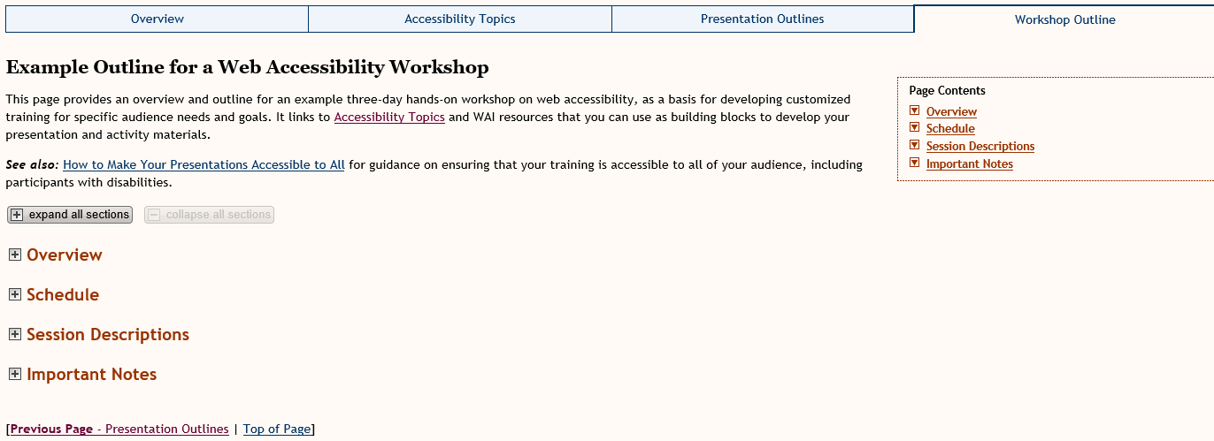

Vivienne’s comments:
- Sorry, but this page feels very much like the previous page
- The material included is good, but needs updating if we’re going to keep this resource
- Check all links and find out which ones are going to be kept on the new website
- This means that there are dependencies on other WAI materials before some of this is decided – we don’t know what other groups are keeping/changing/deleting
- I think the title might need the mention of ‘3-day’ so that they have a reason to open the expanding menus to see what is suggested for each day
- Some of the schedule may not work with the people suggested for each day. For example, would managers really want Session 4 on day 1 – Accessible content authoring? Or Accessible visual design and CSS?

