Developing Web Accessibility Presentations and Training:

Page 1:Overview

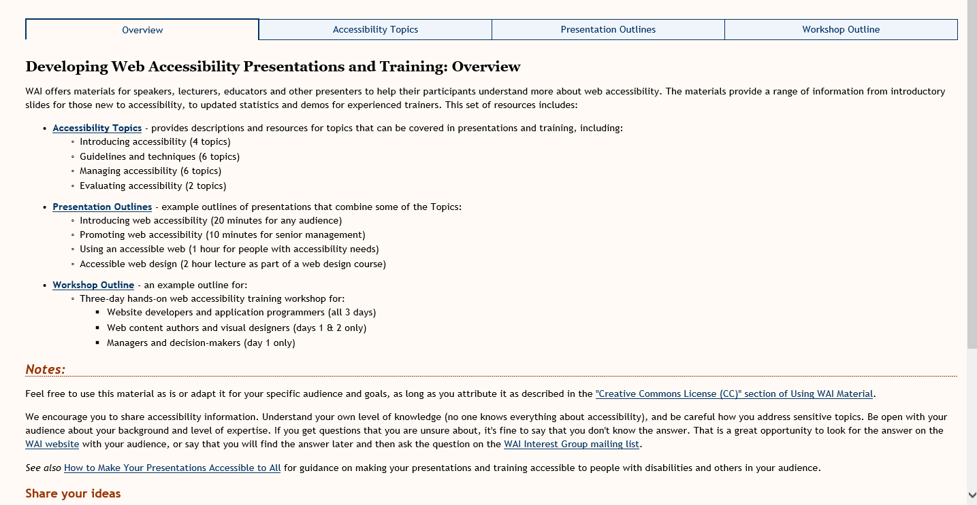

Vivienne’s Suggestions for Page 1

WAI offers materials to assist with communicating the importance of digital accessibility. These materials are suitable for all levels of presentations and include a wide range of topics. This set of resources includes:
Digital Accessibility Topics – provides descriptions and resources for topics that can be covered in presentations and training, including:
- Introduction to digital accessibility
- Understanding guidelines and techniques
- Managing accessibility within an organisation
- Evaluating accessibility of resources
Presentation Outlines - example presentation outlines for:
- Introducing web accessibility
- Promoting web accessibility
- Using an accessible web
- Accessible web design
Workshop Outline – an example outline for a three-day digital accessibility training workshop suitable for:
- Digital developers (all 3 days)
- Content authors and designers (days 1&2)
- Managers and decision-makers (day 1 only)
Notes:
Feel free to use this material as is or adapt it for your specific audience and goals, as long as you attribute it as described in the "Creative Commons License (CC)" section of Using WAI Material.
We encourage you to share accessibility information. Some pointers on sharing:
- Understand your own level of knowledge (no one knows everything about accessibility)
- Be careful how you address sensitive topics.
- Be open with your audience about your background and level of expertise.
- If you get questions that you are unsure about, it's fine to say that you don't know the answer. That is a great opportunity to look for the answer on the WAI website with your audience, or say that you will find the answer later and then ask the question on the WAI Interest Group mailing list.
See also How to Make Your Presentations Accessible to All for guidance on making your presentations and training accessible to people with disabilities and others in your audience.
Share your ideas

Shawn’s ideas:
Add links to new resources:
- Perspectives videos
- Tutorials
- Tips for getting started
- WCAG-EM & report tool
Updating resource titles e.g.
“preliminary review of websites for accessibility” to “Easy checks – a first review of web accessibility”

Notes from discussion with Brent:
Deleting:
References to out of date material e.g. https://www.w3.org/talks/wai-intro
Fix broken links and non-existent targets e.g.
https://validator.w3.org/checklink?url-https://www.w3.org/wai/training/topics
cc emails to: public-eo-develop=training@w3.org or public-eo-archive@w3.org

Page 2 - Topics for Web Accessibility Presentations and Training
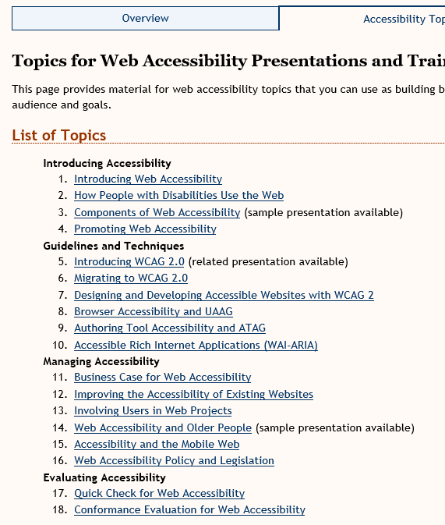

Vivienne’s Thoughts on this resource
- Topics are in dire need of updating
- We will want to make sure that the list of resources and materials is updated in accordance with what will be on the new website
- Does not reflect the work being done on WCAG 2.1 and Silver – need to replace 5&6
- Does not reference the tutorials or videos
- Needs to reference mobile techniques
- Needs to reference non-ICT guidelines
- 17&18 – needs to reference the WCAG-EM and sample WCAG-EM reporting tool
- Each link will need checking against the resources that are being kept on the new website and make sure the links are correct and updated
- Doesn’t reference how to use Easy Checks or BAD

Topics for Digital Accessibility Presentations and Training
(note that I’m suggesting changing Web to Digital)

Topics: (these are all in-page links which lead to a huge number of other links)

Introducing Accessibility (Do we want to change this name?)
- Introducing Web Accessibility (suggest a name change to Digital Accessibility)
‘Description’ and ‘What this topic covers’ are probably okay for now
‘Primary Resources’ – these links are from a variety of sources on the W3C site and have all manner of different styles
- Accessibility goes to: https://www.w3.org/standards/webdesign/accessibility and is on the main W3C site, not to a WAI resource
- Introduction to Web Accessibility – goes to a page not updated since September 2005 – the page is heavy with links and much of it will need to be re-written as there is no mention of WCAG-EM and techniques since produced
- Online Overview of the Web Accessibility Initiative – goes to: https://www.w3.org/Talks/WAI-Intro/ and this resource was late updated in 2005 and there is a note at the top of the page that some of the information is outdated (very) – directs people to the WAI Home page
- All of the 4 links under that sub-heading point to different pages of that same resource and is very outdated
- Web Accessibility for Older Users presentation - Not updated since 2010
Refers to the WAI-AGE project and contains information for a presentation which is probably very outdated
Web Accessibility for Older Users Presentation – points to https://www.w3.org/WAI/presentations/ageing/waiage#demog which is a draft of a presentation created in 2010 and either needs to be updated or removed completely
- How People with disabilities use the web – updated May 2017 and is fine to leave as is
- WAI Guidelines for addressing different components – points to a part of the page on ‘essential components of web accessibility’ which was updated August 2005 with a ‘permission note added May 2016’ – no idea what that means. – the part of the page it refers to seems okay, but its destination from this link is rather obscure – why are we pointing to this, and is it appropriate in this setting?
- Participating in WAI – should be fine to leave – minor updated completed in May 20
‘Handouts’ – points to https://www.w3.org/WAI/flyer/#glance which is confusing and probably seldom used. It was last updated in 2009. For instance, the first one is a WAI Handout from 2007 updated in 2008: https://www.w3.org/WAI/flyer/handout2007a
‘Suggestions for Speakers’ – points to
First link – How people with disabilities use the web: overview – points to the new resource which is fine – updated May 2017
2nd link – Demonstration – points to an old resource “Just ask: integrating accessibility throughout Design 2nd edition draft) which is a draft from 2011 and has sponsor logos, not looking like a WAI material
http://www.uiaccess.com/accessucd/resources_videos.html

Summary: -
I think we need to re-think the inclusion of most of the material under these Primary Resources – many are very out of date, point to resources with various styles and not easily recognisable as WAI material. We could replace them with the Perspectives Videos and other WAI resources.

- How People with Disabilities Use the Web
Goal, Description and What this topic covers are all fine
Primary resources – once again points to ‘How People with Disabilities use the web’ which is current and fine. Suggest it should also include the videos.
Additional Resources:
- Overview of WAI – also points to a set of slides from 2005 – outdated – as per previous link https://www.w3.org/Talks/WAI-Intro/
- Web Accessibility for Older Users presentation – also referred to in previous material – 2010 and needs updating https://www.w3.org/WAI/presentations/ageing/
- Essential components – as above – updated 2005 with permission note May 2016 - https://www.w3.org/WAI/intro/components.php
- Better Web Browsing : Tips for configuring Your computer – very outdated – 2010 – refers to ability to configure browsers etc. which have all changed significantly
Handouts:
- WAI Web Accessibility Resources – outdated 2009 - https://www.w3.org/WAI/flyer/#resources
- WCAG 2.0 at a Glance - https://www.w3.org/WAI/flyer/#glance – outdated 2009 and link should be replaced with Quick Ref resource
Suggestions for speakers
- Should reference new perspectives videos instead of the old videos http://www.uiaccess.com/accessucd/resources_videos.html

- Components of Web Accessibility
Goal is okay
Audience – needs to be expanded and probably remove ‘ICT departments’ – check out the new WIKI page Shadi and I worked on for possible users
Description – needs to be expanded to included non-ICT
Resources:
- Instructions for the “components of Web Accessibility” presentation and step by step guide https://www.w3.org/WAI/presentations/components/ - outdated – 2009
- This resource is describing how to use an old presentation – probably should be removed as the presentation is too old
- How people with disabilities use the web – covered previously
- WCAG overview – material is fine and current – however should contain notes about upcoming 2.1 and Silver
- ATAG Overview – updated 2015 and should be mainly okay but will need to be reviewed quickly
- UAAG Overview – updated 2016 – should be okay, but again should be checked
- WAI ARIA Overview – updated 2016 and should be okay but needs to be checked

- Promoting Web Accessibility
Goal – okay
Audience – I think this is too limited – perhaps see that Wiki page Shadi & I worked on
Description – I think this could be improved
What this topic covers – don’t really like the first point – seems likely to scare rather than encourage – maybe just delete this one

Primary Resources:
- Contacting organisations – https://www.w3.org/WAI/users/inaccessible - good updated July 2017
- Why standards harmonization is essential to web accessibility: https://www.w3.org/WAI/Policy/harmon - outdated - published October 2002 and minor update 2011 – very text heavy and unattractive. If we keep this, it should be more in a bullet-point style or short statements followed by brief descriptions
- How WAI Develops Accessibility Guidelines through the W3C Process… http://www.w3.org/WAI/intro/w3c-process - not altered since 2008 – may be okay to keep if the process hasn’t changed, but needs updated including info on WCAG 2.1 and Silver, also needs info on non-ICT and ARIA
- WAI Working Groups and Interest Groups - https://www.w3.org/WAI/groups - should be okay – updated March 2017 (note strange $ sign before and after Shawn’s name at the bottom)
- Using logos - https://www.w3.org/WAI/WCAG2-Conformance - this was modified in 2016, but needs work – strange $ signs at the top of the page. Should also contain references to WCAG-EM – not sure if all of the information on this page is current?
Additional Resources:
- Translating WAI Documents - https://www.w3.org/WAI/translation - not updated since August 2011 – needs to be thoroughly checked – there are links on this page to outdated documents mentioned above
- Developing organizational policies… - https://www.w3.org/WAI/impl/pol - updated May 2016, but published 2002 – will need to be re-checked.
Handouts:
- WAI Web Accessibility Resources – outdated https://www.w3.org/WAI/flyer/#resources last up-dated February 2009
- WCAG 2.0 at a glance – to be replaced with Quick Ref page.

- Introducing WCAG 2.0 (suggest changing the name to ‘Understanding WCAG 2.0’
Goal – fine
Audience – can be expanded to include a better description as this sounds too limited
Description – okay, but should be expanded as it’s not use the use of WCAG 2.0 for developing, but also for assessment and meeting at least minimum compliance
What this topic covers – okay except for the last part which is unclear – the gateway?
Sample Presentation – probably remove as it is very outdated – updated August 2010 https://www.w3.org/WAI/presentations/WCAG20_benefits/

Primary Resources:
- Overview – okay – updated March 2017 – but could provide more info on the progress of 2.1 which is mentioned and also Silver
- Understanding the 4 principles of accessibility – link to this part of the ‘Understanding’ document – okay https://www.w3.org/TR/UNDERSTANDING-WCAG20/intro#introduction-fourprincs-head
- The WCAG 2.0 documents - https://www.w3.org/WAI/intro/wcag20 - okay but could use up-dating – first published July 2005, updated 2008, so look is quite dated, however the material should be mainly okay
- How to meet: https://www.w3.org/WAI/WCAG20/quickref/ - leads to the quickref (by the way, this doesn’t have an update date that I could see)
Additional Resources
- WCAG 2.0 – link to full 2.0 document spec
- Understanding WCAG 2.0 – okay – link correct to 2016
- Techniques – okay – link correct to 2016
Handouts
- WCAG 2.0 at a glance - https://www.w3.org/WAI/flyer/#glance leads to 2009 resource, but should perhaps be to the quickref – but that isn’t a handout – consider removing this link
- WAI Web Accessibility Resources – points to old WAI handouts and flyer https://www.w3.org/WAI/flyer/#resources – very outdated – last update February 2009 – includes many links to handouts that may be okay, but are for printing in different formats and sizes. Many are in PDF and as brief posters are okay, but branding and format probably need updating. E.g. https://www.w3.org/WAI/flyer/#resources
Suggestions for speakers
- Demonstration: this doesn’t really provide any meaningful information but points to the How to Meet WCAG 2.0 document – suggest removing this or providing something more helpful such as the Perspectives videos.

- Migrating to WCAG 2.0 – suggest removing this completely – migrating from what – 1.0 or from no standard at all? – could eventually replace this with Migrating to or Incorporating WCAG 2.1
- Designing and Developing Accessible Websites with WCAG 2
- Goal – expand - not just for developers but for any stakeholders in a development team – designers, users, management
- Description – ok
Primary Resources – these have been discussed above except the ‘benefits’ link – this is outdated – updated in 2010 and needs to be information needs to be more relevant

Additional Resources:
- Improving the Accessibility of your web site: https://www.w3.org/WAI/impl/improving - looks okay, but links all need to be checked – updated in November 2016
- Implementation Plan for Web Accessibility - https://www.w3.org/WAI/impl/ I think this is the material that is already scheduled for inclusion on the new website as it has the ‘initiate, plan, implement and sustain’ sections. Updated March 2016

Handouts
- WCAG 2.0 at a glance – updated 2011 – okay but print versions are only in PDF
- Including people with disabilities in design studies – points to a section in 2009 update of https://www.w3.org/WAI/flyer/#pwds and is a selection of links to be printed – probably too outdated to use
- Browser Accessibility and UAAG
- Goal – could be re-worded to make it more relevant
- Audience – okay, but not too inviting
- Description – okay
- What it covers – okay – however UAAG 2.0 2was shown as a ‘mature draft’ and this has probably changed? – updated needed here.
- Sample Presentation – link to a previous presentation mentioned above – very old (2009) and in drastic need of updating if we’re to keep it at all
Primary resources
- UAAG Overview – okay – updated 2016
- UAAG Guidelines – link is incorrect – says draft, but this has been updated to the Working Group note December 2015
- UAAG Guidelines 1.0 – this is the 2002 document and should be removed
- Table of checkpoints for UAAG – ‘document not found’ – remove link
- Better web browsing tips - https://www.w3.org/WAI/users/browsing - must be updated – last update 2010 – all browsers and links will have changed
Handouts
- WAI Web Accessibility Handouts - https://www.w3.org/WAI/flyer/#resources – another link to an outdated resource mentioned above – last update 2009
Tips for speakers – all need to be updated and new links provided – suggest pointing to the tutorials and also the perspectives videos.

Page 3 - Example Outlines for Web Accessibility Presentations

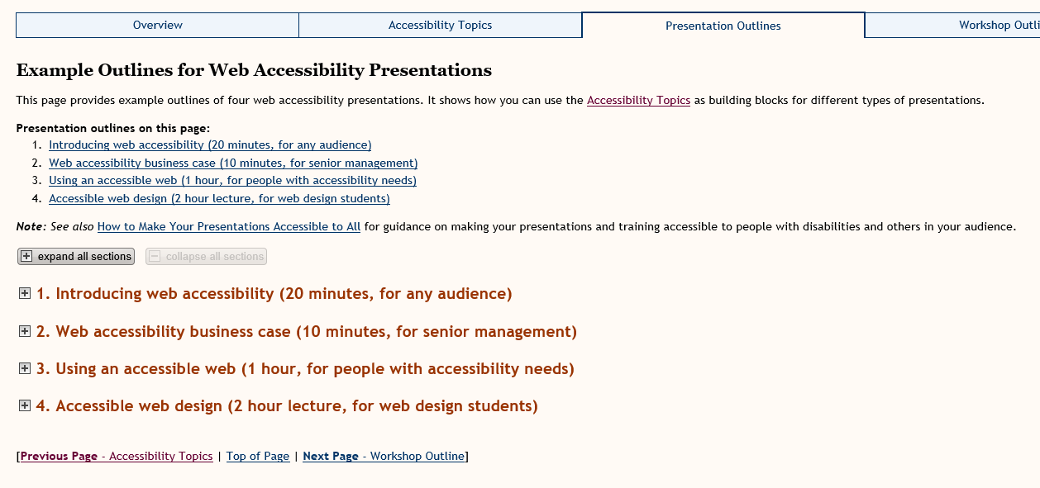

Vivienne’s comments:
- I don’t really like the layout of this page – it is just links and expanding menus and not very engaging
- IMHO none of these provide sufficient time or material to be of great benefit
- I can’t imagine anyone in senior management attending a 10-minute presentation, but perhaps that’s just my perspective
- We do a 45-minute introductory presentation with 15 minutes for Q&A (Learn at Lunchtime style) for these type of presentations, but perhaps others have a different experience

Page 4 Example Outline for a Web Accessibility Workshop

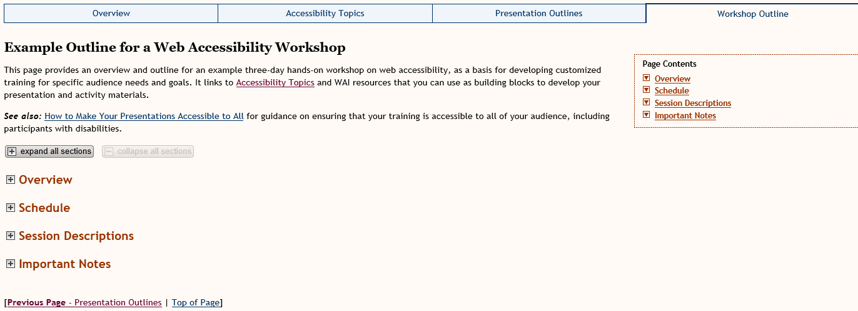

Vivienne’s comments:
- Sorry, but this page feels very much like the previous page
- The material included is good, but needs updating if we’re going to keep this resource
- Check all links and find out which ones are going to be kept on the new website
- This means that there are dependencies on other WAI materials before some of this is decided – we don’t know what other groups are keeping/changing/deleting
- I think the title might need the mention of ‘3-day’ so that they have a reason to open the expanding menus to see what is suggested for each day
- Some of the schedule may not work with the people suggested for each day. For example, would managers really want Session 4 on day 1 – Accessible content authoring? Or Accessible visual design and CSS?

