Instructions for Producing W3C CCG Documents
David W Chadwick Version 0.9 12 Dec 2017

1. Introduction
All master copies of W3C CCG documents are held in separate repositories in Github (https://github.com/w3c-ccg/<docname>). Editors must copy (or clone) onto their local computer the repository containing their document. Then on their local computer they must perform the following steps: create a new branch, edit the document using a text editor, save the edits, and commit the changes to their local Github. Finally the editor should push the update back to Github. Here are the steps in more detail.

2. Create (Clone) a local copy of the Github repository
These instructions are based on using the GitHub Desktop client. The Mac version was used for these instructions. The GitHub Desktop client can be downloaded from

https://desktop.github.com/

We assume the GitHub Desktop client is installed successfully and running on your computer. First you will need to login to Github using your username and password. Once logged in, you can clone the repository onto your computer as follows: select File>Clone Repository. The following screen should pop up:

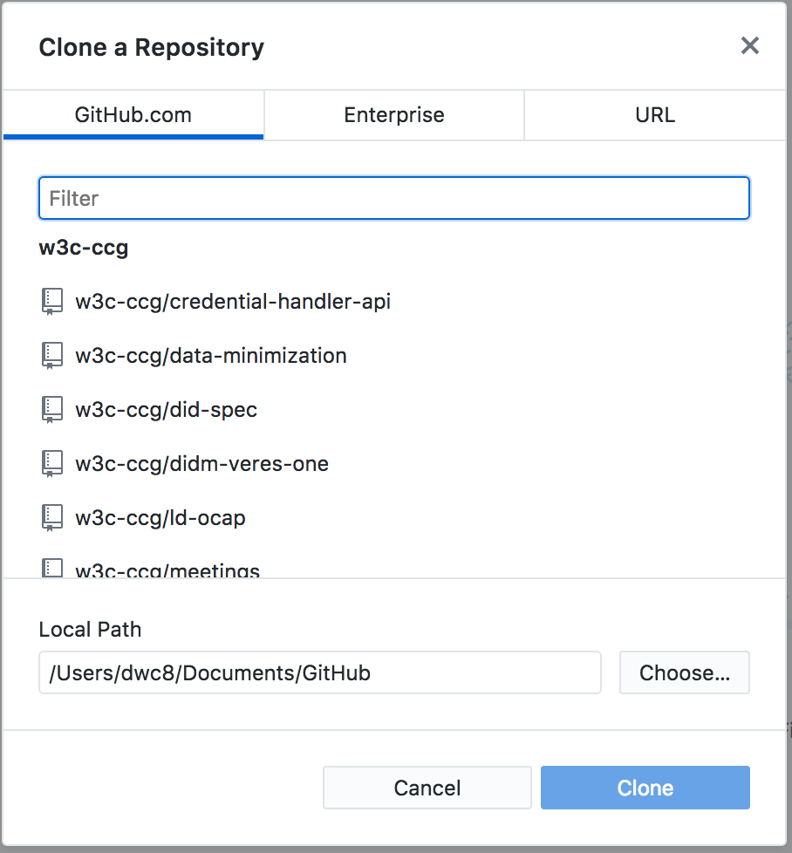

Note the Local Path where the repository will be stored on your computer. Select the w3c-ccg repository you want to clone and click Clone. In these instructions, w3c-ccg/vc-lifecycle has been used in the examples. If you go to your Local Path you should a directory with the name of your repository (e.g. vc-lifecycle) containing 5 files and a diagrams directory, as below:

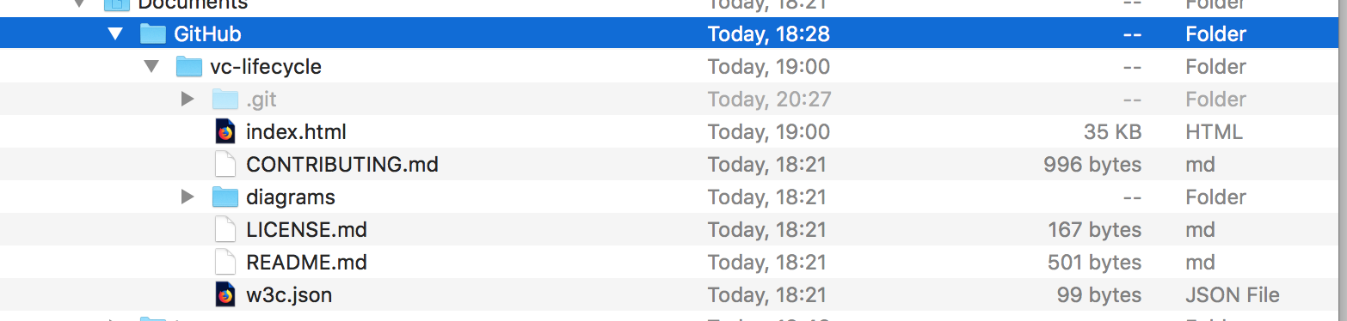

The index.html file is the one that contains the W3C document that you want to edit.

You should now open a browser on your computer, and
- navigate to the URL that shows the rendered version of the document you want to edit (in browser screen 1).
- You should then open file://<Local Path><Repository>/index.html (in browser screen 2). Screens 1 and 2 should be identical.
- You should also open a third browser screen showing the Github repository for your document e.g. https://github.com/w3c-ccg/vc-lifecycle

You are now ready to start the process of editing your document.

3. Edit your document
Your GitHub Desktop should look similar to the screen shot below.
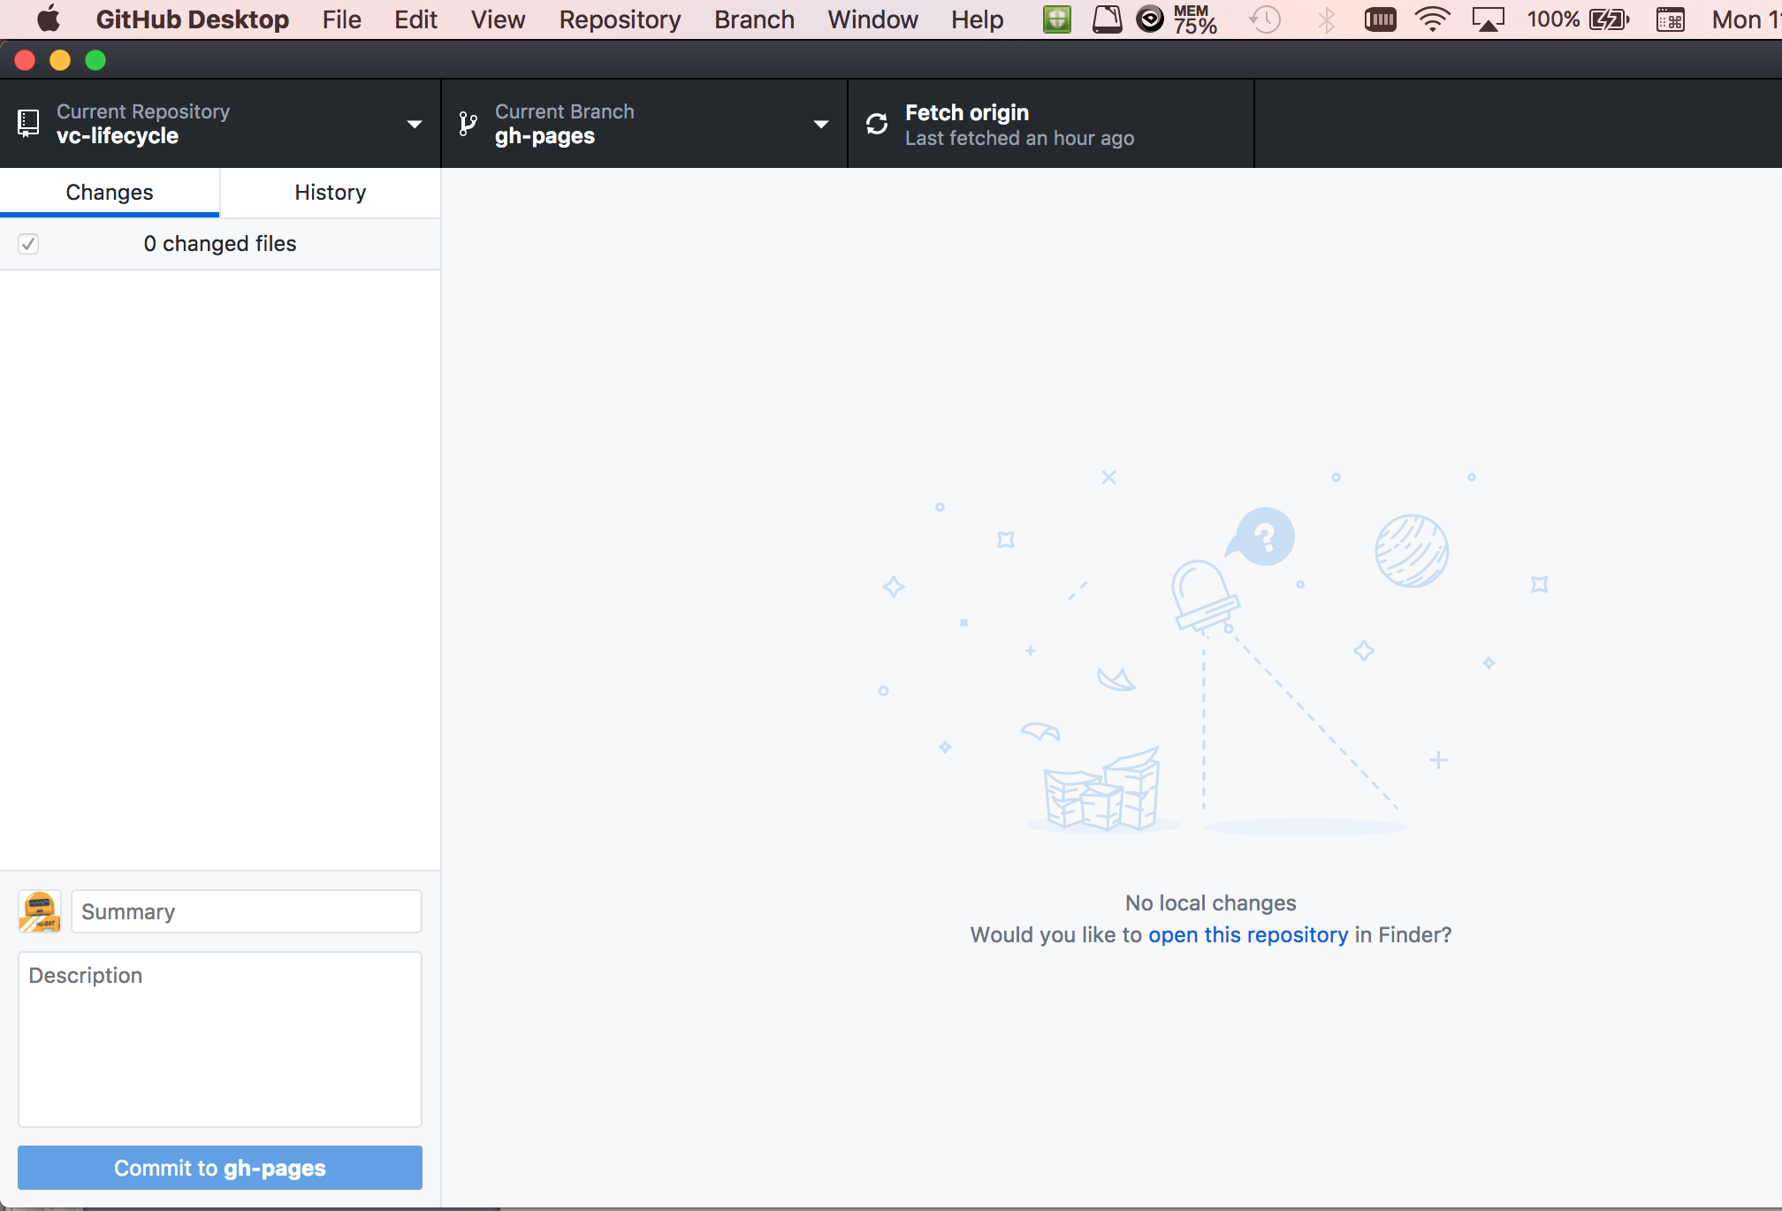

Things to note are: i) the Current Repository should be the one you want to edit, ii) the Current Branch should be gh-pages, and iii) Fetch origin should indicate when you last took a copy of the master repository onto your computer.
Click on Current Branch, then select New. The screen below should pop up.

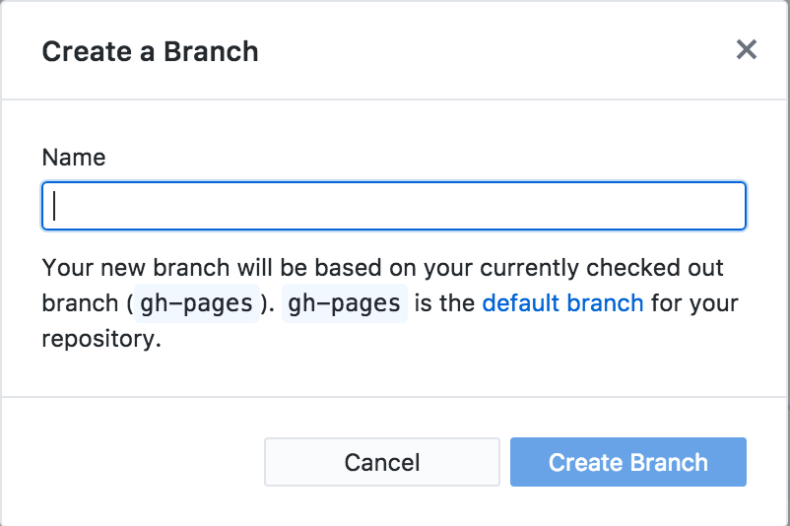

You should name the new Branch <YourSurname><SomethingMeaningful> that describes the edits that you want to make e.g. Chadwick-Fix-Section-Numbering. Then click Create Branch. The Current Branch should now change to the one you have just created.

Locate index.html on your local filesystem and open it in your favourite text editor. In the Apple Mac version of GitHub Desktop, this is made easy by clicking on ‘Would you like to open this repository in Finder?’

Make the edits you wish to make, taking care to keep the existing document layout and look and feel by following the existing HTML tag structure. In particular, make sure that:
- all text you add is kept to 75 characters or less per line
- HTML tags are kept separate on each line

Save your changes.

Now review the changes you have made in GitHub Desktop. It will show in red all the text you have deleted, and in green all the text you have added. Then review the changes in your browser screen 2 by refreshing the page file://…..

If you want to make further edits repeat the above instructions. Once you are happy with your edits, you are ready to commit them.

4. Commit your changes
In the Summary box of GitHub Desktop, say what edits you have made in a short sentence. Start with a command like Add, Delete, Modify etc. and end with a full stop. Your GitHub Desktop screen should now look something like the screen shot below:
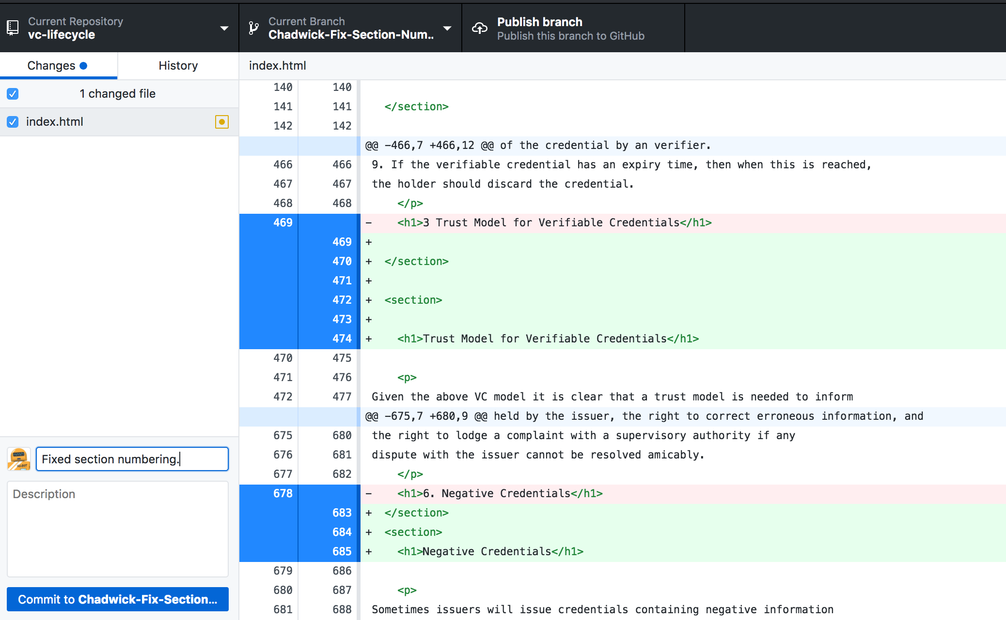

Click on ‘Commit to <Your Repository>’ at the bottom left hand side. This commits your changes to your local repository only. Your edits still have to be copied to the main repository, so click on Publish branch at the top right of centre. This copies your changes to the main Github repository, but they have not yet been accepted by it. So now go to your browser Github screen 3. It should like similar to the screen shot below:
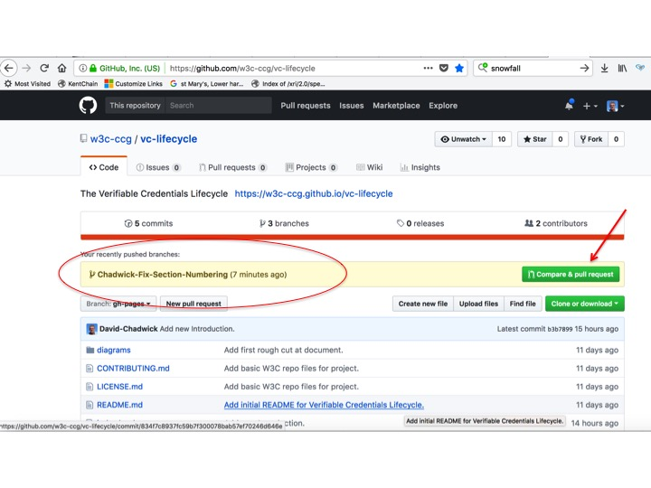
You will see that it shows you have recently pushed your new branch up to Github (shown in red circle). You should now issue a pull request to ask the CCG to accept your changes into the main document. Click on the green Compare and pull request (pointed to by red arrow). This will ‘Open a pull request’ window where you will see that the title of your pull request message to the CCG is the sentence that you typed into the Summary window of GitHub Desktop. You can now leave a comment to the CCG in the Write box if the Summary on its own is insufficient. Once you have completed your comment (if one was necessary, and you have reviewed it in the Preview window to check that it is formatted OK), click the green Create pull request button. A window similar to the one below should be displayed:

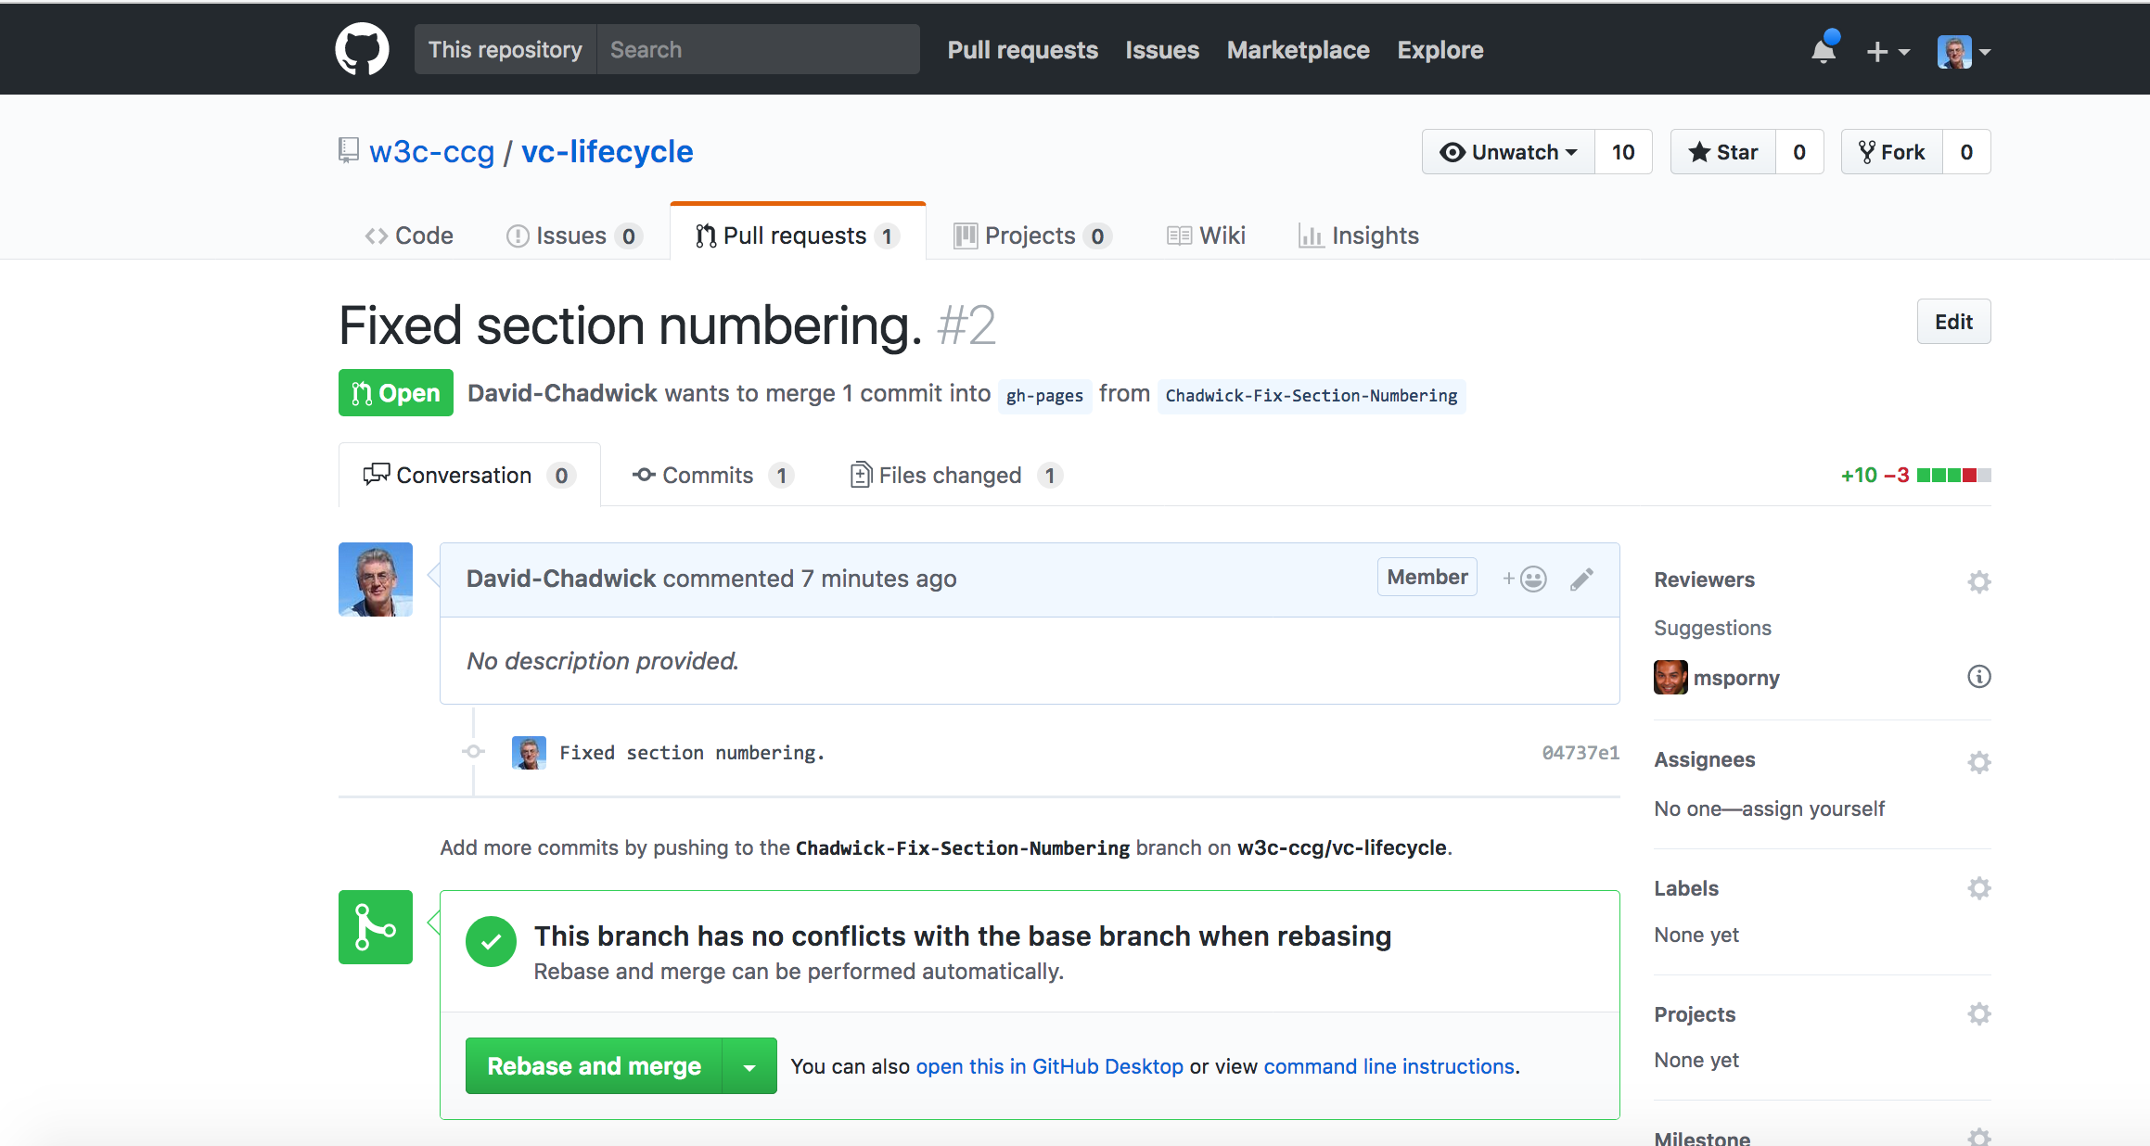

This shows that you have now issued a Pull request for your changes i.e. you are asking the CCG if you can pull your changes into the main document. Once enough CCG members respond to your Pull request with “LGTM” (Looks Good To Me), then you can click on Rebase and Merge which will pull your changes into the main W3C document.

Changes to Procedure for W3C VC WG Data Model document
You have to fork the repository before cloning it.

1. Click on FORK

2. Take a copy to your PC

3. Make the edits, then push up to your fork

