Credentials Community Group

Credentials Specification Roadmap

Project Background

Credentials and the Group Charter
A credential is a claim that represents a qualification, achievement, quality, or piece of information about an entity’s background such as a name, government ID, payment provider, home address, or university degree. The CG’s charter is to define standards necessary for secure, portable digital credentials as described here [link]

Range of Potential Uses
The use of a form of credentials to demonstrate capability, membership, status and minimum legal requirements is a practice as old as society itself. The potential use cases are innumerable, but four are represented here in the domains of:

- Education - where academic credentials are exchanged between institutions
- Workplace - where an applicant’s academic attainment is a condition for employment
- Civil Society - where access to social benefits and contracts may be based on marital status
- Payments - where the legal right to purchase a product depends on the verifiable age or location of the buyer.

Entities Involved
Each Credential-related transaction involves a number of entities. In order to make it clear who the actors are, the following roles are defined:

Credentialee - also known as the credential-owner, an entity that is in control of a particular credential. Typically a credentialee is also the primary subject of the information in a credential and is the entity that initiates the transmission of the credential.

Issuer - an entity that creates and assigns credentials to credentialees.

Requestor - an entity that requests a credential from an credentialee.

User agent - a program, such as a browser or other Web client, that mediates the communication between the credentialee and the requestor.

Credential Service - a program, such as a credential storage vault or personal credential wallet, that stores and protects access to an credentialee's credentials and can on request by the Credentialee provide secure access to Requestors.

Endorser - an entity, such as a witness, that provides assurances verifying a transaction.

High Level Overview
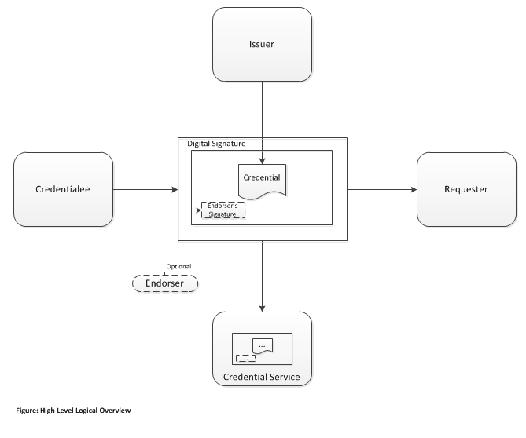

Specific Use Cases
Following are four domain specific use cases to provide examples of the standard’s applicability:

Education - A college student, Louisa has completed her first two academic years and wants to transfer to a four year university to continue her bachelor’s degree. Louisa is also in the job market and wants her future employers to see the skills she has learned. Rather than send paper or physical copies via email, Louisa provides secure, limited-time view access to her transcript and online portfolio to the college admissions department and the employer’s hiring official. Access is provided through Louisa’s sharing of a web link that addresses these resources securely and for a duration that she controls. Completely decentralized and private, Louisa can share her credentials from multiple institutions and issuing organizations in one single, secure and digitally-signed transaction.

Workplace - A hospital would like to ensure that a prospective employee is licensed to practice medicine in their state as well as having up-to-date certificates related to areas of specialization.

Civil Society - Marisol and Harpreet get married and are issued a marriage credential digitally signed by the presiding official and the witness, in that order. The marriage certificate is issued by the marriage official and then counter-signed by the witness.

Payments - Roxy visits the FineWines.com website and selects a number of wines to purchase. The website requests a proof-of-age and shipping address credential from Roxy. Roxy's credential service (IronVaultCorp) delivers both credentials, allowing her to finalize the transaction.

Development Plans

Leveraging Existing Standards
The Credentials Community Group seeks to build upon relevant prior work to simplify and speed adoption of its work products. Specifically, this standard relies on the following existing standards:
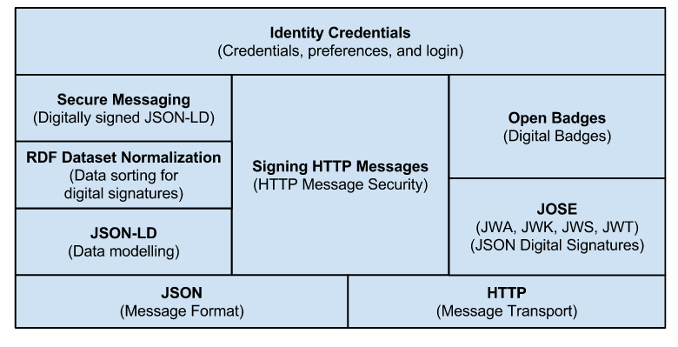

Creating the Credentials Specification
Following are the planned high level activities to create the Credentials specification:
- Activity One
- ...

Important Supporting Activities
In addition to the central specification development, the following additional activities will be performed:
- Creation of supporting software libraries
- Developing demonstration concepts needed for project success
...

Known Issues to be Resolved
The community group has identified the following issues to be addressed during the project:
(Issue “handle” and brief description)

Timeline Targets
Goal Status

Goal for Developing Specification:
Task mm/yy
Task mm/yy
Task mm/yy

Goal for Completing Supporting Activities:
Task mm/yy
Task mm/yy

Goal to Resolve Open Issues:
Issue handle
Issue handle

The Credentials Vocabulary
[This is a machine-readable and human-readable glossary and set of definitions. Example here: https://web-payments.org/specs/source/vocabs/security.html]

