Problems with Java Script when specified colours are over-ridden in Firefox

All the screen shots are, first one in the colours the site dictates, the second one with the preset colours over-ridden so that the page is picking up my preferences.

Google maps

Normally, as I’m only looking at the picture of the map, I don’t bother over-ridding the page, but when the colour is ignored, there are issues.

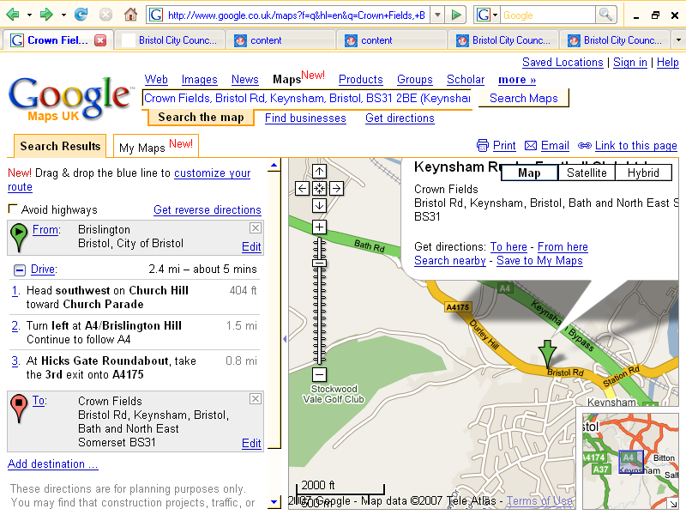

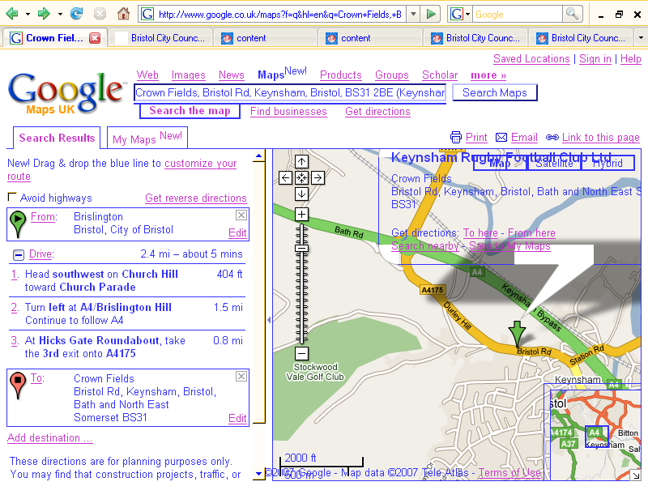

Bedfordshire Libraries:

This is the left hand navigation.




Professional Association of Teachers - http://www.pat.org.uk/.

The left hand menus slide in and out over each other. Trying to capture them in mid-slide is difficult, so it’s probably better to give it a go yourself.

If I disable the Java Scripting, then simply click on the link in the left hand navigation, the page it takes me to, does not give me the same options as there are in the slide out menu, so this is not a ‘reasonable adjustment’.

I’ve used the same colour combinations as before, but this time, because of the sliding effect, the second one, ie in ‘forced’ colours, is truly dire:

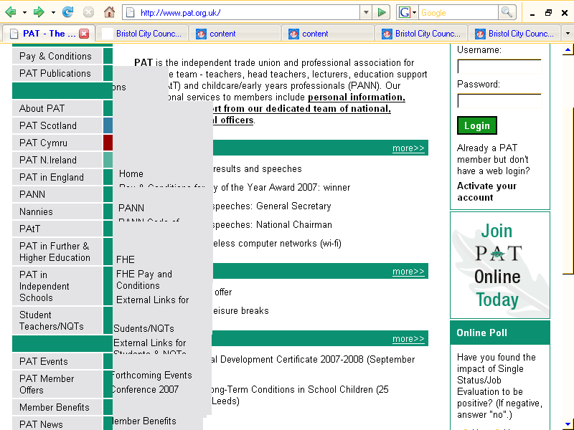

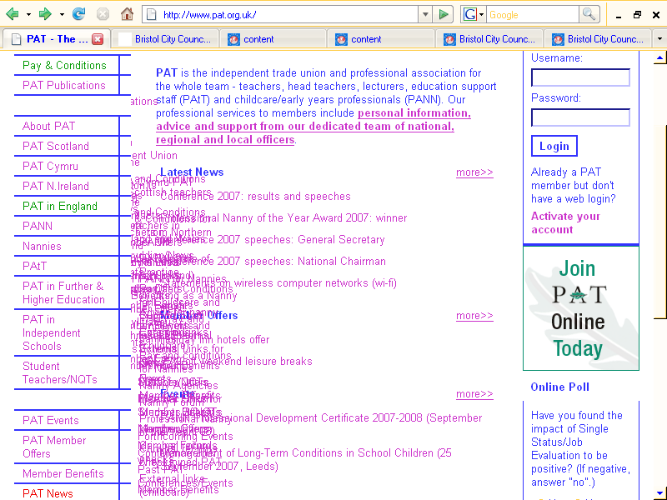

Bristol City Council

Jobs section:

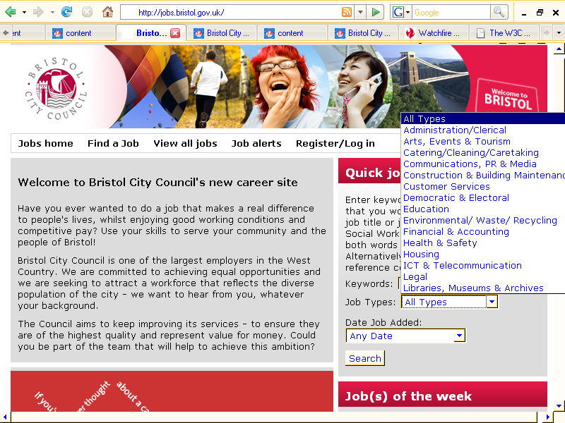

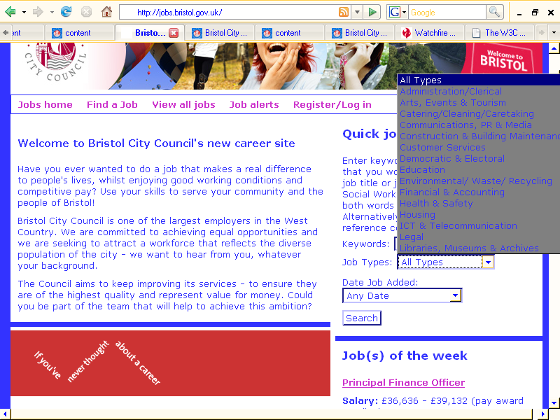
Library Finder:

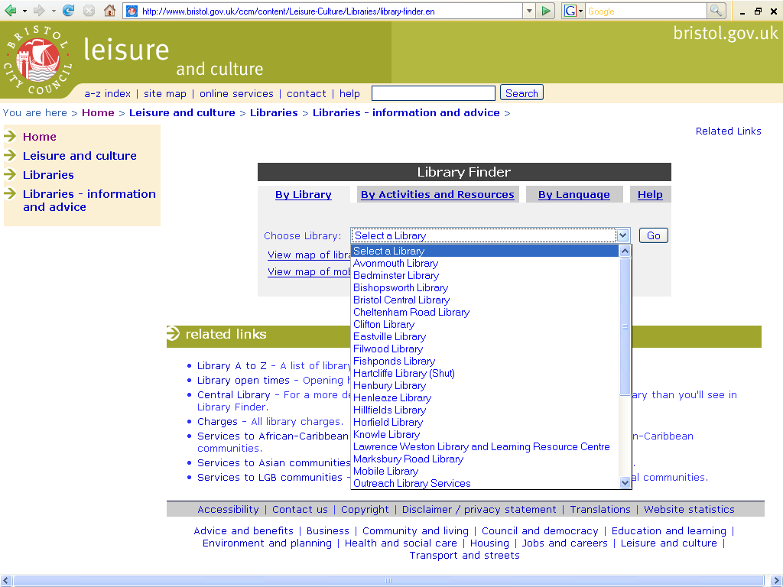

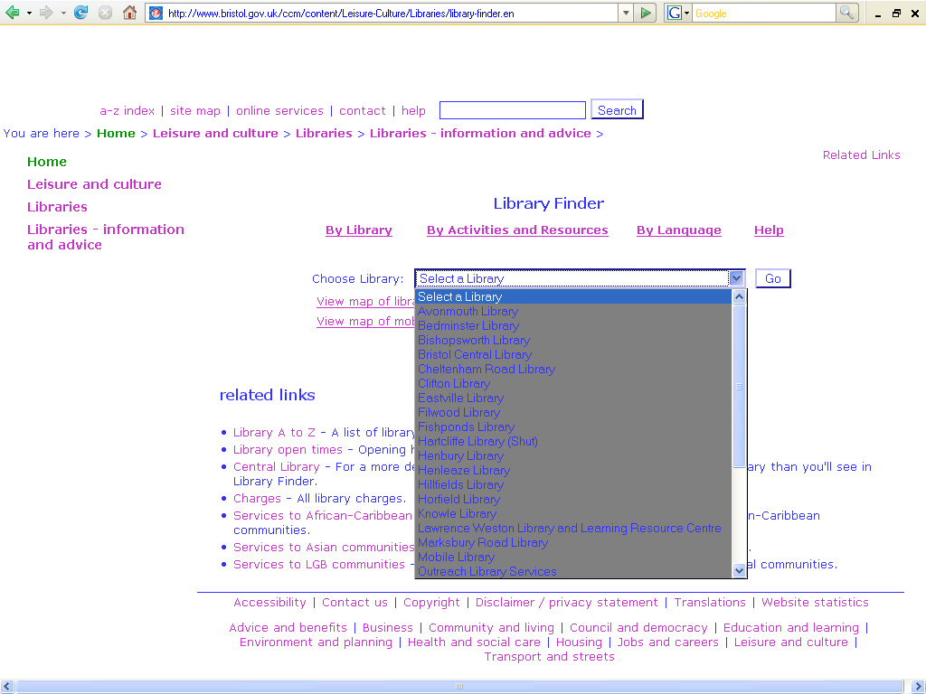
Council Home page:

This is the over-ridden version only and it shows the problem with the SOCITM pop-up survey. As the survey sets a cookie that only allows it to show once in a while, I didn’t manage to capture both the over-ridden and ‘normal’ versions.



