The Cognitive and Learning Disabilities Accessibility Task Force’s aim is to improve web accessibility for people with cognitive and learning disabilities. This is being done as part of the Web Content Accessibility Guidelines (WCAG) and Accessible Platform Architecture Working Group (APA WG), part of the Web Accessibility Initiative (WAI) of the W3C. Challenges facing this work include:
- Lack of availability of open research: Research on this topic tends to be behind a “paywall” which means that developers and policy makers may be unable find out what techniques are proven to work to address the needs of people with disabilities
- There is a wide range of cognitive disabilities; each type of impairment is different, with diverse symptoms and particular digital accessibility requirements. This adds to the complexity of knowing how to address user needs.
- The advice given in the research and available guidance is often vague and is not testable. So, even if developers read the research they would not know exactly what to do or when they have reached an acceptable level of accessibility.
- Some of the issues facing people using web technology is not simply about coding practices or code, but can include wider contexts, such as security concerns and personalization.
- Attitudes and misinformation can also become a barrier to inclusion for people with cognitive disabilities. For example, developers that may feel people with cognitive disabilities are not in their “target audience” and so have no interest in their inclusion. Also, studies of usability often over-sample college students. Thus the results work less well for groups who are not well represented among sub-groups of college students (such the aging population).
- Accessibility has typically been based upon the assumption that any website can be designed to be useable by people with disabilities. However, when making a website useable for people with cognitive disabilities, the content itself may need to be changed (e.g., simplified), or support adaptability (e.g., multi-modal delivery).

Addressing these issues requires us to make a broader view of solutions for accessibility, such as a content focused approach and to explore personalization solutions that incorporate inclusive design. To address these issues we have adopted the following strategies:
- Select a phased approach. In our first phase we looked at eight different disabilities or categories that cut across types of cognitive impairment in terms of severity and brain function. Although some user needs might not have been identified in this phase, this approach made the work involved practical and it is likely that most key needs will have been identified. Other cognitive disabilities and emotional disabilities may be included in a phase 2 and the current user groups may be re-examined.
- Compile user research and literary studies on the selected disability groups. These literary reviews mean that key findings are in the public domain and are easily available.
- Compile a list of authoring techniques that include the most useful strategies from all the different user group research
- Create testable and widely adoptable sets of success criteria that let authors know exactly what they need to do and when they have completed the task. (This will then become the basis for the extension to WCAG for cognitive disabilities)
- Author a series of issue papers that explore topics beyond simple content such as security or personalization.
- Review the techniques and issue papers to identify the gaps between what is currently supported in accessibility guidelines and in the web architecture and what is needed to enable accessibility for people with cognitive disabilities
- Create a roadmap to show how we can fill these gaps.

In addition to this gap analysis we have first drafts of the following accompanying documents:
- Background research document
- Issue papers on topics such as security, safety and how they are affected by cognitive disabilities
- An authoring techniques document, including
  - techniques that help all users and
  - techniques that help specific user groups.
- Proposal for a WCAG 2.0 extension
- A series of issue papers
- Draft for a semantics for adaptive interfaces (that may become a WAI-ARIA extension) and personalization syntax to enable adaptable interfaces.

The diagrams show how these need to be integrated to enable accessibility for people with cognitive disabilities

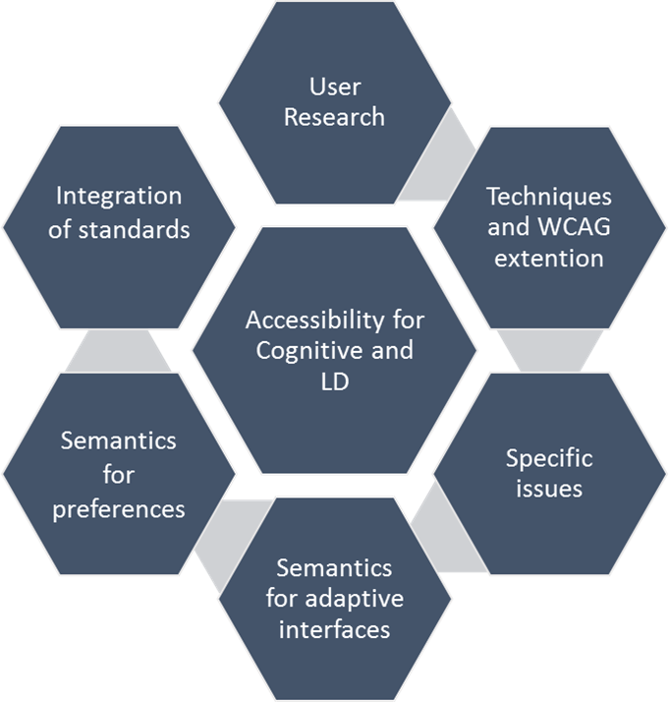

A roadmap must enable the integration of all the pieces that can make accessibility for people with cognitive disabilities workable. A roadmap must also address the author needs and issues that will help make this work practical. For example: Best practice documents and how to ensure that personalization is practical and testable.
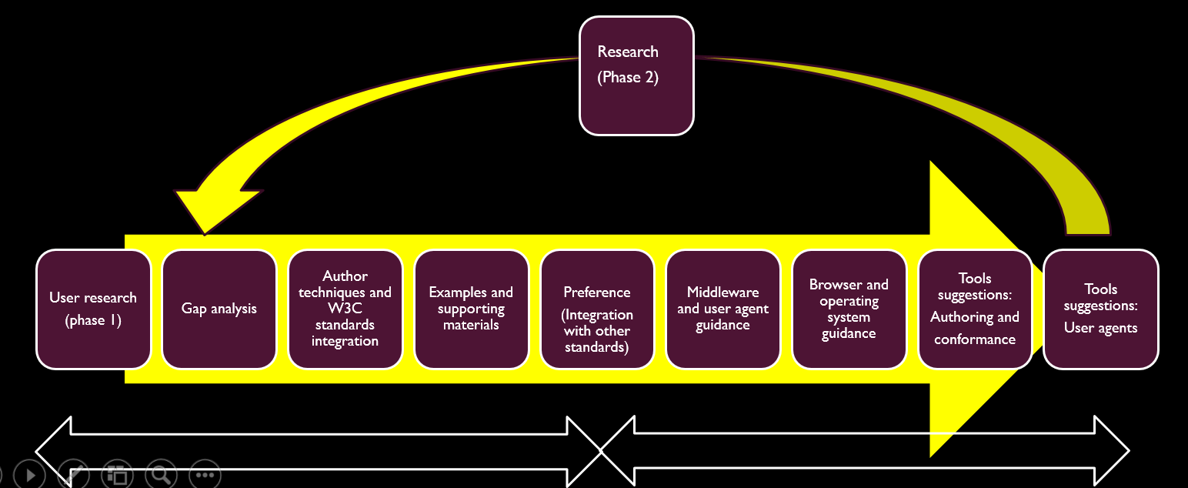
Figure 1 Anticipated Roadmap
The diagram shows what we are anticipating moving towards a roadmap. (Note that this work has yet to be completed.)
- User research (phase 1)
- Gap analysis
- Author techniques and W3C standards integration (such as WCAG and VOICE ML or ARIA)
- Support for Preference and possible standardization of preference settings and metadata (Integration with other standards)
- Author support providing examples and supporting materials such as best practices and techniques. Test cases for personalization
- Middleware and user agent guidance
- Browser and operating system guidance
- Tools suggestions: Authoring and conformance tools, user agents
Then we can start the process again with a phase 2 for additional research and new user groups, possibly including emotional disabilities.

Why this document is important

People with cognitive and learning disabilities may be unable to use web content because of the design choices of the author. For example:
- People with impaired short term memory are unlikely to be able to remember passwords and access codes. They may have trouble or be unable to remember new symbols and interface paradigms.
- People with communication disabilities may need clear literal language and may not understand metaphors or non-literal text and symbols.
- People with dyscalculia may not understand numerical references such as percentages.
- People with language related disabilities may need simple clear language and instructions. They may also need supporting graphics and familiar symbols.
- People who struggle with keeping and regaining focus, may be unable to focus on a task if there are lots of distractions and interruptions. They may need headers and signposts to help them regain the context after their attention has been lost (including in multi-media).
- Many groups will need support to minimize errors and complete their task. They will struggle with
  - complex, multi-stage processes that were not necessary for the task at hand
  - filling out forms or entering data correctly or
  - finding the content or feature that they need.

(Inserted section from old version “why this document is important” from https://w3c.github.io/wcag/coga/gap-analysis.html#importance-of-this-do cument)
This document is important because enabling people with learning and cognitive disabilities to use the Web and ICT is of critical importance to both the individuals and to society.
More and more the internet and ICT has become the main way people stay informed and current on news and health information, keep in touch with friends and family, and provides independence, convenient shopping, and other. People who cannot use these interfaces will have an increased feeling of being disabled and alienation from society.
Further, with the advent of the Web of Things everyday physical objects are connected to the Internet and have ICT interfaces. Being able to use these interfaces now is an essential component of allowing people to maintain their independence, stay in the work force for longer and stay safe.

Consider that the population is aging. By 2050 it is projected there will be 115 million people with dementia worldwide. It is essential to the economy and society that people with mild and moderate levels of dementia stay as active as possible and participate in society for as long as possible. However, at the moment even people with only a mild cognitive decline find may standard applications impossible to use. That means more and more people are dependent on care givers for things that they could do themselves, increasing the crippling cost of care and reducing human dignity.

We therefore invite you to review this draft, comment and consider how your technologies and work may be effected by these issues.

Then Import

- summary of techniques, summary of issue
- the table of user needs
- assumptions
- methodologies
- credits

