People with cognitive and learning disabilities may be unable to use web content because of the design choices of the author. For example:
- People with impaired short term memory are unlikely to be able to remember passwords and access codes. They may have trouble or be unable to remember new symbols and interface paradigms.
- People with communication disabilities may need clear literal language and may not understand metaphors or non-literal text and symbols.
- People with dyscalculia may not understand numerical references such as percentages.
- People with language related disabilities may need simple clear language and instructions. They may also need supporting graphics and familiar symbols.
- People who struggle with keeping and regaining focus, may be unable to focus on a task if there are lots of distractions and interruptions. They may need headers and signposts to help them regain the context after their attention has been lost (including in multi-media).
- Many groups will need support to minimize errors and complete their task. They will struggle with
  - complex, multi-stage processes that were not necessary for the task at hand
  - filling out forms or entering data correctly or
  - finding the content or feature that they need.

Insert section from old version “why this document is important” from https://w3c.github.io/wcag/coga/gap-analysis.html#importance-of-this-document

The Cognitive and Learning Disabilities Accessibility Task Force’s aim is to improve web accessibility for people with cognitive and learning disabilities. This is being done as part of the Web Content Accessibility Guidelines (WCAG) and Accessible Platform Architecture Working Group (APA WG), part of the Web Accessibility Initiative (WAI) of the W3C. Challenges facing this work include:
- Lack of availability of open research: A lot of research on this topic is behind a “paywall” that means that developers and policy makers can not simply find out what techniques are proven to work to address the needs of people with disabilities
- There is a large range of different cognitive disabilities, and each one is different, with different symptoms and user need. This adds to the complexity of knowing how to address user needs.
- The advice given in the research and available guidance is often vague and is not testable. So, even if developers read the research they would not know exactly what to do or when they have finished.
- Some of the issues facing people using web technology is not simply about coding practices or code, but can include wider context such as security concerns, or personalization.
- Attitudes and misinformation can also become a barrier to inclusion for people with cognitive disabilities. For example, developers that may feel people with cognitive disabilities are not in their “target audience” and hence will not be interested in their inclusion. Also, studies of usability often over-sample college students. Thus the results work less well for groups who are not well represented among sub-groups of college students (such the aging population).
- Accessibility has typically been based on the assumption that any content can be made accessible. However when making content useable for people for people with disabilities, the content itself may need to be changed or support adaptability.

Addressing these issues requires us to make a broader view of solutions for accessibility, such as a content focused approach and to explore personalization solutions that incorporate inclusive design. To address the above we have adopted the following strategies:
- Select a phased approach. In our first phase we looked at eight different disabilities or categories that cut across types of cognitive impairment in terms of severity and brain function. Although some user needs might not have been identified in this phase, this approach made the work involved practical and it is likely that most key needs have been identified. Other cognitive disabilities and emotional disabilities may be included in a phase two and the current user groups may be reexamined.
- Compile user research and literary studies on the selected disability groups. These literary reviews means that key findings are in the public domain and are easily available.
- Compile a list of authoring techniques that includes the most useful strategies from all the different user group research
- Create testable and widely adoptable set of success criteria that let authors know exactly what they need to do and when they have completed the task. (This will then become the basis for the extension to WCAG for cognitive)
- Author a series of issue papers that explore topics beyond simple content such as security or personalization.
- Review the techniques and issue papers to identify the gaps between what is currently supported in accessibility guidelines and in the web architecture and what is needed to enable accessibility for people with cognitive disabilities
- Create a roadmap on how we can fill these gaps.

In addition to this gap analysis we also have first drafts of the following accompanying documents:
- Background research document
- Issue papers on topics such as security, safety and how they are effected by cognitive disabilities
- An authoring techniques document, including
  - techniques that help all users and
  - techniques that help specific user groups.
- A series of issue papers
- Proposal for a WCAG 2.0 extension
- Draft for a semantics for adaptive interfaces (that may become a WAI-ARIA extension) and personalization syntax to enable adaptable interfaces.
The diagrams shows how these need to be integrated to enable accessibility for people with cognitive disabilities

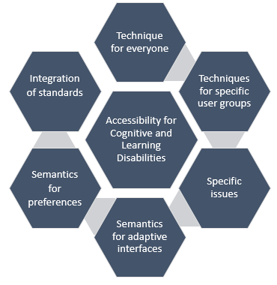

Then Import
- summary of techniques, summary of issue
- the table of user needs
- assumptions
- methodologies
- credits

