Cog Accessibility tree
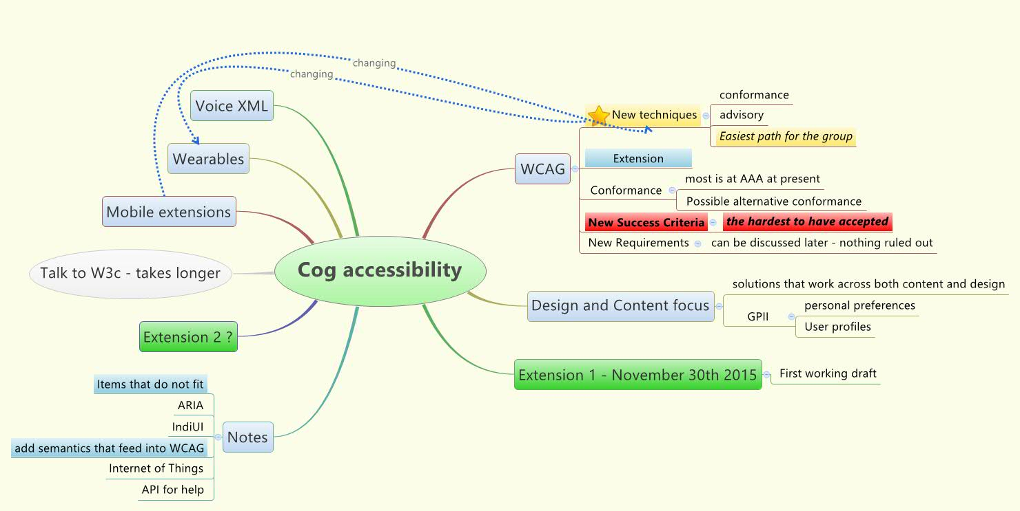
Extension 1 - November 30th 2015 - First working draft
Extension 2 ?
Talk to W3c - takes longer

WCAG
New techniques
See Also: Mobile extensions (changing), Wearables (changing)
conformance
advisory
Easiest path for the group
Extension
Conformance
most is at AAA at present
Possible alternative conformance
New Success Criteria
the hardest to have accepted
New Requirements
can be discussed later - nothing ruled out

Design and Content focus
solutions that work across both content and design
GPII
personal preferences and User profiles

Mobile
See Also: New techniques (changing)

Wearables
See Also: New techniques (changing)

Voice XML

Notes
Items that do not fit
ARIA
IndiUI
add semantics that feed into WCAG
Internet of Things
API for help

