2/18/04

P3P.xml is the reference file

Accessloggingtemplate.xml is the policy statement

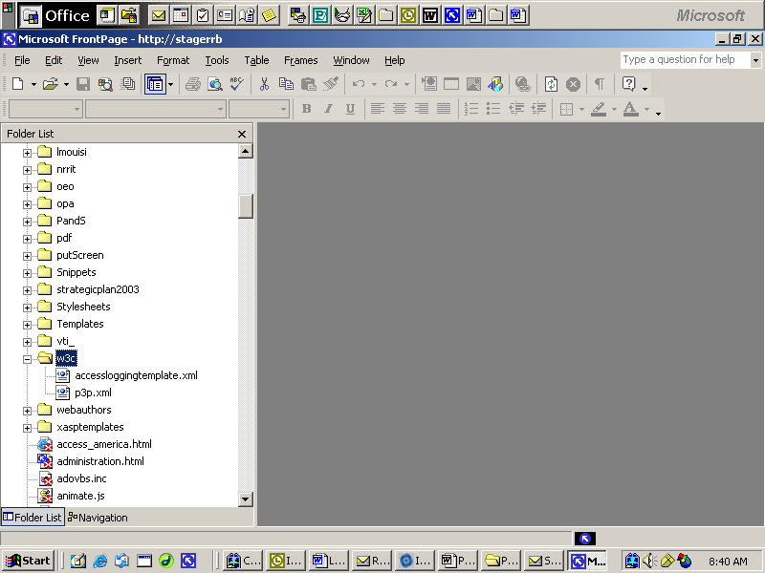
Get this error:

