Stefan Schnabel  User Experience -  Accessibility  SAP AG | Complex Table Grid Types  An Overview
 | Draft Version 1.1 | February 2008

Content
Content 2
Non-Hierarchical Grids 3
Standard Tables 3
Tables with Multi-Level Headers 5
Tables with Common Cell Sections 6
Hierarchical Grids 7
Region Grids 7
Tables with Grouped Rows 7
Tables with Groups to be Toggled 10
Multi-Level Hierarchy Grids (Tree Grids) 12
Single Column Hierarchies 12
Multiple Column Hierarchies 13
Nested Grids 14
Tables in Tables 14

Non-Hierarchical Grids

Standard Tables
These tables contain one (optionally visible) table caption and one visible header per column.

Table Caption
Header 1 | Header 2 | Header 3 | Header 4 | Header 5
text | text | text | text | text
text | text | text | text | text
text | text | text | text | text
text | text | text | text | text

The table cells may contain a number of allowed other UI elements instead of only plain text.

Variants of this table include:
- Selection options
  - Table rows are selectable with either Single or Multi-Selection
  - There may be Master (Lead) Selections and Secondary Selections
  - First Column is often Trigger for Selections (contain a selector)
- Sort Options
  - Headers are sortable
- Filter Options
  - optional filter row for input of filter criteria.

As depicted below.

Table Caption
 | Header 1 | Header 2 | Header 3 | Header 4 | Header 5
(f) | (optional filter row)

Primary (lead) selection
Secondary selection
Pressed selector
Non-pressed selector
Sortable Headers

Keyboard Navigation/Interaction:

- Tab
  - The initial tab enters the grid with focus on the first header cell.
  - Once in the grid a second tab moves out of the grid to the next tab stop.
  - Once focus is established in the grid, a TAB into or a Shift Tab into the grid will return to the cell which last had focus.
- Left and Right Arrow
  - Navigation between columns (including header cells).
  - If the next cell in the row is not present, focus should not move.
- Up and Down Arrow
  - Navigation between Rows.
  - If the next cell in the column is empty, focus should move to the first column in the next row.
  - If the next cell in the column is not empty, focus should move directly to that cell.
- Enter
  - If the cell contains an editable field, the Enter key is used to enter edit mode and the esc key used to exit edit mode.

Assistive Technology:

(to be added)

Example 1: A typical Table with additional filter row and a selected row

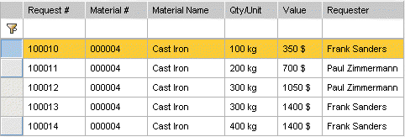

Example 2: A table with Lead- and Secondary selection applied

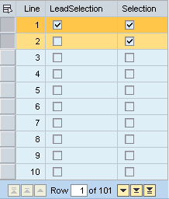

Tables with Multi-Level Headers

This table type contains one top-level header and one to many sub-level headers forming a grouping of headers.

Header 1 |  | Header 2
Header 1a | Header 1b | Header 2a | Header 2b

Keyboard Navigation/Interaction

- (all of Standard Tables)

Assistive Technology:

- Needs to announce header nesting

Example 1: A typical Table with three header levels

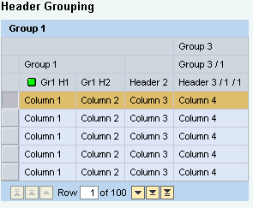

Tables with Common Cell Sections

This table consists of visually paired cells forming common cell sections (rowspans).

Category | Subcategory | Class
Cars | Volvo | Van
(Cars) | (Volvo) | Cabrio
(Cars) | Mercedes | Van
(Cars) | (Mercedes) | Cabrio
Fruits

Sections

Keyboard Navigation/Interaction

- (all of Standard Tables)
- In addition, the sub rows remain selectable and the sub row cells remain focusable.

Assistive Technology:

- Each cell in a section should contain the same information for Screen Reader Texts (may be non-visual in special cell attributes like tool tip).

Example 1: Table with Common Cell Sections

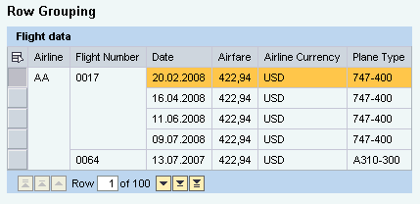

Hierarchical Grids

Region Grids

These Tables contain expandable rows with regions shown below the expanded row.

☞ | It should be discussed if such tables can be considered as special case of Tree Grids or if different semantics should be applied to them.

Tables with Grouped Rows

Header 1 | Header 2 | Header 3
 A
 B
B1 | (text) | (text)
B2 | (text) | (text)
B3 | (text) | (text)
 C

This table consists of expandable, all column-spanning rows forming intermediate expandable headers. Header rows have groups of rows below as their contents hown as result of the expansion of row above.

Keyboard Navigation/Interaction:

- (all of Standard Tables)
- (all of Tables with Common Cell Sections)
- Control and +/- | Num Pad and +/- | +/- only
  - Expand or collapse rows.
  - Note: The Num Pad +/- conflicts with Jaws commands.

Assistive Technology:

(to be added)

Example 1a: All Rows are collapsed

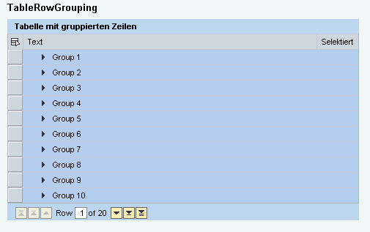

Example 1b: One Row is expanded

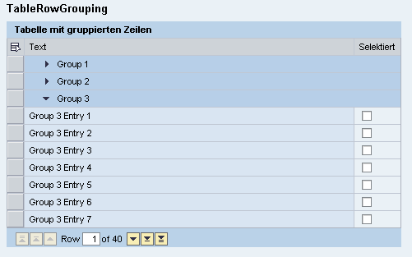

A special case is the presence of summary rows in a table:

Example 2a: Table with collapsed summary cell

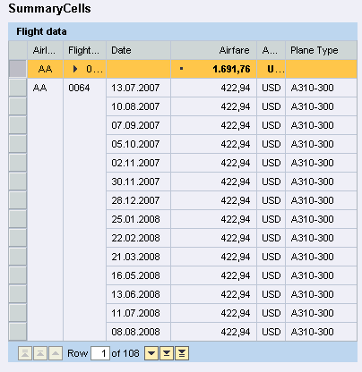

Example 2b: Table with expanded summary cell

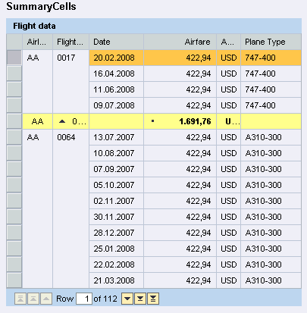

Tables with Groups to be Toggled

This special table cell type opens a region below. Regions are navigated/skipped as Groups.

 | Header 1 | Header 2 | Header 3
 | A
 | This is a region within a table. 
 | B

Keyboard Navigation/Interaction

- (all of Standard Tables)
- (all of Single Level Hierarchy Grids)

Assistive Technology:

(to be added)

Example 1a:

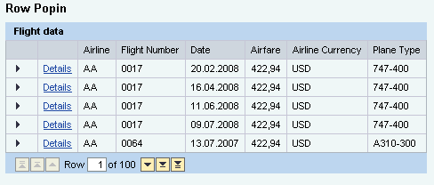

Example 1b:
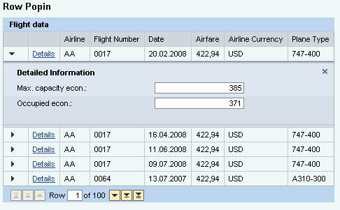
Alternatively, a cell content may toggle the visibility of the region also.

Example 2a:

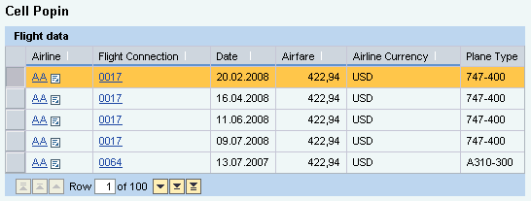

Example 2b:

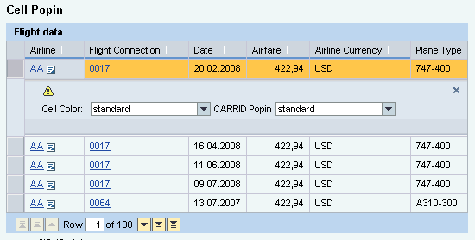

Tree Grids

Single Column Hierarchies

 | Header 1 | Header 2 | Header 3
 |  A | (text) | (text)
 |  B | (text) | (text)
 |  B1 | (text) | (text)
 | ○ B11 | (text) | (text)
 | C | (text) | (text)

A Single Column Hierarchy Tree Grid has rows that are expandable.

Hierarchical tree levels are visualized by a tree indicator control, e.g. by a black triangle. If a sub-node contains items, that sub-node also has a tree indicator control. When the last hierarchical level (leaf node) is reached, a different indicator element, e.g. a square icon, is displayed.

Examples include a threaded view of an email grid; a calendar that opens month, week and day views; or a File Browser that shows directories, subdirectories and files.

A special case may be a table that has only one additional level of hierarchy:

Header 1 | Header 2 | Header 3
 A | (text) | (text)
 B | (text) | (text)
B1 | (text) | (text)
B2 | (text) | (text)
B3 | (text) | (text)

This can be easily confused with a table that has grouped rows (see last chapter).

Keyboard Navigation/Interaction:

- (all of Standard Tables)
- (all of Single Level Hierarchy Grids)

Assistive Technology:

(to be added)

Example 1: Hierarchical Month View of a Calendar

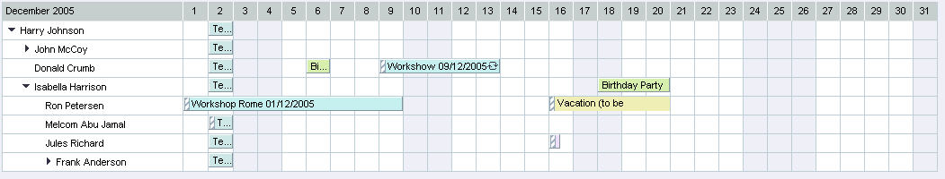

Example 2: Tree Grid with 4 levels

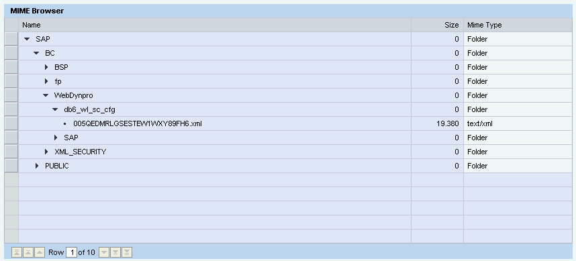

Multiple Column Hierarchies

This variant allows for additional expandable cells within a single row.

Keyboard Navigation/Interaction:

- (all of Standard Tables)
- (all of Single Level Hierarchy Grids)

Assistive Technology:

(to be added)

Example 1: Tree Grid with multiple hierarchies

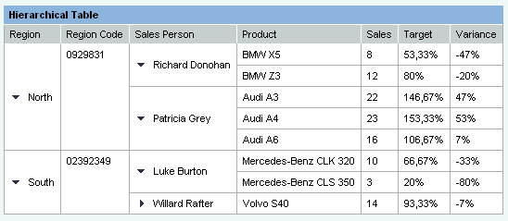

Nested Grids

Tables in Tables

When entire tables are put inside a region or a single table cell we have a nested Table scenario.

Example 1: A Table in a Table in a region
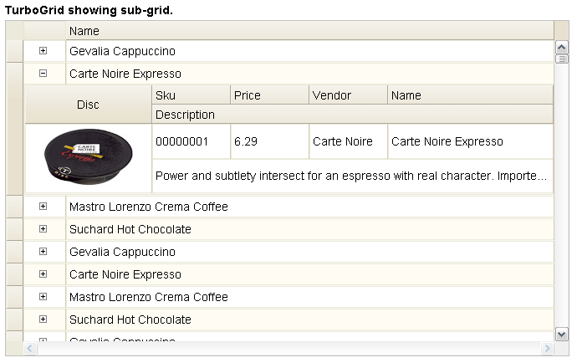

Keyboard Navigation/Interaction

- (all of Standard Tables)
- (all of Single Level Hierarchy Grids)

Assistive Technology:

(to be added)

