Windows 7 Platform Accessibility Service Test Procedure
This procedure can be used with authoring tools that run on Windows 7 to determine whether the tool is properly communicating to platform accessibility services as is required by ATAG 2.0 success criteria.

High Contrast Mode
High Contrast is a feature that heightens the color contrast of some text and images on the screen.
- Press Alt+Left Shift+Print Screen to turn on High Contrast.
- Test the application to ensure that all information that is visible with High Contrast off, it also visible with High Contrast on.

Microsoft Inspect
Microsoft Inspect is an application that provides MSAA and UI Automation information about each object in a software. It is part of the Microsoft SDK.
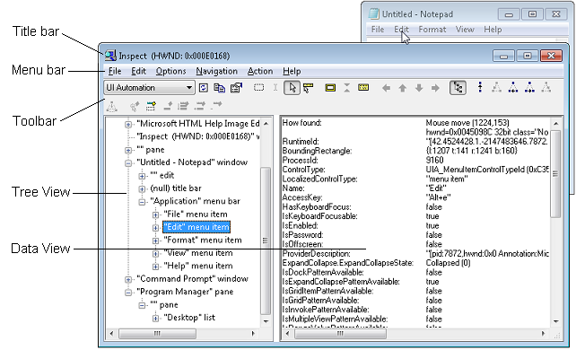
(source: http://msdn.microsoft.com/en-us/library/windows/desktop/dd318521(v=vs.85).aspx)

The Inspect window stays in foreground and displays a snapshot of the accessibility information for objects of interest in an application, selected by mouse movement or keyboard focus change.

For most objects, the properties of interest are:
- Name (“Legacy/Accessible.Name”)
- Value (“Legacy/Accessible.Value”)
- Role (“Legacy/Accessible.Role”)
- State (“Legacy/Accessible.State”)

Consult the Microsoft Dev Center for complete information on using Microsoft Inspect.

Java Access Bridge
(Only used if the Authoring Tool application is a Java program)

The Java Access Bridge is required when using Java applications with assistive technologies. In earlier versions, it was required to install it separately, however, when using the latest JAVA JRE, the Access Bridge installs automatically.

You can also install it manually as follows:
1. Go to Start > Control Panel > Ease of Access > Ease of Access Center.
2. Select Use the computer without a display.
3. In the section Other programs installed, select the check box Enable Java Access Bridge.
4. Restart your Java applications and assistive technologies.
5. Alternatively, you can enable the Java Access Bridge from the command line by:
Move to the %JRE_HOME%\bin directory
type: jabswitch -enable

Java Monkey
The Access Bridge installation contains a utility called Java Monkey. When you run this program, it displays the object tree of all running Java applications, which are accessible. On this tree, you can check if all objects are exposed to the Java Access Bridge, and to assistive technologies.

You can right click on any item and see all associated accessibility information. Please note that this application is not fully accessible, and cannot be operated using the keyboard. However, information can be obtained when using a screen readers virtual mouse functionality.

The standard Java SDK comes with demo applications, one of the simplest one is Notepad, which is fully accessible. You can use this application to understand how Java Monkey works.

Java Ferret
Under the Access Bridge installation, you will find another utility, called the Java Ferret. This program helps you find accessibility information about a currently focused Java object. When you navigate a Java application, you can see how accessibility information changes in the Java Ferret. This utility is also difficult to use with a screen reader. Navigate to a Java object, and switch over to the Java Ferret to read the updated information.

In Java Ferret, you will find an Events, and an Accessibility Events menu. Under these two menus, you can check all events that you want to watch for. These include change of focus, mouse events, menu events, accessibility properties, etc. To achieve the best accessibility testing results, it is recommended to enable all events before using the Java Ferret.

