As agreed during last phone conference (ACTION-12), I try to describe what I see as an important challenge towards the definition of an emotion markup language. I'll be very curious to see to what extent the solutions that are possible in XML, RDF and OWL differ.

Marc

"Custom descriptor challenge"
-----------------------------

Let us assume that John is a user of our future Emotion Markup Language. John wants to annotate some content (photos of faces taken in real-life situations, say in a subway) with emotion-related information.

1) Initially, John wants to use two types of coarse descriptors:
- Emotion categories following Ekman's earlier work, i.e. the "big six" categories: anger, fear, sadness, surprise, disgust, joy
- Emotion dimensions following Fontaine et al.: evaluation, potency, activation, unpredictability.

Emoxg-base.xsd contains the different abstract datatype (e.g. dimensionType, categoryType). These datatypes are defined by <xsd:complexType> with… anything! We cannot use directly this type in the definition of an element…

<!-- ABSTRACT CATEGORY TYPE DEFINITION -->
<xsd:complexType name="categoryType">
<xsd:annotation>
<xsd:documentation>emotion category</xsd:documentation>
</xsd:annotation>
</xsd:complexType>

Then, sub-types inherit of these complex type by extension. This mechanism allows us to add elements (for example, element anger in EckmanCategoryType).

<xsd:complexType name="EckmanCategoryType">
<xsd:complexContent>
<xsd:extension base="categoryType">
<xsd:annotation>
<xsd:documentation>Definition of Ekman's categories </xsd:documentation>
</xsd:annotation>
<xsd:choice>
<xsd:element name="anger" type="interval01Type"/>
<xsd:element name="annoyance" type="interval01Type"/>
...
</xsd:choice>
</xsd:extension>
</xsd:complexContent>
</xsd:complexType>

In the case where the number of elements (for example, EckmanCategoryType) is too large, we can restrict the complex type by restriction.
<xsd:complexType name="bigsixEckmanCategoryType">
<xsd:complexContent>
<xsd:restriction base="EckmanCategoryType">
<xsd:annotation>
<xsd:documentation>Definition of Ekman's categories </xsd:documentation>
</xsd:annotation>
<xsd:choice>
<xsd:element name="anger" type="interval01Type"/>
<xsd:element name="fear" type="interval01Type"/>
...
<xsd:element name="joy" type="interval01Type"/>
</xsd:choice>
</xsd: restriction >
</xsd:complexContent>
</xsd:complexType>

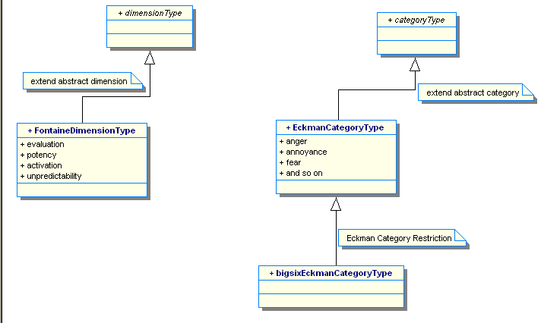

John can import directly the emoxg-base.xsd in his own XML schema definition.
Let us assume that we as EmotionML specifiers have provided several "default" sets of categories and dimensions centrally, so all John should have to do in his document at stage (1) is to refer to these centrally defined sets from his document.

2) After working with the data for a while, John feels the "big six" categories don't quite fit his needs.
- instead of the "big six", he wants to define, and use, a custom set of "subway emotions": stressed, scared, in-a-hurry, relaxed, friendly
- he feels the dimensions are OK, so he still wants to refer to the centrally-defined dimensions

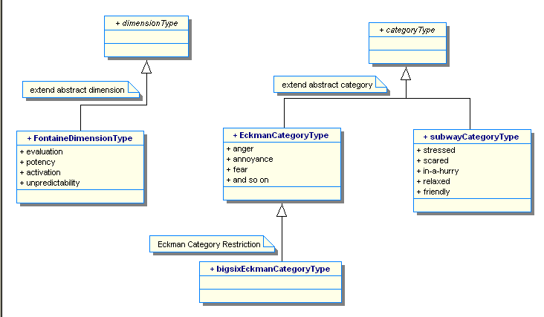

John can import directly the emoxg-base.xsd in his own XML schema definition (named here John-emoxg.xsd).
Then, John defines the subway emotion category type by extending the abstract categoryType.

<!-- definition of subway emotion -->
<xsd:complexType name="subwayCategoryType">
<xsd:complexContent>
<xsd:extension base="categoryType">
<xsd:annotation>
<xsd:documentation>Definition of subway categories : stressed, scared, in-a-hurry, relaxed, friendly</xsd:documentation>
</xsd:annotation>
<xsd:choice>
<xsd:element name="stressed" type="interval01Type"/>
<xsd:element name="scared" type="interval01Type"/>
<xsd:element name="in-a-hurry" type="interval01Type"/>
<xsd:element name="relaxed" type="interval01Type"/>
<xsd:element name="friendly" type="interval01Type"/>
</xsd:choice>
</xsd:extension>
</xsd:complexContent>
</xsd:complexType>

3) After refining his analyses further, John wants to replace also the dimensions with a custom set:
- categories: custom "subway emotions"
- custom dimensions: socially-open, degree-of-time-pressure
<!-- socially-open, degree-of-time-pressure -->
<xsd:complexType name="customDimensionType">
<xsd:annotation><xsd:documentation>custom dimension definition</xsd:documentation></xsd:annotation>
<!-- dimension redefine -->
<xsd:complexContent>
<xsd:extension base="dimensionType">
<xsd:sequence>
<xsd:element name="socially-open" type="interval01Type" minOccurs="0" maxOccurs="1"/>
<xsd:element name="degree-of-time-pressure" type="interval01Type" minOccurs="0" maxOccurs="1"/>
</xsd:sequence>
</xsd:extension>
</xsd:complexContent>
</xsd:complexType>

An another solution is to redefine the dimensionType :

In the plug-in file :
...
<xsd:redefine schemaLocation="emoxg-basetype.xsd">
<!-- dimension redefine -->
<xsd:complexType name="dimensionType">
<xsd:complexType name="customDimensionType">
<xsd:annotation><xsd:documentation>custom dimension definition</xsd:documentation></xsd:annotation>
<!-- dimension redefine -->
<xsd:complexContent>
<xsd:extension base="dimensionType">
<xsd:sequence>
<xsd:element name="socially-open" type="interval01Type" minOccurs="0" maxOccurs="1"/>
<xsd:element name="degree-of-time-pressure" type="interval01Type" minOccurs="0" maxOccurs="1"/>
</xsd:sequence>
</xsd:extension>
</xsd:complexContent>
</xsd:complexType>
</xsd:redefine>
<!-- and definition of John’s specific types -->
...

In each case, it should be possible for John to indicate clearly where he is taking his labels from, so that it is possible to verify that his documents are valid with respect to the specification. Ideally, it should not be necessary to define new "dialects" of the language as we had done with EARL [1], but it would be sufficient to refer to a set of categories or dimensions, which *instantiate* or *subclass* a generic concept of "EmotionML category set" or "EmotionML dimension set".

In the XML instance:
We can indicate the type used by the facet xsi:type in the concerned tag (like dimensions)
Example:
<emotion id="ID456">
<utterance xlink:href="picture.jpg"/>
<modality>face</modality>
<category xsi:type="bigsixEckmanCategoryType"
xmlns:xsi="http://www.w3.org.2001/XMLSchema-instance" >
<joy>0.4</joy>
</category>
<dimensions xsi:type="fontaineDimensionType"
xmlns:xsi=="http://www.w3.org.2001/XMLSchema-instance" >
<activation>0.4</ activation >
</dimensions>
...
</emotion>

An another solution : we can use the notion of qualified namespace for element and attribute...

