Proposed Revisions to Where section of

Who What Where When Emergency Response Coordination

(Gary Berg-Cross)
One of key questions in emergency response is Who is doing What, Where, and When. We use this as a framework in our brainstorm session to highlight some of data requirements and challenges in emergency response.
Who
We need to keep track of all organizations and coordination centers involved in an incident. Information about mission of the organizations - overall and in the context of an incident, their capabilities, and their current responsibilities can support situational awareness and time-boxing required for emergency operations. In this context, we identified the following organizational contact information:
- Unique Identifier
- Phone
- Email (create virtual domain?)
- Means of communication/contact/availability
- Role (same as mission?)
- Service Area - geographical
- Established Locations
- Credentials (forms part of Governance)
- Functional/Legal/other responsibilities
- Status (Active/Inactive, Available/Unavailable)
- Clearance/Dependency
Of note, although the focus here is on organizational entities, local efforts by persons affected are not often captured in existing data models.
Other issues:
- Information inherited from organisational relationships
- What is the means to identify, locate, contact the Who
- Under what circumstances?
- Expectations
What
The activities that the organizations perform are mainly emergency support functions (ESF) (ETc??), transportation, and evacuation. The key point in such activities is the ability to assess the needs, and to address and integrate available resources versus capabilities. The activities can be characterized as following:
- Service/Activity
  - Domain
- Coverage
  - No of people covered or required
- Capabilities
- Categories
The type of disaster/incident will also determine (or give a good indication of) the range of Whats that should be provided. These activities would be applied to respond and recover from the incident.
Where
Geospatial location is a fundamental property for understanding emergences in a coherent and intuitive way. In emergecies all parties can relate to where they are on a map, follow directions to or from a place, grasping the spatial context of their route etc. Handling the “where”may mean using information from a map or an image, data encoded as an address, zip code, or phone number, or landmark or events described in a text message, Howerver, there is no single frame of reference to locate people, areas and/or resources. For example, some use identifiers (such as place names e.g. ISO 19112 - Spatial referencing by geographic identifiers), coordinate reference system (CRS e.g. ISO 19111 - Spatial referencing by coordinates), or jurisdiction for this purpose. Some humanitarian information centers use universal indicators such as p-code instead. Areas involve different types of geospatial concepts and may involve basic geometric constructs. The approach taken here is to leverage existing ISO and Open GeospatialConsortium (OGC) standards for spatial objects and relations in support of the Framework Concepts and harmonize these as needed. The strategy for this section is as follows. First ISO and OGC standards are identified and briefly discussed, Following this the standards are discussed to terms within Framework Concepts to illustrate their utility and identify issues (note since the Framework is undergoing change this is just a placeholder now). Then a start is made grounding these standards in better semantics and any extant geographical taxonomies and ontologies. Final remaining issues are identified for further work.
A. Existing Geospatial Standards
We start with the ISO 19100 series of geographic information standards is a set of interlocking object-based standards consistent with principles and methodology of ISO/TC211 that can be used to define, describe, and manage geographic information about objects, events or phenomena that are located relative to the Earth. For location the most relevant are the ISO 19112 (Spatial referencing by geographic identifiers), and ISO 19111 – (Spatial referencing by coordinates) previously mentioned. But the nature of spatial characteristics and geographic features is also important since geographical objects can be defined in different ways by different people for different purposes. This geospatial objects can be referenced like location, by name, number or description. The ISO 19107 standard for Spatial schema has a conceptual schemas to describe the spatial characteristics of geographic features needed to support understanding and usage of geographic information. For example, the standard can support representing the geometry of a road or wall needed to communicate information about a supply or escape route and barriers to transport.
Also of interest is the ISO 19123 Geographic information schema for coverage geometry and functions coverages include digital orthoimages, gridded elevation data sets, and thematic classification maps such as soils maps.
The Geography Markup Language standard original GML of OGC model was based on the World Wide Web Consortium's Resource Description Framework (RDF). Subsequently, the OGC introduced XML schemas into GML's structure to help connect the various existing geographic databases, whose relational structure XML schemas more easily define. The resulting XML-schema-based GML retains many features of RDF, including the idea of child elements as properties of the parent object (RDFS) and the use of remote property references.
The OGC features model (shown below) is a useful way to organize several aspects of geospatial information. More broadly this is a start on a geo-spatial continuum. This starts with spatial things like arrangements of parts of a natural object which we might see in an image, them there are geo-spatial mixtures such as building designs and more abstract, geographic rendering in maps and models.

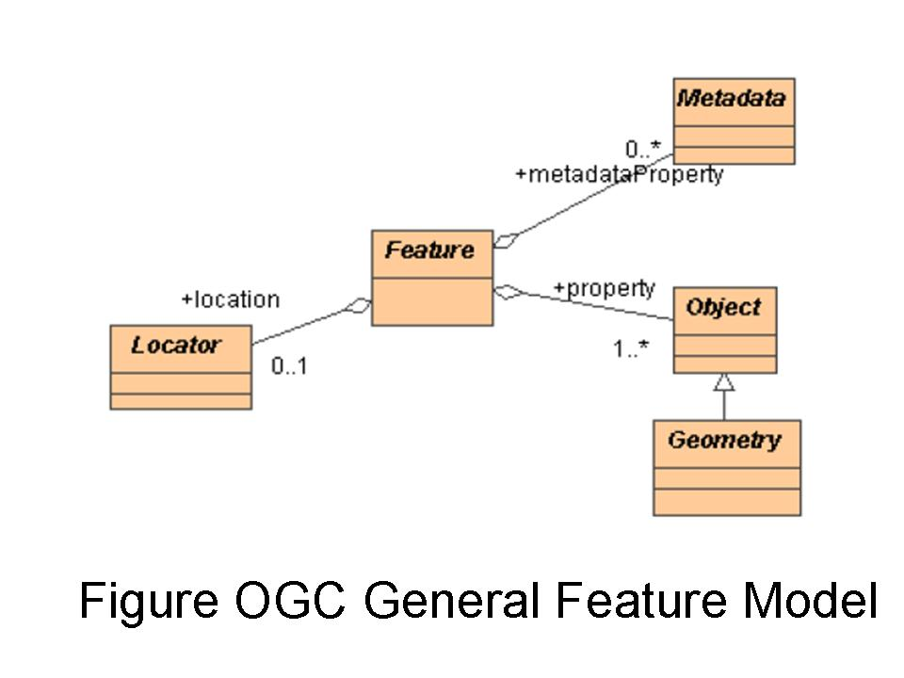
As shown in the Figure GML contains a rich set of related primitives which are used to build application specific schemas or application languages. These primitives include:
- Feature – distinction from a geometry object. A feature is an object in our domin that represents a physical entity, e.g. a building, a river, rescue area, or a person. We are primarily interested in these, but need the other primitive concepts to locate them or describe them as in locating and describing a rescue area.
- Geometry – things like Point. LineString or Polygon that may describe a Feature or area
- Coordinate Reference System to provide coordinates of geometry objects (e.g. line coordinates)
- Coverage (including geographic images) as discussed above for ISO 19123

B. Illustrating Framework Concepts with Geostandards
TBD
C. Grounding Geospatial Concepts in Better Semantics
A start on this is to use extant geographical taxonomies as input to subsequent ontologies. An example of one such taxonomy from

Physical Environment | ID : 1.3.1 | (subClassOf,this,Environment), sameAs,core,Natural environment)
Land Environment | 1.3.1.1 | (subClassOf,this,Physical Environment)
Terrain | 1.3.1.1.1 | (subClassOf,this,Land Environment)
Terrain Relief Features | 1.3.1.1.1.1 | (subClassOf,this,Terrain)
Vegetation | 1.3.1.1.1.2 | (subClassOf,this,Terrain)
Landlocked Waters | 1.3.1.1.1.3 | (subClassOf,this,Terrain)
Terrain Traction | 1.3.1.1.1.4 | (subClassOf,this,Terrain)
Terrain Slope | 1.3.1.1.1.5 | (subClassOf,this,Terrain)
Terrain Elevation | 1.3.1.1.1.6 | (subClassOf,this,Terrain)
Terrain Firmness | 1.3.1.1.1.7 | (subClassOf,this,Terrain)
Terrain Relief | 1.3.1.1.1.8 | (subClassOf,this,Terrain)
Geological Features | 1.3.1.1.2 | (subClassOf,this,Land Environment)
Magnetic Variations | 1.3.1.1.2.1 | (subClassOf,this,Geological Features)
Subsurface Water | 1.3.1.1.2.2 | (subClassOf,this,Geological Features)
Geological Activity | 1.3.1.1.2.3 | (subClassOf,this,Geological Features)
Synthetic Terrain Features | 1.3.1.1.3 | (subClassOf,this,Land Environment)
Urban Centers | 1.3.1.1.3.1 | (subClassOf,thisSynthetic Terrain Features)
Civil Structures | 1.3.1.1.3.2 | (subClassOf,thisSynthetic Terrain Features)
Obstacles | 1.3.1.1.3.3 | (subClassOf,thisSynthetic Terrain Features)
Line of Communication | 1.3.1.1.3.4 | (subClassOf,thisSynthetic Terrain Features)
Urban Environment Characteristics | 1.3.1.1.4 | (subClassOf,this,Land Environment)
Sea Environment | 1.3.1.2 | (subClassOf,this,Physical Environment)
Ocean Waters | 1.3.1.2.1 | (subClassOf,this,Sea Environment
Ocean Depth | 1.3.1.2.1.1 | (subClassOf,this,Ocean Waters)
Ocean Current | 1.3.1.2.1.2 | (subClassOf,this,Ocean Waters)
Sea State | 1.3.1.2.1.3 | (subClassOf,this,Ocean Waters)
Ocean Temperature | 1.3.1.2.1.4 | (subClassOf,this,Ocean Waters)

Saline Content | 1.3.1.2.1.5 | (subClassOf,this,Ocean Waters)
Ocean Features | 1.3.1.2.1.6 | (subClassOf,this,Ocean Waters)
Sea Room | 1.3.1.2.1.7 | (subClassOf,this,Ocean Waters)
Ocean Subsurface Characteristics | 1.3.1.2.2 | (subClassOf,this,Sea Environment)
Sea Bottom Contours | 1.3.1.2.2.1 | (subClassOf,this,Ocean subsruface Characteristics)
Sea Bottom Composition | 1.3.1.2.2.2 | (subClassOf,this,Ocean Subsruface Characteristics)
Harbor Capacity | 1.3.1.2.3 | (subClassOf,this,Sea Environment
Harbor Shelter | 1.3.1.2.3.1 | (subClassOf,this,Harbor Capacity)
Harbor Depth | 1.3.1.2.2.2 | (subClassOf,this,Harbor Capacity)
Harbor Currents | 1.3.1.2.2.3 | (subClassOf,this,Harbor Capacity

In this taxonomy the geographic objects are specialized into physical, such as mountains, rivers and forests. An additional taxonomy is needed for humanly organized , such as countries, cities, etc. Thus a geographic object may be composed by a of both physical and human concepts described by and attributes like altitude and by a border. The relations can be of type mereology, location or topology. In a mereology association, a geographic object A is part of a geographic object B.
The location relation associates a geographic concept with a set of coordinates, and
a topology relation spatially associates two geographic concepts.

D. Other issues
These issues include:
- geographical governance constraints/requirements
- jurisdictional boundaries
- infrastructure access (roads, cities, facilities, addresses)
- demographics
- effort to deliver, protect, obtain, distribute services and resources
- accountability to make resources/services available

When
The incident can be described by the following properties:
- Instance
- Range and periods
- State
- Phase of an event
- calendar time
(What about the activities timeline??).
On validity and interoperability issues
The information comes from data inputting and external sources. Validity of such information is an important issue. Some assign a degree of confidence to the data and often use different frames of reference to assign probabilities. Veracity of the information is sometimes questionable as well. Interoperability is another concern. As mentioned before, there are different geographical frameworks to locate things. The other factors affecting interoperability are as following:
- Sensitivity
- Privacy
- Access control/rights
- Validity
- Security (e.g., data encryption)
- Uniqueness (applies especially to missing persons, perhaps not to other data?)

[edit] Related Work
- OCHA Database Schema for W3/3W (pdf)
Retrieved from "http://www.w3.org/2005/Incubator/eiif/wiki/WWWWCoord"

Who What Where When Emergency Response Coordination
One of key questions in emergency response is Who is doing What, Where, and When. We use this as a framework in our brainstorm session to highlight some of data requirements and challenges in emergency response.
Who
We need to keep track of all organizations and coordination centers involved in an incident. Information about mission of the organizations - overall and in the context of an incident, their capabilities, and their current responsibilities can support situational awareness and time-boxing required for emergency operations. In this context, we identified the following organizational contact information:
- Unique Identifier
- Phone
- Email (create virtual domain?)
- Means of communication/contact/availability
- Role (same as mission?)
- Service Area - geographical
- Established Locations
- Credentials (forms part of Governance)
- Functional/Legal/other responsibilities
- Status (Active/Inactive, Available/Unavailable)
- Clearance/Dependency
Of note, although the focus here is on organizational entities, local efforts by persons affected are not often captured in existing data models.
Other issues:
- Information inherited from organisational relationships
- What is the means to identify, locate, contact the Who
- Under what circumstances?
- Expectations
What
The activities that the organizations perform are mainly emergency support functions (ESF) (ETc??), transportation, and evacuation. The key point in such activities is the ability to assess the needs, and to address and integrate available resources versus capabilities. The activities can be characterized as following:
- Service/Activity
  - Domain
- Coverage
  - No of people covered or required
- Capabilities
- Categories
The type of disaster/incident will also determine (or give a good indication of) the range of Whats that should be provided. These activities would be applied to respond and recover from the incident.
Where
There is no single frame of reference to locate people or resources. Some use identifiers (such as place names), coordinate reference system (CRS), or jurisdiction for this purpose. Some humanitarian information centers use universal indicators such as p-code instead. One of challenges is to map among geographical ontologies.
Other issues:
- geographical governance constraints/requirements
- jurisdictional boundaries
- infrastructure access (roads, cities, facilities, addresses)
- demographics
- effort to deliver, protect, obtain, distribute services and resources
- accountability to make resources/services available

When
The incident can be described by the following properties:
- Instance
- Range and periods
- State
- Phase of an event
- calendar time
(What about the activities timeline??).
On validity and interoperability issues
The information comes from data inputting and external sources. Validity of such information is an important issue. Some assign a degree of confidence to the data and often use different frames of reference to assign probabilities. Veracity of the information is sometimes questionable as well. Interoperability is another concern. As mentioned before, there are different geographical frameworks to locate things. The other factors affecting interoperability are as following:
- Sensitivity
- Privacy
- Access control/rights
- Validity
- Security (e.g., data encryption)
- Uniqueness (applies especially to missing persons, perhaps not to other data?)

[edit] Related Work
- OCHA Database Schema for W3/3W (pdf)
Retrieved from "http://www.w3.org/2005/Incubator/eiif/wiki/WWWWCoord"
Reply

The Who and Where aspects may be covered by the OASIS Customer Information Quality standards...

<http://www.w3.org/2005/Incubator/eiif/wiki/EMInfoStdsReview#Customer_Information_Quality_.28CIQ.29>

I'm not sure if it supports What though.

Cheers Gav
Hi Chamindra,
Sahana and OCHA is working on building
> some interop between the 3W applications in both systems.
what do you mean 3w data exactly? And what systems? (sahana is a system, but ocha is an organization, right?)
please tell us more
pdm
3w is short for "Who is doing what where"
As Gavin indicated, CIQ would be useful for the "who" and part of the "where" and you could look at GeoRSS for the (spatial) "where". The "what" could be new "roles" as part of CIQ.

This is a good example of what this XG can do and provide back to the community.

For example, we can look at what is required to move towards full specifications for the two Use Cases we now have (WWWW and Missing People). And make recommendations based on that.

Cheers... Renato Iannella
NICTA
The 3W / W3 is the minimum information requirement for effective co-ordination in the humanitarian community. We've been working on it as an established concept since at least 1999 (Kosovo), developing databases and collection systems with varying degrees of success (ahem). OCHA now has a schema (supported by a database) which is being used in a number of different country offices - I assume that this is what Chamindra is referring to as their system. We are interested in generating a standard based on this which can then be adopted by other developers.
Office for the Coordination of Humanitarian Affairs

--
Paul Currion

MONTENEGRO / CELL : + 382 (0)69 64 63 12
GLOBAL / VOICEMAIL: + 44 (0)20 71 93 71 67 MSN / SKYPE / YAHOO / IRC: paulcurrion Web / www.humanitarian.info / www.currion.net

Thanks Paul
Can we look at the schema so that we can evaluate its suitability to
be used as the basis for standardization? Is it publicly available and
any documentation provided?
cheers PDM
The 3W / W3 schema can be found at http://www.humanitarianinfo.org/imtoolbox/02_Standard_Products/01_W3/3W_Tool/3wSchema2_0.pdf
- Show quoted text -

--
Paul Currion
This is a good opportunity to review the Use Case [1] against the OCHA Schema and determine any gaps.
Then look at the outcome and move towards defining the *core8 elements of a W3/3W "standard".
Any volunteers to take this on?

Cheers... Renato Iannella
NICTA
<http://www.w3.org/2005/Incubator/eiif/wiki/WWWWCoord>

Would be nice to have this as a UML model as then would be in more of a form conducive to standardization work - or encoding as XML or GML or some other payload encoding.
Carl
 | show details Jul 10 (6 days ago)
  Mandana Sotoodeh
  to Renato, public-xg-eiif, Vincent
  Reply
All right, I can do the review on OCHA schema and our first use case, however I'm not sure how much of it can be done by July 17th.

Mandana

Hi Gary -
To progress todard a data schema we should organize these into Subject Areas and probably need to go beyond Who, What Where and Why although these might be first approximations - people are "who" but are organizations "Who" or "what" ?
Organisations and people are both "who", but people are usually attached to an organisation. The key in W3 is to identify organisation (and particularly office locations and details) since there is a very high turnover in staff.
We would need to organize the sub-types into theire higher order types. For example if "What" includes "Organizations" it would also include "activities" , which has many sub-types (like Communicastion).
"What" refers to activity type rather than entity - usually referred to as Clusters or Sectors, with various sub-categories such as e.g. reproductive health within Health. The aim is usually to capture detail at a project level, since it's a level of granularity that provides sufficient detail for co-ordination and is feasible to achieve.
cheers
Paul C
--
Paul Currion

MONTENEGRO / CELL : + 382 (0)69 64 63 12
GLOBAL / VOICEMAIL: + 44 (0)20 71 93 71 67
MSN / SKYPE / YAHOO / IRC: paulcurrion
Web / www.humanitarian.info / www.currion.net

Just one other thing that I think is important ...

The *final* XG report will provide recommendations for future
activities. Part of this concerns the pros and cons of performing future
activities.

The present areas being investigated (vocabs/terms ; interop framework)
provide a factual background, and this needs to be done.

But when it comes to recommendation for future work, we should say
something about things like:
- what *can* be done?
- are there meaningful *levels* of comprehensiveness in such results?
- what is the *timeframe* (window of opportunity) for doing work?
- what is the *benefit* of doing it?
- benefit for *whom*?
- what *effort* might be needed to reach a usable result?
- *who* might invest such effort?
- what is the expected *uptake* of results of future work?

Answers to questions like these should provide a foundation for actually
deciding on engaging in future work, so the final XG report can provide
this kind of perspective.

And identifying such questions can also help us document targeted useful
information during the analysis phase.

I do not think we can resolve these questions in the teleconference, but
it would be valuable to at least agree on what we should say in the
final XG report. In a speculative mindset, I can see the advantage -- in
the sorter time-frame -- of at least identifying the Table-of-Contents
for the final report.

Regards,

/olle

Renato Iannella wrote:
>
>
> Teleconference today Thu 17 July at 13:00 UTC.
>
> The details (agenda etc) are here:
> <http://www.w3.org/2005/Incubator/eiif/wiki/2008-07-17>
>
> Cheers... Renato Iannella
> NICTA
>
>

