SKOS use case: TV-Anytime genre classification

============================================================================Section 0. Contact and confidentiality
============================================================================

Contact e-mail: P.A.E.Bellekens@tue.nl; l.m.aroyo@cs.vu.nl

Do you mind your use case being made public on the working group website and documents?

No

============================================================================Section 1. Application
============================================================================
1.1. What is the title of the application?

Semantic-based Framework for Personalized TV Content Management in a cross-media environment: A Personalized Program Guide on the Web, TV and Mobile

1.2. What is the general purpose of the application? What services does it provide to the end-user?

The main goal of the application is to support the user with a personalized access to distributed TV content (e.g. on the Web, TV Broadcast, local storage collections, and mobile devices). The framework supports two main applications – a Web-based remote control and a home media server (e.g. PVR, set-top box, media center). Both are used in a complementary way. Additional mobile application is also considered. The user searches for and browses TV content, sets up personal preferences and interest level for various topics. The application can recommend TV content to the user according to his accumulated interests and current context (both stored in a user model). The results from the searching, browsing and recommending of content are represented in dynamically generated TV-Anytime packages.

We integrate content from IMDB, Wikipedia, Web-based TV Guides, Movie-list.com. The descriptions of these collections follow different metadata schemes and contain values from different controlled vocabularies for content indexing.

*1.3. Provide some examples of the functionality of the application. Try to illustrate all of the functionalities in which the vocabulary(ies) and/or vocabulary mappings are involved.

- Browsing (“zapping”) TV content: The TV-Anytime packaging concept allows the user to “zap” TV- and related content beyond traditional channels, programs and providers. The content is organized in packages according to topics of user’s interest (e.g. Billy Wilder). In one package the user can navigate through different types of content (e.g. TV programs, pictures, audio and video files) coming from either the Web, broadcast or local storage. For example, the package on Billy Wilder might contain movies directed by him, posters from his movies, bio notes from Wikipedia. Next to this, a package also contains content about related topics (e.g. Ernst Lubitsch, Greta Garbo, Dean Martin, comedy, 1920-1960 movies, black&white).
- Searching by textual queries: The use can directly query for content (e.g. “news London”, “golf 1940”, “documentary Alfred Hitchcock”, “movies tonight”). The querying is done on different fields describing the content (e.g. title, creator, year, genre, language, location, …). The search results are presented as TV-Anytime packages organized according to concepts from common vocabularies (e.g. TV-Anytime CS, Time Ontology, Geo Ontology, WordNet).
- Linking common vocabularies: By linking thesauri like WordNet, TVA-CS, GeoNet, Time ontology allows us to refine the search query (increase recall and precision of the results) and find relevant content.
  - WordNet - find synonym and alternative forms of query terms, e.g., “weather” = {“weather report”, “weather forecast”, etc.}.
  - Geo Ontology – find related geographical areas, e.g., “London” = {City of London, Camden, Westminster, Greenwich, Greater London, England, UK}.
  - Time ontology - determine temporal context e.g., “tonight” = {18:00 – 24:00}, or “this week” = {10/02 – 17/02}.
  - TVA-CS - find related genres (e.g. “sports” = {sport reports, sport live, sport news, sport documentary, football game, etc.}

1.4. What is the architecture of the application? What are the main components? Are the components and/or the data distributed across a network, or across the Web?

Distributed architecture for personalized TV content management and consumption:

Fig. 1a. A web server handles user queries from a web browser and contains an interface generator for web pages. A back-end server gets the content related to the user request and responds with an on-the-fly created content package. A User Modeling Server keeps track of all user profiles and the contexts there are used in. An Ontology Server maintains the mappings to the vocabularies. A Metadata service maintains content metadata according to the TV-Anytime specification. The CRID Authority maintains unique identifiers of content elements. | Fig. 1b. Within this overall architecture, we have defined a semantic-based framework for personalized access of TV content. It consists of four layers: Content Retrieval & Serving layer = retrieval, transformation and integration of content from distributed sources and in various formats. Package Handling layer = clustering content into packages and resolving them via the CRID Authority. Personalization layer = refines user queries and filters content according to user profiles, context and stereotypes. Application Server layer = identifying users and devices.
1.5. Briefly describe any special strategy involved in the processing of user actions, e.g. query expansion using the vocabulary structure.

The hierarchies of the TVAnytime, GeoNet and Times, as well as the WordNet synsets are used for automatic refining of user queries. Ones the result is presented to the user, the related sub-sets of those hierarchies are also presented to the user. The user then can browse terms in those hierarchies (see Fig. 3) and find the appropriate concepts he is interested in. In this way he filters only the relevant content (e.g. from sports content, he can choose only the ones on swimming in the news reports after 18:00).

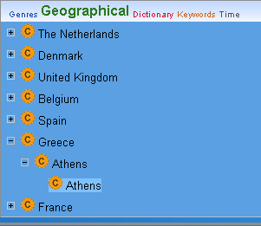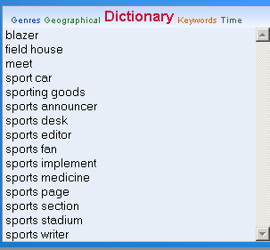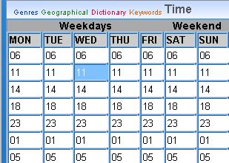

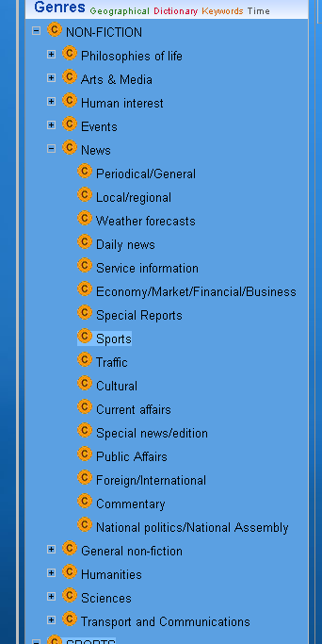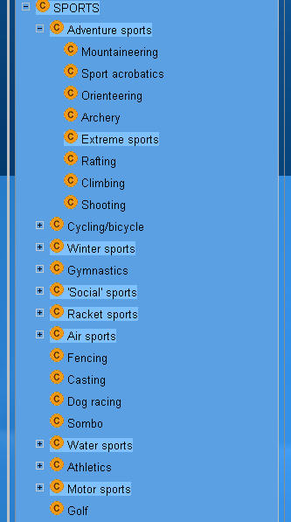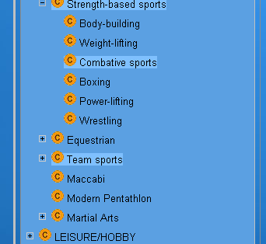

Fig. 3. Screen shots from the Web-based TV search interface

1.6. Are the functionalities associated with the controlled vocabulary(ies) integrated in any way with functionalities provided by other means? (For example, search and browse using a structured vocabulary might be integrated with free-text searching and/or some sort of social bookmarking or recommender system.)
Google-like free-text search interface - for each user query the system will add matches, proposals and alternatives from the vocabularies and from the current context and user models (see Fig. 4.).

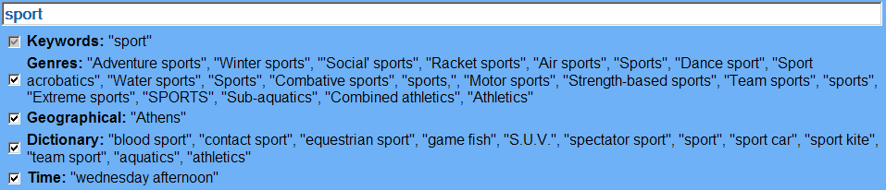

Fig. 4. User query expansion interface

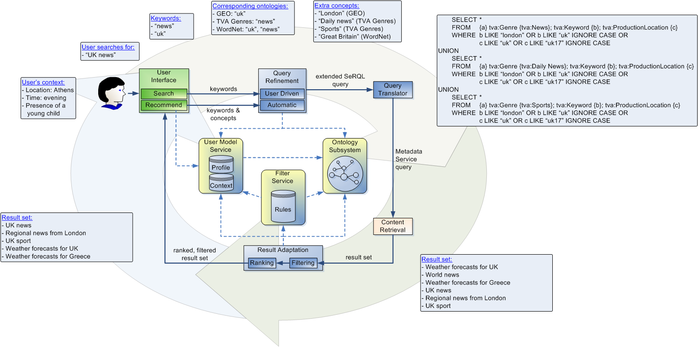
Fig. 5. User query refining process

If the user tries to search with an empty text input field, the system will interpret this as a request for a recommendation and try to find content fitting the user’s current context.

================================================================
Section 2. TV-Anytime ContentCS Vocabulary
================================================================
TV-Anytime ContentCS
http://wwwis.win.tue.nl/~ppartout/Blu-IS/Ontologies/TV-Anytime/PhaseI/Classifications/ContentCS.owl

WordNet:
http://www.w3.org/2006/03/wn/wn20/rdf/wordnet-synset.rdf
http://www.w3.org/2006/03/wn/wn20/rdf/wordnet-glossary.rdf
http://www.w3.org/2006/03/wn/wn20/rdf/basic/wordnet-senselabels.rdf

2.2. Briefly describe the general characteristics of the vocabulary, e.g. scope, size...
TVAnytime ContentCS contains a hierarchy of television genres. This RDF/OWL version, which only contains ‘subclassOf’ relations, is a translation of an XML term hierarchy. Currently it contains 685 classes.

2.3. In which language(s) is the vocabulary provided? In the case of partial translations, how complete are these?

Originally it was available in XML. We translated it to RDF/OWL. The translation is 100% complete.

*2.4. Please provide below some extracts from the vocabulary. Use the layout or presentation format that you would normally provide for the users of the vocabulary. Please ensure that the extracts you provide illustrate all of the features of the vocabulary.

<owl:Class rdf:ID="3.1.1">
<rdfs:subClassOf rdf:resource="3.1"/>
<rdfs:label xml:lang="en">News</rdfs:label>
<rdfs:comment xml:lang="en">Time-sensitive information</rdfs:comment>
</owl:Class>
<owl:Class rdf:ID="3.1.1.1">
<rdfs:subClassOf>
<owl:Class rdf:about="3.1.1"/>
</rdfs:subClassOf>
<rdfs:label xml:lang="en">Daily news</rdfs:label>
</owl:Class>
<owl:Class rdf:ID="3.1.1.2">
<rdfs:subClassOf rdf:resource=" 3.1.1"/>
<rdfs:label xml:lang="en">Special news/edition</rdfs:label>
<rdfs:comment xml:lang="en">one off program to carry specific news events e.g. coverage of breaking news such as train crash</rdfs:comment>
</owl:Class>

3.1.1 News
3.1.1.1 Daily News
3.1.1.2 Special news/edition

The main categories of the TVA hierarchy are:

3.1 NON-Fiction
3.1.1 News
3.1.1.9 Sports
...
3.2 Sports
3.2.1 Athletics
3.2.2 Cycling
...
3.3 (deprecated does not exist anymore)
3.4 Fiction
3.5 Amusement
3.6 Music
3.7 Interactive Games
3.8 Leisure/Hobby/Lifestyle
3.9 Adult

2.5. Describe the structure of the vocabulary. What are the main building blocks? What types of relationship are used? If you can, provide examples by referring to the extracts given in paragraph 2.4.

Originally there are only subclassOf relations in the TVA hierarchy. We can use OWL and SKOS constructs, which can introduce links between related concepts and express the semantics of the genres better:

- “Sports” (3.1.1.9) meaning sport news ideally should be related to the category “sport”. Possibly it could be realized with SKOS:related or SKOS:subject / SKOS:primarySubject;
- To improve textual matching all names containing ‘/’ or ‘()’ like ‘leisure/hobby’ or ‘Football (Soccer)’ could be split in ‘leisure’ and an alternative label like ‘hobby’ and ‘Football’ with an alternative label ‘soccer’.
- Concepts, such as “Football (Soccer)”, “Football (Indoor)”, “Street soccer” and “Beach soccer”, which currently are represented at the same level in the hierarchy could be reorganized with the help of SKOS:narrower and SKOS:broader for instance.

2.6. Is a machine-readable representation of the vocabulary already available (e.g. as an XML document)? If so, we would be grateful if you could provide some example data or point us to a hyperlink.

http://wwwis.win.tue.nl/~ppartout/Blu-IS/Ontologies/TV-Anytime/PhaseI/Classifications/ContentCS.owl

2.7. Are any software applications used to create and/or maintain the vocabulary? Are there any features which these software applications currently lack which are required by your use case?

No.

2.8. If a database application is used to store and/or manage the vocabulary, how is the database structured? Illustration by means of some table sample is welcome.

The vocabulary is stored in a Sesame triple database.

2.9. Were any published standards, textbooks or written guidelines followed during the design and construction of the vocabulary? Did you decide to diverge from their recommendations in any way, and if so, how and why?

Guideline 1 in http://www.cs.vu.nl/~mark/papers/Assem04a.pdf was followed.

2.10. How are changes to the vocabulary managed?

Changes are made through direct editing. We do not divert from the original TV-Anytime specification and stay backward compatible with it.

================================================================
Section 2. Time Ontology
================================================================
Time ontology
http://wwwis.win.tue.nl/~ppartout/Blu-IS/Ontologies/Time/time.owl

Based on:
http://www.isi.edu/~pan/damltime/time.owl

2.2. Briefly describe the general characteristics of the vocabulary, e.g. scope, size...

The original Time ontology provided the means to construct time-specifications. We extended it with the instances needed for our application.

2.3. In which language(s) is the vocabulary provided? In the case of partial translations, how complete are these?

RDF/OWL

*2.4. Please provide below some extracts from the vocabulary. Use the layout or presentation format that you would normally provide for the users of the vocabulary. Please ensure that the extracts you provide illustrate all of the features of the vocabulary.

A instance to exemplify the concept “morning” (mind some abbreviations to preserve outline):

<ProperInterval rdf:ID="morning">
<rdfs:label>morning</rdfs:label>
<begins rdf:resource="#instant_MorningStart"/>
<ends rdf:resource="#instant_MorningEnd"/>
<before rdf:resource="#noon"/>
</ProperInterval>

<Instant rdf:ID="instant_MorningStart">
<inCalendarClock>
<CalendarClockDescription rdf:ID="cCD_MorningStart">
<second rdf:datatype="XMLSchema#decimal">00</second>
<minute rdf:datatype="XMLSchema#nonNegInt">00</minute>
<hour rdf:datatype="XMLSchema#nonNegInt">06</hour>
</CalendarClockDescription>
</inCalendarClock>
</Instant>

<Instant rdf:ID="instant_MorningEnd">
<inCalendarClock>
<CalendarClockDescription rdf:ID="cCD_MorningEnd">
<hour rdf:datatype="XMLSchema#nonNegInt">10</hour>
<minute rdf:datatype="XMLSchema#nonNegInt">59</minute>
<second rdf:datatype="XMLSchema#decimal">59</second>
</CalendarClockDescription>
</inCalendarClock>
</Instant>

2.5. Describe the structure of the vocabulary. What are the main building blocks? What types of relationship are used? If you can, provide examples by referring to the extracts given in paragraph 2.4.

For the structure of the Time ontology refer to:
http://www.cs.rochester.edu/~ferguson/daml/

2.6. Is a machine-readable representation of the vocabulary already available (e.g. as an XML document)? If so, we would be grateful if you could provide some example data or point us to a hyperlink.

http://wwwis.win.tue.nl/~ppartout/Blu-IS/Ontologies/Time/time.owl

2.7. Are any software applications used to create and/or maintain the vocabulary? Are there any features which these software applications currently lack which are required by your use case?

No.

2.8. If a database application is used to store and/or manage the vocabulary, how is the database structured? Illustration by means of some table sample is welcome.

The vocabulary is stored in a Sesame triple database.

2.9. Were any published standards, textbooks or written guidelines followed during the design and construction of the vocabulary? Did you decide to diverge from their recommendations in any way, and if so, how and why?

No.

2.10. How are changes to the vocabulary managed?

Changes are made through direct editing.

================================================================
Section 2. Geo Ontology
================================================================
Geo ontology
http://wwwis.win.tue.nl/~ppartout/Blu-IS/Ontologies/Geo/Europe.owl

2.2. Briefly describe the general characteristics of the vocabulary, e.g. scope, size...

The Geo ontology gives a simple structure where geographical locations are divided in country-province-city relations. The ontology is far from complete. It contains data for the following countries: the Netherlands, Denmark, the United Kingdom, Belgium, Spain, Greece and France. For every country all the provinces are present, but for every province only the main cities were added.

2.3. In which language(s) is the vocabulary provided? In the case of partial translations, how complete are these?

RDF/OWL

*2.4. Please provide below some extracts from the vocabulary. Use the layout or presentation format that you would normally provide for the users of the vocabulary. Please ensure that the extracts you provide illustrate all of the features of the vocabulary.

<Country rdf:ID="TheNetherlands">
<hasProvince>
<Province rdf:ID="ZeelandProvince">
<hasCity rdf:resource="#Sluis"/>
<rdfs:label rdf:datatype="XMLSchema#string">Zeeland</rdfs:label>
</Province>
</hasProvince>
</Country>
<City rdf:ID="Sluis"/>

2.6. Is a machine-readable representation of the vocabulary already available (e.g. as an XML document)? If so, we would be grateful if you could provide some example data or point us to a hyperlink.

http://wwwis.win.tue.nl/~ppartout/Blu-IS/Ontologies/Geo/Europe.owl

2.7. Are any software applications used to create and/or maintain the vocabulary? Are there any features which these software applications currently lack which are required by your use case?

No.

2.8. If a database application is used to store and/or manage the vocabulary, how is the database structured? Illustration by means of some table sample is welcome.

The vocabulary is stored in a Sesame triple database.

2.9. Were any published standards, textbooks or written guidelines followed during the design and construction of the vocabulary? Did you decide to diverge from their recommendations in any way, and if so, how and why?

No.

2.10. How are changes to the vocabulary managed?

Changes are made through Protégé:
<!-- Created with Protege (with OWL Plugin 2.1, Build 284) http://protege.stanford.edu -->

================================================================
Section 3. Vocabulary Mappings
================================================================

To exemplify the different mappings between our vocabularies the following picture is shown. Here we can see all the links from a certain content item described in TVA to other vocabularies like WordNet, Time, Geo and the content classification hierarchy. What the picture does not show is the interrelation between WordNet and all the other vocabularies. By this we can for example check every location of the Geo and every genre in the ContentCS hierarchy in WordNet to find synonyms.

