Developing Web Accessibility Presentations and Training: Overview

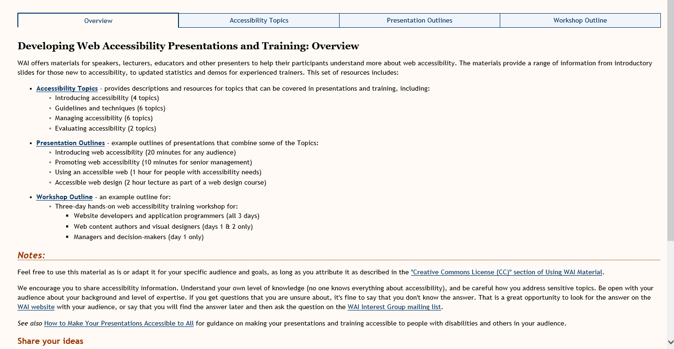

Vivienne’s Suggestions:

WAI offers materials to assist with communicating the importance of digital accessibility. These materials are suitable for all levels of presentations and include a wide range of topics. This set of resources includes:
Digital Accessibility Topics – provides descriptions and resources for topics that can be covered in presentations and training, including:
- Introduction to digital accessibility
- Understanding guidelines and techniques
- Managing accessibility within an organisation
- Evaluating accessibility of resources
Presentation Outlines - example presentation outlines for:
- Introducing web accessibility
- Promoting web accessibility
- Using an accessible web
- Accessible web design
Workshop Outline – an example outline for a three-day digital accessibility training workshop suitable for:
- Digital developers (all 3 days)
- Content authors and designers (days 1&2)
- Managers and decision-makers (day 1 only)
Notes:
Feel free to use this material as is or adapt it for your specific audience and goals, as long as you attribute it as described in the "Creative Commons License (CC)" section of Using WAI Material.
We encourage you to share accessibility information. Some pointers on sharing:
- Understand your own level of knowledge (no one knows everything about accessibility)
- Be careful how you address sensitive topics.
- Be open with your audience about your background and level of expertise.
- If you get questions that you are unsure about, it's fine to say that you don't know the answer. That is a great opportunity to look for the answer on the WAI website with your audience, or say that you will find the answer later and then ask the question on the WAI Interest Group mailing list.
See also How to Make Your Presentations Accessible to All for guidance on making your presentations and training accessible to people with disabilities and others in your audience.
Share your ideas

Topics for Web Accessibility Presentations and Training
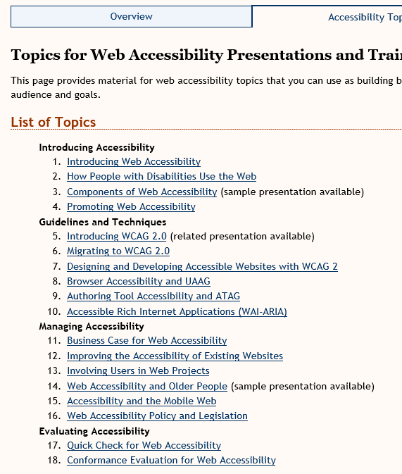

Vivienne’s Thoughts on this resource
- Topics are in dire need of updating
- We will want to make sure that the list of resources and materials is updated in accordance with what will be on the new website
- Does not reflect the work being done on WCAG 2.1 and Silver – need to replace 5&6
- Does not reference the tutorials or videos
- Needs to reference mobile techniques
- Needs to reference non-ICT guidelines
- 17&18 – needs to reference the WCAG-EM and sample WCAG-EM reporting tool
- Each link will need checking against the resources that are being kept on the new website and make sure the links are correct and updated
- Doesn’t reference how to use Easy Checks or BAD

Example Outlines for Web Accessibility Presentations

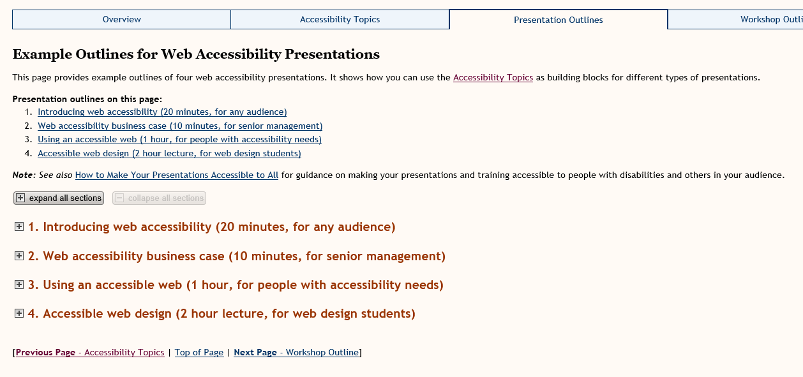

Vivienne’s comments:
- I don’t really like the layout of this page – it is just links and expanding menus and not very engaging
- IMHO none of these provide sufficient time or material to be of great benefit
- I can’t imagine anyone in senior management attending a 10-minute presentation, but perhaps that’s just my perspective
- We do a 45-minute introductory presentation with 15 minutes for Q&A (Learn at Lunchtime style) for these type of presentations, but perhaps others have a different experience

Example Outline for a Web Accessibility Workshop

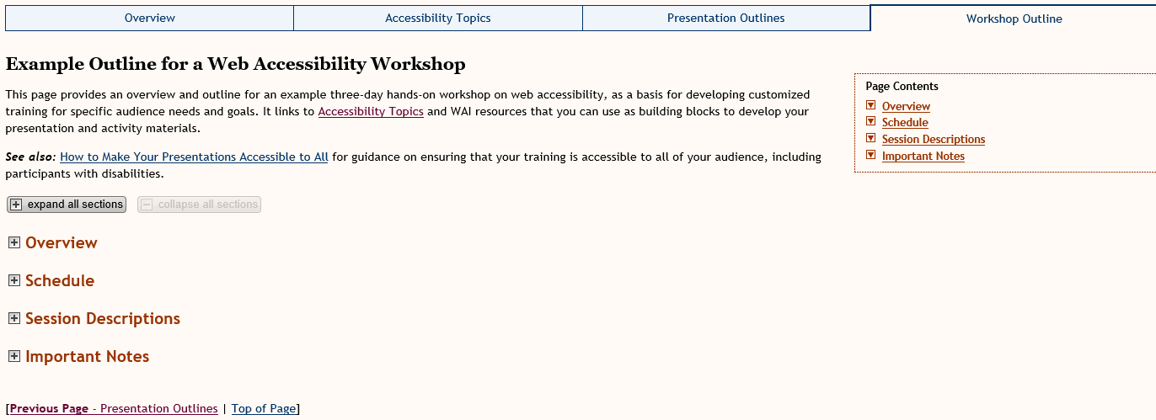

Vivienne’s comments:
- Sorry, but this page feels very much like the previous page
- The material included is good, but needs updating if we’re going to keep this resource
- Check all links and find out which ones are going to be kept on the new website
- This means that there are dependencies on other WAI materials before some of this is decided – we don’t know what other groups are keeping/changing/deleting
- I think the title might need the mention of ‘3-day’ so that they have a reason to open the expanding menus to see what is suggested for each day
- Some of the schedule may not work with the people suggested for each day. For example, would managers really want Session 4 on day 1 – Accessible content authoring? Or Accessible visual design and CSS?

