Hubs and Agents Notes
August 13, 2019

Agent Protocol Use Cases / Strawmen
Define an agent as: A service where a requesting party other than the data subject may present access credentials.

1 - Mobile-to-Online: Alice owns both agents. e.g. Alice’s biometrically protected mobile wallet delegates to Alice’s online agent service based on Intel SGX.

2 - Online-to-Online: Alice owns both agents. e.g. Alice’s online agent delegates to another agent that Alice also owns for pairwise-pseudonymity privacy reasons.

3 - Online-to-Data Processor: Alice’s agent is the GDPR data controller and delegates to a GDPR data processor that is a separate entity. e.g. Alice gets a blood test at a national lab. The lab does not process or act on the basis of requesting party credentials. (except law enforcement).

3a - Online-to-Alice-owned Data Processor: This is the case where Alice owns both the controller and the processor. This case does not require a standardized protocol between the controller and processor but could benefit from it in some cases where the services are provided to Alice by separate hosts. e.g. Alice chooses Apple for her controller and Microsoft for her processor.

4 - Online-to-Data Broker: Alice’s agent is the data controller and delegates to another data controller that is a separate entity. e.g. Alice gets a blood test at a national lab and posts a link to the lab to a dating service directory. The dating service decides if Bob can access the data pointing to the lab.

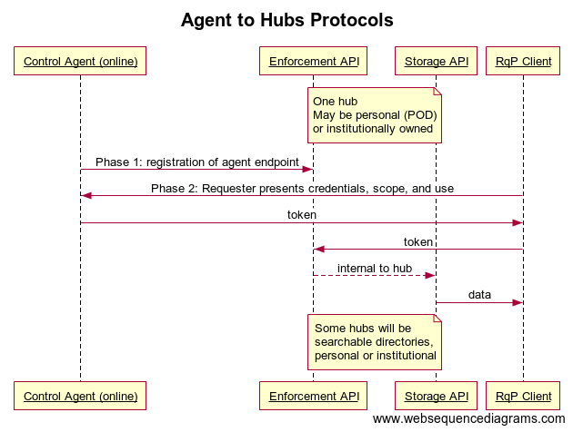
title Agent to Hubs Protocols

participant Control Agent (online) as A
participant Enforcement API as B
participant Storage API as C
participant RqP Client as D

note over B,C: One hub\nMay be personal (POD)\nor institutionally owned

A->B: Phase 1: registration of agent endpoint
D->A: Phase 2: Requester presents credentials, scope, and use
A->D: token
D->B: token
B-->C: internal to hub
C->D: data

note over B,C: Some hubs will be\nsearchable directories,\npersonal or institutional

