Can people with dementia use your web application or App?

By Rebeca Garcia, Lisa Seeman-Kestenbaum, Tony Fenton, Peter Anderberg, Maria Quintana, Michel Stefan, Ifty Ahmad, David Mena, Evi lemmens

SMART4MD is an app and platform developed under European Commission, H2020 Project 643399 for people living with dementia to manage their health and improve their quality of life.
The application was tailored via using the recommendations from the early drafts of our deliverables, design patterns, and making content useable. Full details of the guidance given, explanations and examples of the platform customizations for users with mild dementia can be found in the Customization Guidance Document (D2.4) for the project.

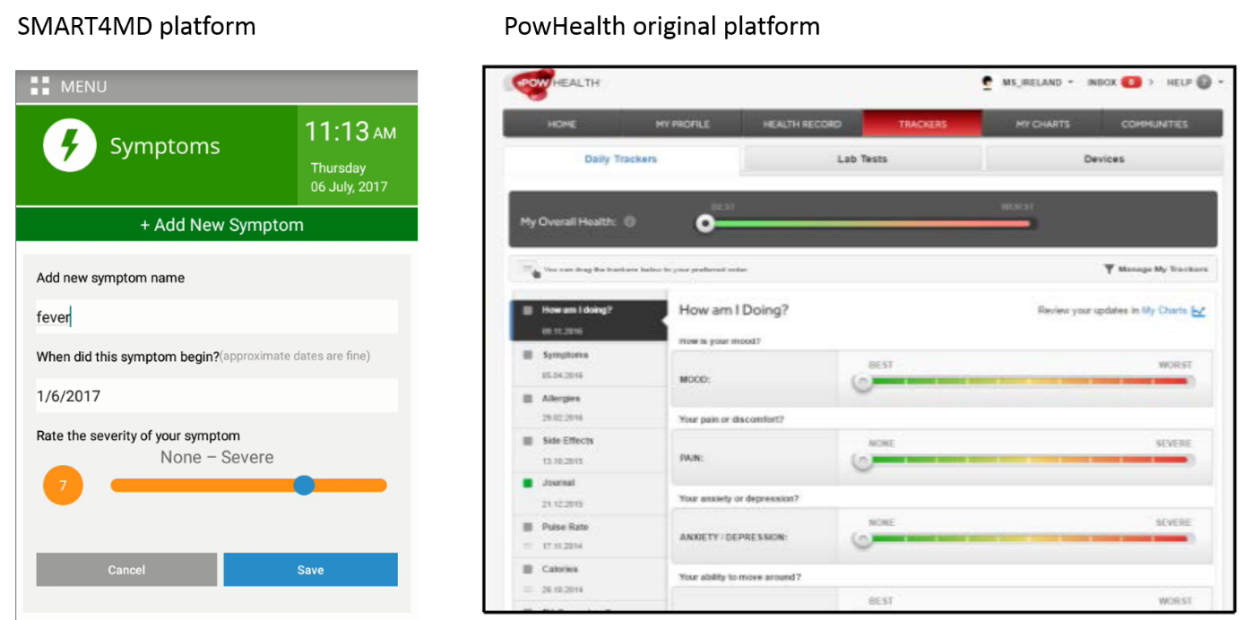
System health trackers:
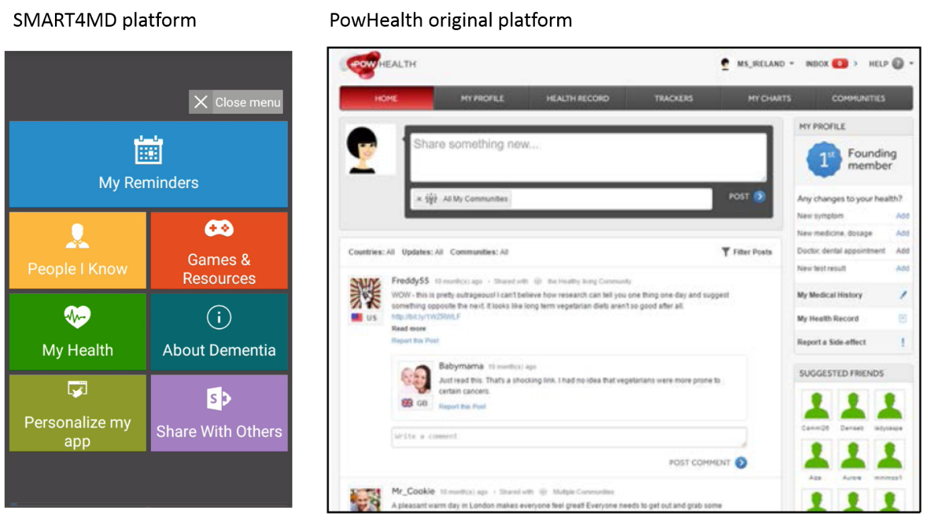

Features included:
- My Reminders - A simple, easy to use, and intuitive calendar for supporting the user’s daily routine.
- People I know – Simple and elegant contact list providing friends’ and families’ contact details including a large picture.
- Games and Resources – List of easy-to-use links to several games and news webpages that were pre-selected by the project team.
- My Health – A section dedicated to medical appointments, recording user medicine use and optional health trackers that track the development of symptoms and illness severity.
- Personalise my app – An approachable, customisable, settings menu that allow the users to change and adapt the system’s look and feel.
- About dementia – a section that provides general information about dementia and includes video links and web links to professional information about the condition.
- Share with others – A sharing option that allows the user to share their daily schedule medication profile or health situation with pre-designated carers or family members.

This prototype platform was tested from June 2017 – November 2019 as part of the project feasibility study in two clinical sites in Spain and Sweden

Conclusions
Not only were people living with mild dementia able to use the application and platform but use may have slowed the progression of the dementia.

Now for the scientific data from the first report:
Two groups ran controlled tests:
- BTH Blekinge Institute of Technology (Sweden)
- SAS Servicio Andaluz de Salud (Spain)
The mean and SD from one group (BTH) analysis (1,22; SD=1,737) suggest that in general the majority of participants from the intervention group improve their MMSE score by one point after using the SMART4MD application for 6 months. For the second group (SAS) participants from the intervention group maintain the same or similar (SD=2,588). Note that the typical decline of the MMSE is about 2-4 point a year a person with Alzheimer's . Note this is the preliminary analysis, and full results are expected by the end of 2019.

What did they use?
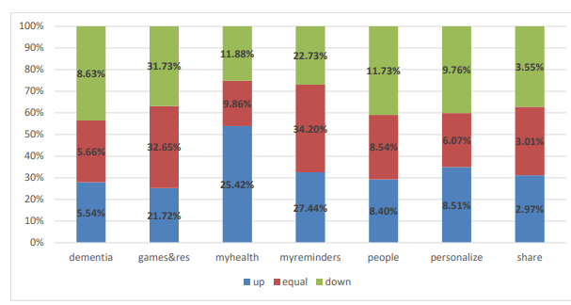
BTH group - participants differences vs usage (described below)

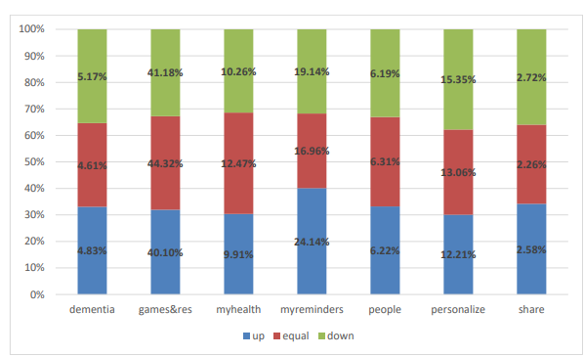
SAS group - participants differences vs usage (described below)

For the BTH group Participants with the same or with an improvement on MMSE score used mostly the My Reminders section with a 47,39% and 39,53% of usage respectively. In this case people who had a decrease on MMSE score also used My Reminders section with a 32,07% of usage, as well as the Game and Resources section with a 32,07% of usage while in the other groups this section had less usage percentage (equal 14,58% and up 26,07%).
In the SAS group participants used the SMART4MD application in a similar way. The section most used was Games and Resources section with a 40,10% of usage in the group with an improvement of MMSE score, a 44,32% in the group that maintaining the MMSE score, and a 41,18% for the group with a decrease in their MMSE score. The next section most used in all groups was My Reminders section with a 24,14%, 16,96% and 19,14% respectively.

See SMART4MD.eu for more details

With thanks to
The European Commission, H2020 program
Anglia Ruskin England
Athena ICT Limited - Israel
Blekinge Tekniska Hogskola - Sweden
Consorci Sanitari De Terrassa - Spain
Dex Innovation Centre - Czech Republic
Healthbit - United Kingdom
Servicio Andaluz De Salud-Instituto De Investigacion Biomedica De Malaga (Andalusian Health Institute – Health Research Institute of Malaga) SAS-IBIMA - Spain
UC Limburg - Belgium
Universidad Politecnica De Madrid - Spain

