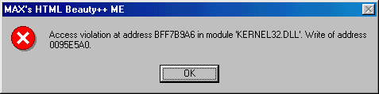
Access violation at address BFF7B9A6 in module ‘KERNEL32’. Write of
Address 0095E5A0

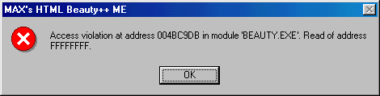
Access violation at address 004BC9DB in module ‘BEAUTY,EXE’. Read of
Address FFFFFFFF

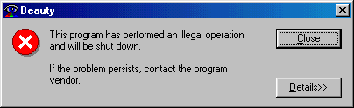
This program has performed an illegal operation and will shut down.
If the problem persists, contact the program vendor

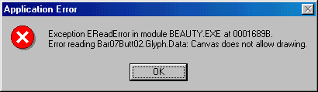
Exception EReadError in module BEAUTY.EXE at 0001689B.
Error reading Bar07Butt02.Glyph.Data: Canvas does not allow drawing.

